
IEEE R8 Technical Activities Report
R8 Committee Meeting in Riga 8-9. May 2010

Major VC-TA objectives
- Obtain a serviceable cooperation with competent and active SCs to run smoothly
- ‘Standardize’ simplified to-the-point reporting templates and procedures
- Stimulate and follow up pertinent SC’s actions
- Initiate for evaluation new inter-committee initiatives to benefit R8 MD through e.g. joint IRSC - CCSC-Student Activities engagements ⇨
(‘MeDICI’- “Membership Development Inter-Committee Initiative” - see Appendix)

Sub-Committees
- Chapter Coordination Sub-Committee (CCSC)
- Péter Magyar (Germany) - Chair (& Control)
- Daniel Pasquet (France) - Telecom/MMT
- Tamás Ruzsányi (Hungary) - Power
- Samir I. Shaheen (Egypt)* - Computer
- Cor Claeys (Benelux) * - Electronics
- Conference Coordination Sub-Committee (CoCSC)
- Marian P. Kazmierkowski (Poland) - Chair
- Gerhard Hancke (South Africa) - Africon
- Carl Debono (Malta)Error: Reference source not found - Melecon
- Baldomir Zajc (Slovenia) - Eurocon
- Educational Activities Sub-Committee (EASC)
- João Costa Freire (Portugal) - Chair
- Bakr Hassan (Saudi Arabia) - Pre-University Activities and ICED
- Saurabh Sinha (South Africa)* - Pre-University Activities
- Andreas Luxa (Germany)* - ICED
- Maciek Ogorzałek (Poland)* - ExpertNow
- Okyay Kaynak (Turkey)* - ExpertNow
- Industry Relations Sub-Committee (IRSC)
- Benito Palumbo (Italy) - Chair
- Ghaleb Al-Dandan (Saudi Arabia) - ICED & EICP Initiatives
- Boris Levitas (Lithuania) - Collaboration Std’s & Ind. Leader Award
- Ferhan Özkan (Turkey) - ISBIR (& IROs WS?)
- Igor Gazdik (Sweden)* - Environment Initiative
- Standards Coordinator
- David Law (UKRI) - Coordinator

For more details regarding each SC team members and their functions follow this TA link.

*) New members

Chapter Coordination Sub-Committee (CCSC)

Chapter Statistics
Total number of chapters according to SAMIEEE as of Apr 10, 2010 436
Estimated number of non-registered / chair position vacant chapters 50
Estimated total number of R-8 chapters 486

Newly created chapters since the Lisbon Meeting (Oct 1, 2009 – Apr 10, 2010)

by sections
Austria, Hungary, Israel, Nigeria, Ukraine, each 1
Czechoslovakia, Morocco, Romania, Turkey, each 2
Norway, South Africa, UKRI, each 3
Tunisia 6
Total 28

by SB/regular chapters
Student branch chapters 9
South Africa 1
Ukraine 1
Turkey 2
Tunisia 5
Regular chapters 19
Total 28

2010 Chapter Of The Year Award Contest for 2009 performance
Nominated chapters:
Egypt Section CIS Chapter
Germany Section IAS/PELS/IES Joint Chapter
Hungary Section CIS Chapter
Budapest University of Technology and Economics Student Branch PES/IAS
Italy Section PHOS Chapter
Poland Section AP/MTT/AES Joint Chapter
Spain Section IES/PELS Joint Chapter
Tunisia Section CIS Chapter
Ukraine Section IM/CIS Joint Chapter
Status:
Last date of submission Feb 18, 2010
Evaluation finished Mar 6, 2010
Winner chapter informed Mar 7, 2010
Award presentation: May 8, 2010, during the R8 Committee Meetings Award Ceremony

Chapter Chair Conferences overview

Chapter Chair Group | Event, Date & Venue
Computer and Control | R-8 First COMP/RAS/EMB/IES/IAS/PELS Chapter Chairs Meeting & Workshop on “Move from Research to Business”  Lisbon, Portugal, May 29-30, 2010
Computer and Control | R-8 CCSC Chapter Chairs Conference & Leadership Joint Workshop  Mopani Camp, Kruger National Park, South Africa, June 4, 2010
Power | R-8 Power Chapters Technical & Leadership Joint Workshop  Budapest, Hungary – Zilina. Slovakia, - Bratislava, Slovakia, May 21-26, 2010
Power | R-8 Power Chapters Leadership Workshop  Manama, Kingdom of Bahrain, Dec 19, 2010
Telecommunications | ED/AP/MTT/AES/GRS/NPS/EMB Societies Chapter Chair Meeting  Kharkiv, Ukraine, June 25-26, 2010
Telecommunications | MTT-S Chapter Chair Meeting  Paris-La-Défense, France, Sep 27, 2010

CCC details (program, registration, travel & accommodation subsidy): www.ieee.org/go/r8chapters

Conference Coordination Sub-Committee (CoCSC)
CoCSC – Invited Members
- Pilar Molina Gaudo – HISTELCON2010
- Prof. Andrey Fionov – SIBIRCON2010
- Dr. Ing. Carl J. Debono – MELECON2010
- Prof. João Costa-Freire – EUROCON2011

Improvements in Conference Organization
Data base with about 20 000 addresses of potential participants from the R8 has been developed to be used for advertisement of R8 conferences, and will be under continuous development. Additionally e-Notice IEEE service is used for R8 conference advertisement (e-mails only to R8 members).

Industry Activities
- Industry Track & Exhibition at major R8 conferences
- Industry Track Co-Chairman
- Simplified paper submission for speakers from industry
- Industry Track has to be included into CfP
- One keynote speaker from industry

New Rules for R8 Conference Sponsorship and Technical Co-Sponsorship
New detailed ‘Requirements and Application Forms’ have been developed. Non-IEEE conferences will be charged a general administrative fee of $300.00 for R8 Technical Co-Sponsorship

Present and Future R8 Conferences
AFRICON 2009 was held in Nairobi Kenya, September 22-25th, 2009, organized jointly by the South Africa and Kenya sections.
A full report on AFRICON 2009 is expected at the R8 Meeting in Riga.

HISTELCON 2010 (History of Electrotechnology Conference), will be held in Madrid, Spain November 3-5, 2010, its website (incl. CfP) being: http://www.aeit.es/histelcon2010/index.html

MELECON 2010 was organized by Malta Section on 26 - 28 April 2010, its website being: www.melecon2010.org

SIBIRCON 2010 (The International Conference on Computational Technologies in Electrical and Electronics Engineering) will be held in Irkutsk Listvyanka, Russia, July 11-15 2010, its website being: http://sibircon2010.sibsutis.ru/user.php

ENERGYCON2010 will be held in December 18-20, 2010 at Manama, Bahrain.
The Saudi Arabia Section will organize this Conference for the first time, its website (incl. CfP) being: http://www.ieee-energycon.org/

EUROCON 2011 will be held in Lisbon, Portugal, on 27-29 April, 2011.
The CfP and information was presented at the Gala Dinner in St. Petersburg and MELECON 2010 in Malta, its website (incl. CfP) being: http://www.eurocon2011.it.pt

AFRICON 2011 will be held on September, 2011 in Victoria Falls, Zambia.
MELECON 2012 will be held on April, 2012 in Tunis, Tunisia.
ENERGYCON 2010 will be held on May 17-20, 2012 in Firenze, Italy.
EUROCON 2013 will be held on July 2-5, 2013 in Zagreb, Croatia.

... and we are calling upon candidates to organize:
- SIBIRCON 2012
- ENERGYCON 2012
- HISTELCON 2012
- AFRICON 2013
- MELECON 2014
- EUROCON 2015

Educational Activities Sub-Committee (EASC)
Major EASC objectives
- Pre-University education activities: To inform the Sections on available IEEE EAB programs and support those wanting to implement them. Supporting Macedonia Section and it’s involvement in Summer Campus Roboteka and possible extension to neighbor Sections.
- Continuing education: Increase the number of Sections/Chapters using ExpertNow and Technical English Programs. Continue to participate on ICED initiative.

EASC activities
On Pre-University education
- Teacher In-Service Program Training (TISP) (Bakr Hassan, Saurabh Sinha and João Costa Freire)
  - A TISP event is to be organized in Lusaka, Zambia 24-25 September 2010. We expect 60 delegates (50 IEEE members and the rest from education departments). Already confirmed attendees from 6 Southern and Eastern African countries: Uganda, Botswana, Namibia, South Africa, Swaziland and Zambia. Individuals from Zimbabwe are also expected to attend this event. The event financing is supported by IEEE EAB.
  - We are supporting the implementation at least in three new Sections. Discussions with Saudi Arabia, Portugal and Spain Sections Education Chapters to implement the program with the support of EASC will continue. One of the difficulties we are facing now is the lack of IEEE volunteers to implement the program.
- TryEngineering (João Costa Freire, Saurabh Sinha and Bakr Hassan)
  - A survey on existing activities within knowledge of engineering careers by pre-university students in Region 8 countries and information of this IEEE program was sent to all R8 Section Chairs last year. Feedback from Sections is needed. Up to now only 6 out of 58 Sections have answered, and only two completely. The same information was recently resent to the 18 known Section’s EA Officers.
  - Up to now only Sections with interest in translation of the lessons to Arabic and Italian have been revealed.
- Engineering Projects in Community Service (EPICS) (Saurabh Sinha)
The IEEE EPICS-High initiative proposal to IEEE NIC has been approved by the IEEE BoD. It is regarded and can be executed as an IEEE pre-university education effort, which will engage IEEE Sections from different Regions, including 4 from Region 8: Botswana Sub-section (George Anderson); Israel Section (Ofer Barnea); South Africa Section (Saurabh Sinha); Zambia Section (Reuben Munungwe)
- Summer Campus (João Costa Freire)
Support to Macedonia Section participation at a summer campus in Macedonia for students aged 10 -16 years from Balkan countries to promote robotics and computer engineering careers.
On Continuing Education
- Industry Continuing Education Development (ICED) (Bakr Hassan, Andreas Luxa and João Costa Freire)
We are cooperating with IRSC on the ICED initiative lead by Ghaleb Al-Dandan.
- ExpertNow (Maciek Ogorzałek and Okyay Kaynak)
The identification of useful subjects for R8 members to be included in future ExpertNow activities will be analysed. Information on this program will be sent to Sections/Chapters. Their support is needed.
- Technical English (João Costa Freire)
Support Sections that want to implement this program. Following the Russian experience, started 2007, Hungary had already started this year its implementation. First meetings schedule for spring semester.
Additional EAB events in Region 8 planned for 2010
- On Sunday 26 September, after the TISP event, the EAB CGAA (Accreditation Committee) has also planned to hold a meeting in Lusaka, Zambia ( Moshe Kam the chair of CGAA will lead the meeting).

Industry Relations Sub-Committee (IRSC)
Not all of the goals of the 2009 R8 IRSC Plan have been fully achieved, due to difficulties in the management and implementation of the tasks. Better results are expected in 2010 from a more integrated participation of the SC members and involvement of dedicated volunteers at Section level.

- The IRSC members have contributed to completing the Industry Continuing Education Development (ICED) program planning, Industry Leader Award Program (IL) selection and nomination criteria, topics suggestions, and in the last period to the direct Champion's responsibility.
- The Energy Industry Collaboration Program (EICP), led by Ghaleb Dandan, is an initiative successfully carried out for the last three years and presently with deep involvement from individuals and organizations from the whole R8 geographical area. One important fallout of the initiative is the R8 Energy Conference (Energycon 2010) to be held in Bahrain, and the EICP is presently at an independent self-sustaining stage.
- The focus for the three years IEEE Student Branches Industry Relations (ISBIR) Program, started in 2007 and led by Ferhan Özkan, has been aimed to integrate major initiative activities and results into IEEE process.
- The IROs' list has been updated and distributed to the pertinent members, together with clarifications on the expected tasks of the IROs, who have been alerted to be available for possible cooperation with the Initiative Champions at local level.
- The planned study for evaluating and proposing a new R8 Environment Initiative to IEEE New Initiatives Committee (NIC) was not carried out in 2009, and has consequently been included to the 2010 Plan. The purpose is to assess and evaluate the potential of establishing Environment initiative in R8 areas to focus on and develop implementation plans accordingly.
- A motion to establish an R8 Industry Award Program for industry leaders driving their organization to success by in-house developed advanced technologies has been presented, but apparently not formally approved at Lisbon R8 Meeting.

Standards
Goals and status
The major tasks assigned to the IEEE R8 Standards Coordinator for 2009, with the current status, are summarized below.

Standards education

Goals:

Provide educational content about IEEE standards, both about the process, for example the inclusion of patented technology in standards, and also about the various standards themselves. (Collaboration with IEEE Standards Education Committee (SEC))

Encourage IEEE R8 students and faculty mentors to apply for IEEE SEC mini-grants program to help with graduate and capstone design projects with an industry standards component. The IEEE then publishes the results as a Student Application Paper. (Collaboration with Student Activities)

- Status
  - Provide educational content
This is being provided mainly through standards tracks at major IEEE R8 conferences (see below). In addition to this it will be looked for other opportunities to cooperate with local sections to provide standards workshops similar to the one that took place in South Africa last year.
  - Student Application Papers
The next deadline for Student Application Paper mini-grant applications is 15th June 2010 and promotion will be through the IEEE R8 Standards web site, IEEE R8 news and working with the Student Activities.
  - Student and GOLD congress 2010
It is proposed a presence at the IEEE R8 Student and GOLD congress 2010 and, similar to the 2008 congress, I propose to do this in collaboration with the IEEE SEC.
Standards speakers and tracks at conferences
- Goals:
  - Arrange both individual speakers on standards and/or whole standards tracks at major IEEE R8 conferences. Collaborate with SEC to arrange workshops on standards such as IEEE 802 in parallel with conferences.
  - Continue to collaborate with SEC to pilot the new ‘Standards Education Speaker’s Bureau’ in R8 which will be similar to the existing Distinguished Lecturer program run by societies.
- Status
MELECON 2010
A standards track titled ‘Demystifying IEEE 802 Standards’ co-sponsored by IEEE R8, IEEE-SA and the IEEE Standards Education Committee is being run at MELECON 2010 providing an overview of the IEEE Standards Association and IEEE 802 standards with an emphasis on wireless.

ENERGYCON 2010
The IEEE-SA has agreed to provide a full day standards track as part of the conference. As such this is now being managed by IEEE-SA International Standards Programs staff and my only role is to monitor, and provide assistance when needed.

AFRICON 2011
Progressing request for a re-run of the standards workshop provided to South Africa section last year (see SESB item below).

Standards Education Speaker’s Bureau (SESB)
The SESB is to continue in pilot mode this year with the IEEE SEC continuing to work on defining its operation.The IEEE-SA, thorough its SESB budget, and IEEE R8, jointly funded a successful one day Standards Workshop for the South Africa section last autumn. A request to re-run this event at AFRICON 2011 has been received and will be progressed.

In addition to the above it is continuously being looked for other opportunities to cooperate with the SESB.

Appendix: New initiative ‘MeDICI’
“Membership Development Inter-Committee Initiative”

Slogan: ‘Today’s students are to become tomorrows IEEE members’

Rationale: Student Members are inclined to carry IEEE membership to their subsequent
working communities – however mainly related to their professional disciplines (i.e. Society-related)

Objective: Increasing the number of IEEE Members by reinforcing the Student-Industry chain, particularly through Societies’ involvements

Means: Establishing forums for SAs - GOLD - IRs to tighten the interrelations bonds, preferably by:
- Establishing SBSCs to augment the character of SAs by increasing the level of professional activities, in bringing Student Members closer to Societies - and vice versa
- Utilising GOLD as an active intermediary facilitator between students and industry - linked to Societies
- IR activities to be focusing Societies involvements

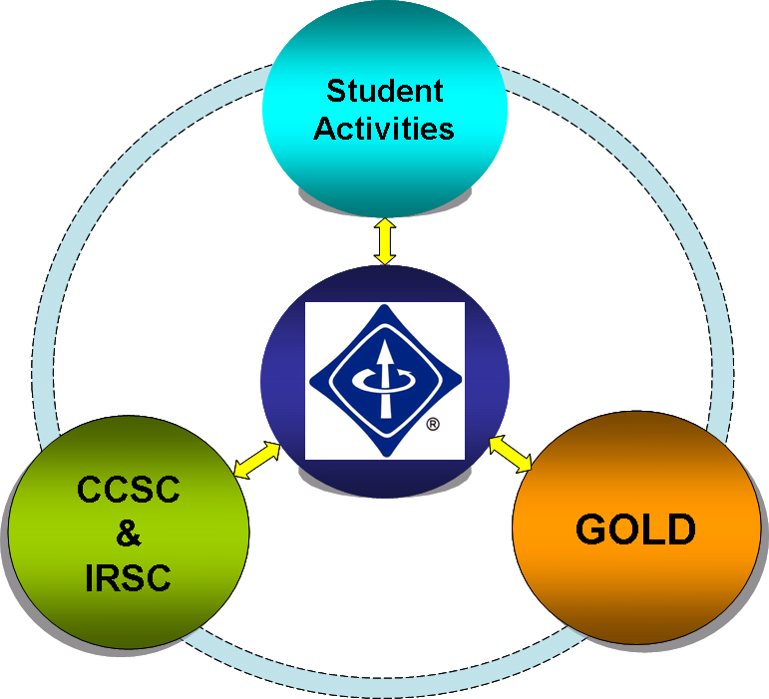
⇨’The Region 8 Golden Triangle’: R8-GT

Ref. ISBIR follow-up
Ref. STEP (one)

