Electronic Communications Coordinator (ECC)
George Michael, Region 8 ECC

The Region 8 Electronic Communication Coordinator's job is to facilitate communication, both between members of the Region 8 Committee, and between this committee and present or future IEEE members.

IEEE Region 8 – Sections Website Competition
The IEEE Region 8 had its first Sections Website Competition this year.
The goal of this Contest was to give a motive to all Sections to create or improve their own website that will serve as a reference point for all their members. This will help the Sections place their mark on the map and facilitate their future actions and activities.
The winners of the Contest received the following prizes:
- United Arab Emirates - First place - $500 to the Section and a plaque to the webmaster that will be given in person at the next IEEE Region 8 meeting
- Ghana - Second place - $500 to the Section and a plaque to the webmaster
- Italy - Third place - $250 to the Section and a plaque to the webmaster
- Egypt - Fourth place - $250 to the Section and a plaque to the webmaster

IEEE Region 8 website statistics

A monitoring tool has been installed on our website (http://ieee.org/r8). Using the Google(TM) Analytics feature here are presented the statistics were obtained over the period from the 20th of November 2009 to the 22nd of April 2010. Over this period, 18,301 people visited the website and 45,142 pages were viewed. On an average visit, a user looks at 2.47 pages, and stays for a little over 2 minutes.
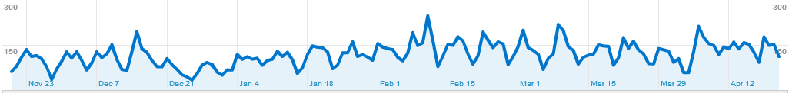
Our visitors come from 131 countries/territories all around the world, many of whom are outside Region 8. The origin of the visitors is depicted in the following map.
