IEEE Region 8 Membership Development Report – March 2010

INTRODUCTION
IEEE membership in Region 8 continues to grow.
At the end of 2009 in Region 8 we had 70,371 members. We surpassed for the first time the 70,000 barrier! Comparing to 67,221 at the end of 2008 it is an increase of 3,150 members or 4.7%.
In the diagram bellow, we can see the changes of membership in Region 8 from month to month. The read line shows the steady growth of membership from year to year.
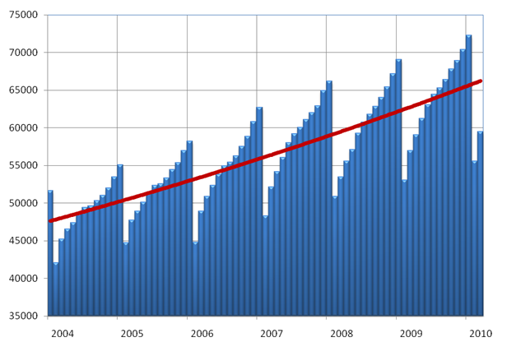

February and March Statistics

After the Service Terminator Action at the end of February 2010 membership went down as usually. The drop is mostly depending on the retention of members. From 64,967 members at the end of August 2009 we retained 45,032 members or 69.3%. Concerning retention in our Sections, the best one in Region 8 was the Switzerland Section having 85.8% retained members (2,252 from 2,624).
In comparison to February 2009 the membership in February 2010 was higher by 2,459 members or 4.6%.

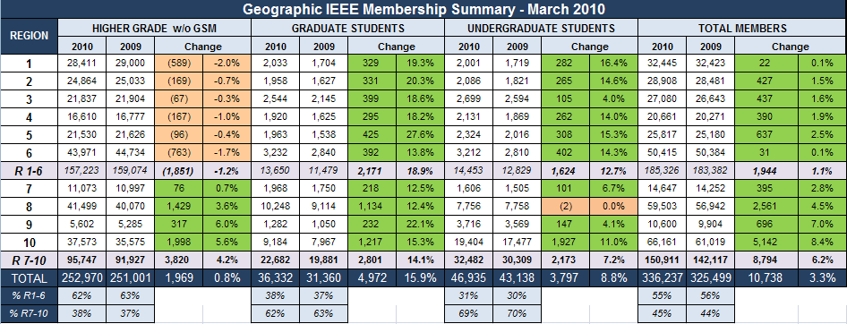

At the end of March 2010 we had 2,561 more members than at the end of March 2009. During March 2010 our membership increased by 3,952 members owing to recovery and recruitment.

Retention vs. Recruitment Rate of Higher Grade Members in Region 8 Sections, March 2010

Vertical axes: Comparative, year-over-year recruitment, i.e. up or down compared to last year
Horizontal axes: Comparative retention rates
Membership Development and Statistics in R8 Sections
For Membership Statistics visit https://analytics.ieee.org/analytics/saw.dll?dashboard
Look into your Section Membership Statistics every month. Is your membership increasing or decreasing? Contact the arrears in your section to see what are the reasons for not renewing. Don't loose members! Big Sections should take into consideration the formation of MD Teamsc covering different areas/towns of the country to make the MD job more easy and more efficient.
To learn more about the members in your Section use the predefined Queries in SAMIEEE: www.ieee.org/organizations/vols/samieee/index.html
Register for participation in the IEEE Membership Development Community https://www.ieeecommunities.org/ieee.md.net

Deactivated Members - Arrears
We sent personal e-mails to all higher grade members who didn’t renew for 2010 on 8 February. Many members renewed after they received the letter and we could solve many problems they had with the renewal. The IEEE MGA Staff helped us to solve many cases. We received many answers and we learned a lot about the reasons why some members don’t renew.
A similar letter has been sent on 19 February to undergraduate and graduate student members who didn’t renew by the IEEE R8 Student Branch Coordinator.
After the Service Terminator Action on 28 February (Service Deactivation), the number of deactivated members or arrears (members who didn’t renew for 2009) was 18,812.
In March we asked all the Section Chairs/ Section Membership Development Officers to take action concerning recovery and recruitment. On 15 April the number of arrears in Region 8 reduced to 17,226. That means that in 45 days 1,586 arrears recovered. But there is still a long road ahead of us. The percentage of recovery is always the highest immediately after the Service Terminator. So we must strengthen our efforts to further reduce the number of arrears being so high this year.
In the future we should work more in advance by showing more activity in our Sections. We should point out the benefits of membership, especially on the Section level, to encourage members to renew on time (during November, December, January), well before the Service Terminator.

Use SAMIEEE to Indentify the Arrears in your Section
Go to SAMIEEE www.ieee.org/organizations/vols/samieee/index.html
- Click Access SAMIEEE
- Insert your IEEE User ID and Password and Login
- Click SAMIeee in Shared Folders
- Click Geographic Predefined Query and you will get the list of Predefined Queries
- Select (GEO) Arrears – Member Contact Info – By Section, By Grade
- Download to Excel and sort the Arrears data as you like!

The Half-Year Dues Period for New Members
The half-year dues period is a peak recruitment time. It allows people to test IEEE membership for a smaller initial monetary outlay. New members pay half-year dues when they sign up from 1 March through 31 August. Services commence immediately upon joining and continue through December 31. A member joining in April receives a bonus of 3 months of extra service above and beyond the six months they are paying for. Take care about the Special Circumstances*.
For Membership Development Resources visit http://www.ieee.org/mdresources and for best practices visit http://www.ieee.org/ra/md/bestpractices.html

Member-Get-A-Member Program
The payout for recruited professional members (not students) is 15.00US$ per member. Recruiters (including student members) have the option of using their reward vouchers to pay for IEEE products or services, including the membership renewal, or they can use the vouchers for a donation to the IEEE Foundation.
Announce and provide information on the Member-Get-A-Member (http://ieee.org/mgm) and Student-Get-A-Student (http://ieee.org/sgs) programs at Section, Student Branch and Chapter Meetings and Conferences. Make it a challenge within your Section to see who will be the best in Membership Development. The reward is more than a 15$ IEEE credit voucher, it's a bigger organization with better connections into industry and community. If each of us recruited just one new Member, we would double our size in one year!!! But let's increase our membership by 10%. Remember, without Membership Development, we cannot build the IEEE of tomorrow.

Don’t Forget - Graduate Student Members Have the Rights and Privileges of Members
According to the IEEE Bylaws the Graduate Student Members shall have the rights and privileges of Members. They can be Section Officers. GS Members are also qualified to sign the petition to establish a new Section – important for new section and new chapter development!

Section Membership Development Officers
We all, the members and volunteers in IEEE, should be aware that Membership Development on all levels and especially on the section level is of extreme importance if we want to have more members, new volunteers and more activity. Few sections in R8 have not appointed Section Membership Development Officers yet! We are asking these sections to appoint Membership Development Officers willing to do their job with enthusiasm and fun without sparing efforts! Report to IEEE the names of your Section MD Officers online at http://ewh.ieee.org/forms/scs/interactofficer.php We are also asking all Sections to send us the names and email addresses of their MD Officers especially if you have new ones appointed.
All the Section MD Officers belong to our Region 8 MD Team working on Membership Recruitment, Retention and Recovery. The work of Section MD Officers is of great importance to our Sections, our Region and to IEEE as a whole.

Small Sections
The R8 MD Subcommittee initiated a program to increase the membership of small Sections**. We have 56 Sections and 5 Subsections in Region 8. We have large Sections having several hundreds or several thousands of members, but we have also small Sections having even less then hundred members.
At the moment we have 20 Sections having less than 200 professional members (not counting the student and graduate student members). Few of them are new ones, but many of them exist for years. We are asking small Sections to increase their membership to become bigger and stronger organizations. Let us try to increase the membership of the small Sections gradually. The goal during the 2010 Membership Year should be to achieve 100 members (for Sections having less than 100 members), 150 members (for Sections having more than 100, but less than 150 members) and 200 members (for Sections having more than 150, but less than 200 members).
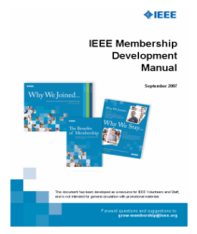

Membership Development Manual– Plan your MD Activities – Set the Goals
The MD Manual is an essential overview of MD. It includes resources such as the MD
calendar and MD checklists. It helps you to coordinate your local efforts with headquarters’
programs and processes. There is also a listing of IEEE member benefits, as well as sample
letter templates for suggested outreaches. You can download it from the IEEE MD page
http://ieee.org/web/volunteers/membership_dev/index.html .
You can also find it at our R8 MD Page by visiting http://www.ieee.org/r8.
Select Membership Activities and afterwards Membership Development.

Membership Development Promotional Material
The 2010 Membership Recruitment Kits have been sent to Sections and Student Branches in August
2009. To order additional supplies visit http://ewh.ieee.org/forms/md/supplies.php

R8 MD Newsletters and R8 MD Reports
IEEE Region 8 Membership Development Newsletters have been sent from time to time to all R8 Committee Members and Section MD Officers pointing out important information and MD actions to be done.
IEEE Region 8 Membership Development Reports have been sent monthly to all R8 Committee Members and Section MD Officers presenting membership data for every Section. Information and guidelines for important MD actions are given. R8 MD Newsletters and MD Reports are also available at the IEEE Region 8 Membership Development Page. Visit http://www.ieee.org/r8 , select Membership Activities and afterwards Membership Development.

MD meetings by Webcasts/Conferences Call
Every month an MD Webcast/teleconference takes place with very informative and useful pp presentations and discussions. It is organized by the IEEE MGAB MRR Committee and the IEEE Staff. All MD Officers in all organizational units are invited to the Webcast/Conference Call by e-mails sent from Piscataway.

First Region 8 Membership Development Webcast/Conference Call held in December 2009
A new Region 8 MD Webcast/Conference Call has been organized by the R8 MD Subcommittee and the IEEE Staff on 17 December 2009 especially for all the Section MD Officers in Region 8.

Member Grade Elevation: Associate to Member and Member to Senior Member
Most of the Associates qualify for the Member Grade. Emails have been sent out to all Associate Members in Region 8 asking them to simply apply for transfer to Member Grade online www.ieee.org/organizations/mga/md/memelv.html
Section MD Officers could also help. They can select from the Section Membership list the Associate Members and ask them to simply apply for transfer to Member Grade online. In our Region MDSC Dirk Van Hertem dirk.vanhertem@ieee.org is taking special care about Associate to Member Grade elevation.
Many of our members qualify for the Senior Member Grade. Sections are asked to start Senior Member Initiatives. Visit www.ieee.org/web/membership/senior-members/index.html

MD at IEEE Conferences in Region 8
We should continue to use our many conferences in R8 as a platform for IEEE promotion. There should be an IEEE booth or table at the conference with IEEE posters, brochures, magazines and application forms, and a local volunteer hosting the table. In 2007 and 2008 we had several successful events at conferences and we are going to continue with the same approach this year.
The best way of preparing the necessary arrangements is to find colleagues and friends in our local sections, who are willing to support our promotion events. May we kindly ask you, the Section Chairs and Section MD officers to select conferences in 2009 in your section for promotion, to nominate a volunteer – maybe yourself – and inform us. We will of course work with you and your volunteers to organize the event and get the material shipped from the IEEE staff. Many thanks in advance for your support.

* Special Circumstances

IEEE realizes that economic circumstances may impact some members' ability to pay the full amount of IEEE membership dues. For this reason, the following special circumstance categories have been established. Special circumstances are not available to Student members and Graduate Student members. Only one category may be claimed in any year.

Minimum Income Provision: Applicants who certify that their prior year's income did not exceed US $12,900 or equivalent are granted a 50% reduction in IEEE dues, regional assessment and dues for one IEEE Society and its optional publications. Please submit written certification with application and payment. Student members are NOT eligible.

Retired Provision: A retired member, not gainfully employed and not qualifying for Life Member Status, on attaining the age of 62 years, may apply for a 50% reduction in dues and assessments. An individual who qualifies for the IEEE Retired Member category may continue any and all Society memberships held for not less than the 5 prior years. Optional publication fees equal those established for Student members.

Unemployed Provision: A 50% reduction in membership dues, Society dues, other subscriptions and assessments are available to a member or applicant who informs the IEEE Operations Center Office that he/she: (1) has become involuntarily unemployed and is seeking reemployment, or (2) has become voluntarily unemployed for reasons of raising children. A statement of continued unemployment shall be provided with each annual dues payment. In the case of voluntary

** R8 Program to Increase the Membership of Small Sections
The R8 MD Subcommittee initiated a program to increase the membership of small Sections. We want the small Sections to become bigger and stronger organizations with more volunteers and more activity.
The best way to maintain and enhance programs and services on the Regional and Section level to our members while holding down or reducing the member cost is to increase the number of members.
Let us try to increase the membership of the small Sections gradually. The goal during the 2010 Membership Year should be to achieve 100 professional members (for Sections having less than 100), 150 members (for Sections having more than 100, but less than 150) and 200 members (for Sections having more than 150, but less than 200 professional members). To successful Sections in increasing their membership a financial incentive will be provided.
In order to qualify for the incentive, a Section would have to rise its professional (higher-grade, full dues paying) previous membership level for the current calendar year (using the August membership report as the reference base).
Sections which achieve the goal would receive US$10 incentive funding for each Professional/higher grade member recruited in that Section during the period September-August above the previous year’s total higher grade membership up to 100, 150 or 200 members respectively. “Migrating” members (i.e. members who moved from one region/section to another) would not count.
Transfer would be in a lump sum in the amount determined sometime in early Fall (following release of the August membership report and new membership determination).
Section Incentive Example for a possible case (goal 100 higher-grade members):
Professional/Higher-Grade, Full Dues Paying Members, August 2009: 70
Professional/Higher-Grade, Full Dues Paying Members, August 2010: 108
Professional/Higher-Grade, Full Dues Paying Migrating Members August 2010: 2
Section qualified for the incentive (108-2=106).
Qualifying for Rebate: 100-70=30
Rebate for the Section: US$ 300.00
Full Dues Paying Members include members using the reduction of dues according to the Special Circumstances.
Milestones:
The membership of Sections can easily be checked every month by the sections themselves. The final results will be known in September 2010.
The program would be for a period of one year, after which it would be assessed and a determination made whether to continue for another year on a permanent basis.

The activity on the Section and Chapter level is of great importance for recruiting and retaining members.
Membership Development is the business of all of us!
If you have any questions concerning MD don't hesitate to ask us.
Thank you for your work in your Sections.

Aleksandar Szabo, Chair a.szabo@ieee.org
Ali El-Mousa elmousa@ju.edu.jo
Dirk Van Hertem dirk.vanhertem@ieee.org
Mourad Loulou mourad.loulou@ieee.org

