IEEE Bosnia and Herzegovina Section Report October 2009

Officers: (Term End Date: 30 April 2010)

Executive Officers
- Chair: Dr. Branislava Drazenovic
- Chair Deputy: Dr. Kemo Sokolija
- Treasurer: Dr. Semsudin Masic
- Secretary: Mr. Sasa Mrdovic

Committee
- Educational Activities: Dr. Novica Nosovic
- Membership Development Officer: Mrs. Dusanka Boskovic
- Professional Activities: Mr. Leid Zejnilovic
- Student Activities: Mrs.Sabina Dacic
- SAMIEEE : Mr. Nedim Osmic

Affinity Groups:
- WIE Chair: Dr. Lejla Banjanovic-Mehmedovic.
- GOLD Chair: Mr. Omer Tanovic.

Chapters
- Communications Society Chapter COM019: Chair: Dr. Narcis Behlilovic,
- Joint Computing Intelligence/Computer Society Chapter: CIS11/C16: Chair: Dr. Haris Supic.
- Power Engineering Society Chapter PE31: Chair: Dr. Salih Carsimamovic.
- Signal Processing Society Chapter SP001 Chair: Mr. Elvir Causevic.

Membership:

Statistics from Membership Development indicate the following as of September 18, 2009:
The IEEE Bosnia & Herzegovina Section has in total 173 active members (221 in October 2009): 7 Senior Members, 141 Members (including 64 Graduate Student Members); 25 Student Members; 3 Associate Members and 3 Affiliate Members.
The number of members will increase during the course of the calendar year.

Meetings:
Technical meetings and Activities: (3 meetings)
Administrative meetings: (1)
Social (2)
Educational Meetings (2)

This is the number of the meetings reported thorough L31 MEETING REPORT FORM. Many more meetings were held, and we are planning to organize training for volunteers in using IEEE tools and reporting forms, to improve visibility of BH Section activities.

- XXII International Symposium on Information, Communication and Automation Technologies – ICAT 2009 supported by Bosnia and Herzegovina IEEE Section as a technical co-sponsor, took place in Sarajevo from 28 to 31 October.  - There were almost half of the presenters coming from abroad, distinguished invited speakers, and papers published in the IEEE Xplore Digital Library for the first time. | 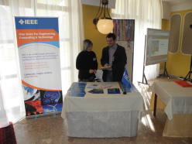

Activities in the near future:

Technical Co-Sponsorship of the 8th SYMPOSIUM ON INDUSTRIAL ELECTRONICS - INDEL 2010, to be held 4-6 November 2010, in Banja Luka.

IEEE 125th Anniversary activities:
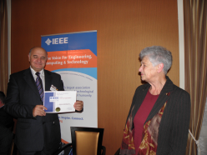 | Special event during the XXII International Symposium on Information, Communication and Automation Technologies – ICAT 2009, on October 30, 2009.  BH Section Chair prof. dr Branislava Drazenovic presented awards to distinguished BH Section IEEE Members.
Special PES event with invited speaker  Meliha B. Selak, P. Eng, from BC Hydro,  Vancouver, Canada: Powering the 2010 Olympic Winter Games.  At that occasion PES Outstanding Engineer Award was presented to Luka Vidovic. | 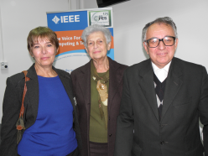

Best practices:

We have established technical co-sponsorship with the organizers of the largest ICT conference in BiH – International Symposium on Information, Communication and Automation Technologies – ICAT what helped promoting IEEE membership among non-student members.

