IEEE Jordan Section Report April 2010

First Name | Last Name | Position Description | Position Start Date | Position End Date
Ali | El-Mousa | Chair | 1/1/2010 | 12/31/2011
Ali | El-Mousa | Educational Activities | 1/1/2008 | 12/31/2009
Tala | Haddad | Membership Development | 1/10/2009 | 12/31/2011
Ali | El-Mousa | Professional Activities | 1/1/2006 | 12/31/2009
Mousa | AL-Akhras | Secretary-General Activity | 1/1/2010 | 12/31/2011
Loay | Khalaf | Vice Chair | 1/1/2010 | 12/31/2011
Hussein | Al-Natsheh | Student Activities | 1/1/2006 | 12/31/2011
Dia | Abu-Al-Nad | Treasurer | 1/1/2010 | 12/31/2011
Rana | Ramadan | Secretary | 1/1/2010 | 12/31/2011
Bushra | Al-Habashneh | WIE AG Chair | 1/1/2010 | 12/31/2010
Mohammad | Hamdan | Webmaster | 1/1/2004 | 12/31/2009

Membership:

Section Name | IEEE Current Grade Description | IEEE Membership Status Description | Count of Members
Jordan Section | Affiliate | Active | 4
Jordan Section | Associate Member | Active | 9
Jordan Section | Graduate Student Member | Active | 14
Jordan Section | Life Fellow | Active | 1
Jordan Section | Member | Active | 105
Jordan Section | Senior Member | Active | 26
Jordan Section | Student Member | Active | 310
Total 469

Date of above results by using SAMIIIE:
April 17 2010

Meetings:
The section and chapters had quite a few meetings in the last few months among them:
The section took the lead in organizing a seires of technical presentations that were held along side the Middle East Technology Show (METS 2009). This is the biggest national event in Jordan to do with the IT sector. A series of eight presentations from experts in their fields were held during the period 18-21 November 2009. The list of presentations was:
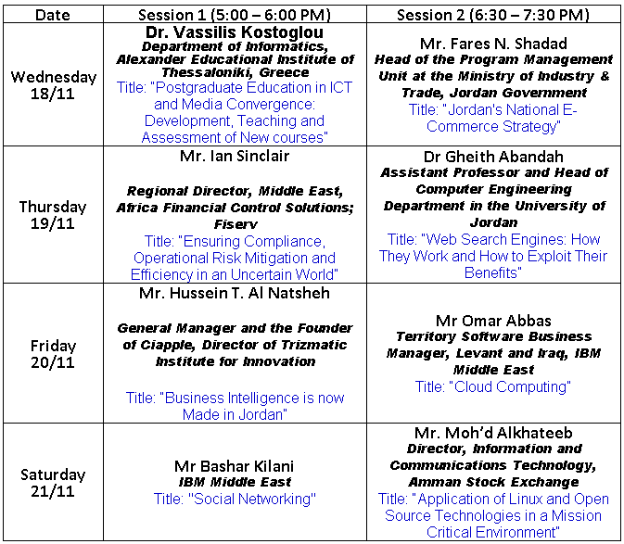
The section also was present during METS 09 in the form of a booth which was manned by IEEE volunteers.
The section also is sponsoring a series of technical lectures in cooperation with the departments of Computer, Electrical and Mechatronic Engineering in the Faculty of Engineering and Technology at the University of Jordan which is the largest university in the country. This series has proved to be very successful and covers a whole variety of topics.
Activities in the near future:
The section will continue with its series of lectures at the University of Jordan and at other locations. Also, cooperation in the fom of many joint events are planned with both the Jordan Computer Society and the Jordan Engineers Society. These will cover technical lectures, social events, technical trips etc.

The section is planning to establish a technical English language and soft skills workshop for students and professionals during the upcoming summer.

The section is technically sponsoring the 7th International Multi-Conference on Systems, Signals & Devices which is going to be held in the period of 27-30 June 2010.

Also, the section is sponsoring the National Technology parade to be held at the Jordan University of Science and Technology. This is a national event showcasing the work of graduating students of technical schools and universities in the country with prizes given to the best achievers.

Best practices:
Continuous cooperation with other national technical institutes in the country. This has proved to be extremely useful.
The continues cooperation with academic departments in major universities.

Topics to be discussed in Venice:
The need to establish better method of follow-up to the motions of the section congress to make sure it is getting a fair and balanced hearing.
The need to establish a protocol or a working blueprint with support to better motivate inter-section cooperation. This is to encourage the sharing of knowledge and resources and also to cut costs.

