IEEE Zambia Section Report May 2010

Officers:
- Chair: Reuben Kapala Munungwe
- Section Advisor: Adrian Pais
- Vice-Chair: Gertjan Van Stam
- Professional Activities Co-ordinator: Dr Lemba Davy Nyirenda

- Secretary: Mwizukanji Sikanyika
- Treasurer: Belington Kabwe
- Membership Development Officer: Custom Thomas Nthara
- Membership Development Officer: Kingfrey Kaoma
- Events Co-ordinator: Mpaisha Phiri
- Assistant Secretary: Chris Tshani

Membership:

Number of members.

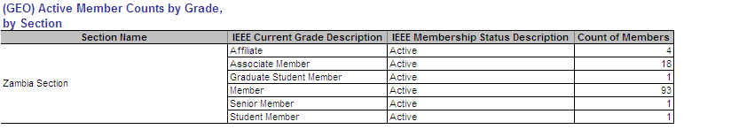
Date of above results by using SAMIEEE: 11th April, 2010

Meetings:

Number of meetings so far:2

Activities in the near future:

TISP Workshop in September, 2010
EPICs Talk in August, 2010
Members Meeting in July

Best practices:

- Section member engagement and development through increased section orgainised events
- Using IEEE organised events on Zambian soil to increase visibility of the section and engage our members
- Ensuring IEEE activities count towards continuing professional development (CPD) credits, as required by the Engineering Institution of Zambia. http://www.eiz.org.zm

Topics to be discussed in Riga:

- Legal status in country
- Section activities that are successful
- VTools usage
- Society membership
- Publications

Compiled by:

Reuben Kapala Munungwe
munungwer@cec.com.zm
reuben.munungwe@ieee.org

