Membership Development Subcommittee (MDSC) Report
September 2009

Region 8 Membership
IEEE Region 8 membership continues to grow. At the end of August 2009 in Region 8 we had 65,318 members. Comparing to 61,790 at the end of August 2008 it is an increase of 3,528 members or 5.71%.

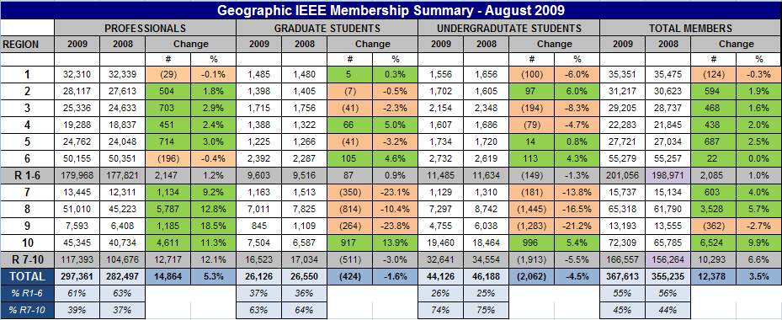

Important! IEEE has begun representing August student elevations in the August membership statistics, rather than December. We will experience a short-term (August through November) anomaly in our year-over-year reporting of higher-grade and student membership. During this period, year-over-year counts for higher-grade membership will appear higher than expected for 2009, with student membership counts appearing lower than expected. All will be reconciled in December, as the August elevations have been traditionally represented in December’s membership statistics. 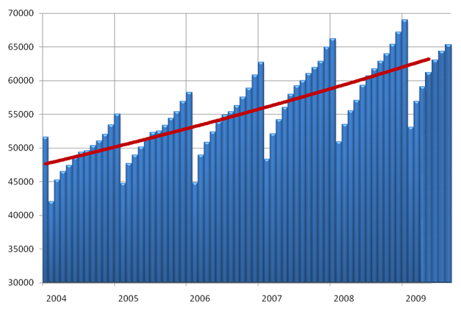
In the zigzag diagram above, we can see the changes in membership from month to month. The read line shows the steady growth of membership in Region 8 from year to year.

Deactivated Members – Arrears
We sent personal e-mails to all higher grade members who didn’t renew for 2009 on 12 February. Many members renewed after they received the letter and we could solve some problems they had with the renewal. We received more than 4000 answers and we learned a lot about the reasons why some members don’t renew. In March we have sent e-mails to all the Section Chairs/ Section Membership Development Officers asking them to take action concerning recovery and recruitment in their Sections. After the Service Terminator Action on 28 February (Service Deactivation), the number of arrears (members who didn’t renew for 2009) in Region 8 was 17,847.
3,022 arrears recovered till 11 September. The number of arrears went down to 14,825 what is still a high number.

The Renewal Period for 2010 Started
To prevent having many arrears we should work more in advance showing the benefits of membership and have more activity, especially on the Section level, to encourage members to renew on time (during November, December, January), well before the Service Terminator. Inform them about Special Circumstances*.
In our Sections we should take special care about new members joined IEEE for 2009 – the first year members. The IEEE statistics from previous years shows that more than 50% of the first year higher-grade members and 75% first year student members (including GSM-s) don't renew...

Membership Development and Statistics in R8 Sections
For Membership Statistics visit https://analytics.ieee.org/analytics/saw.dll?dashboard
Look for Membership Statistics of your Section every month. Is your membership increasing or decreasing? Contact the arrears in your section to learn about the reasons for not renewing. Don't loose members! Recruit new members! To learn about members in your Section use the Geo Predefined Queries in SAMIEEE www.ieee.org/organizations/vols/samieee/

Small Sections
We have 56 Sections and 5 Subsections in Region 8. We have large Sections having several hundreds or thousands of members, but we have also small Sections having even less then hundred members.
At the moment we have 20 Sections having less than 200 professional members (not counting the student and graduate student members). Few of them are new ones, but many of them exist for years. We are asking small Sections to increase their membership to become bigger and stronger organizations. Let us try to increase the membership of the small Sections gradually. The goal during the 2010 Membership Year should be to achieve 100 members (for Sections having less than 100 members), 150 members (for Sections having more than 100, but less than 150 members) and 200 members (for Sections having more than 150, but less than 200 members).

MD Teams in Sections Having Many Members
Some of our Sections like UK&RI, Germany, Italy, Spain, France, Benelux etc. have thousands members. They are asked to take into consideration the formation of an MD Team covering different areas/towns of the country to make the MD job more easy and more efficient. The UK&RI Section is our first Section having an MD Team consisting of the Chair an additional 3 MD officers.

Start of the New 2010 Membership Campaign - The Full-Year Dues Period
The beginning of the full-year dues period starting on 1 September is the peak recruitment time. Services for new members commence immediately upon joining and continue through 31 December 2010. A member joining in September receives a bonus of 4 months of extra service above and beyond the 12 months he is paying for. Take care about the Special Circumstances*. The goal of our MD Team is to increase our membership to be the highest in the history of IEEE.
For Membership Development Resources visit http://www.ieee.org/md and for best practices http://www.ieee.org/ra/md/bestpractices.html

Member-Get-A-Member Program
The payout for recruited professional members (not students) is 15.00US$ per member. Recruiters (including student members) have the option of using their reward vouchers to pay for IEEE products or services, including the membership renewal, or they can use the vouchers for a donation to the IEEE Foundation.
Announce and provide information on the Member-Get-A-Member (http://ieee.org/mgm) and Student-Get-A-Student (http://ieee.org/sgs) programs at Section, Student Branch and Chapter Meetings and Conferences. Make it a challenge within your Section to see who will be the best in Membership Development. The reward is more than a 15$ IEEE credit voucher, it's a bigger organization with better connections into industry and community. If each of us recruited just one new Member, we would double our size in one year!!! But let's increase our membership by 10%. Remember, without Membership Development, we cannot build the IEEE of tomorrow.

Member Grade Elevation: Associate to Member and Member to Senior Member
Most of the Associates qualify for the Member Grade. Emails have been sent out to all Associate Members in Region 8 asking them to simply apply for transfer to Member Grade online www.ieee.org/organizations/mga/md/memelv.html
Section MD Officers could also help. They can select from the Section Membership list the Associate Members and ask them to simply apply for transfer to Member Grade online. In our Region MDSC Dirk Van Hertem dirk.vanhertem@ieee.org is taking special care about Associate to Member Grade elevation.
Many of our members qualify for the Senior Member Grade. Sections are asked to start Senior Member Initiatives. Visit www.ieee.org/web/membership/senior-members/index.html

Don’t Forget - Graduate Student Members Have the Rights and Privileges of Members
According to the IEEE Bylaws the Graduate Student Members shall have the rights and privileges of Members. They can be Section Officers. GS Members are also qualified to sign the petition to establish a new Section – important for new section and new chapter development!

Section Membership Development Officers
We all, the members and volunteers in IEEE, should be aware that Membership Development on all levels and especially on the section level is of extreme importance if we want to have more members, new volunteers and more activity. Few sections in R8 have not appointed Section Membership Development Officers yet! We are asking these sections to appoint Membership Development Officers willing to do their job with enthusiasm and fun without sparing efforts! Report to IEEE the names of your Section MD Officers online at http://ewh.ieee.org/forms/scs/interactofficer.php
We are also asking all Sections to send us the names and email addresses of their MD Officers especially if you have new ones appointed.
All the Section MD Officers belong to our Region 8 MD Team working on Membership Recruitment, Retention and Recovery.
The work of Section MD Officers is of great importance to our Sections, our Region and to IEEE as a whole.

The Updated September 2009 Membership Development Manual – Plan your MD Activities – Set the Goals

The MD Manual is an essential overview of MD. It includes resources such as the MD
calendar and MD checklists. It helps you to coordinate your local efforts with
headquarters’ programs and processes. There is also a listing of IEEE member benefits,
as well as sample letter templates for suggested outreaches. You can download it from
the IEEE MD page http://ieee.org/web/volunteers/membership_dev/index.html .
You can also find it at our R8 MD Page by visiting http://www.ieee.org/r8/ and selecting
Membership Activities and Membership Development.


Membership Development Promotional Material
in August 2009 the 2010 Membership Recruitment Kits have been sent to Sections and
Student Branches. To order additional supplies visit
http://ewh.ieee.org/forms/md/supplies.php

MD in the Middle East
Owing to our R8 MD SC member Ali El-Mousa elmousa@ju.edu.jo, an MD presentation
took place in Damascus, Syria at the Higher Institute for Applied Science and Technology
on 25/7/2009 to acquaint academics and students with the value of IEEE membership.
Efforts are underway to start a section in Syria. Potential leaders have been identified and
actions are being followed in this regards.

MD in Africa
During recent years some new Sections and Subsections have been formed in Africa as an outcome of the MD Workshop held in Cape Town in 2006, the help of neighbour Sections and the help of volunteers (Adrian Pais, Saurabh Sinha, Gerhard Hancke, Aleksandar Szabo). The Education Society is willing to help by offering free Society Membership for the first year and also offering help in the Education Chapter activity (for more information ask a.szabo@ieee.org and the Education Society Secretary Rob Reilly reilly@media.mit.edu).
We have still a lot of countries without an IEEE Section and there is still a lot to do in Membership and Section Development in Africa. In the MDSC our expert for Africa who is also encouraging the Section Solidarity Initiative is Adrian Pais a.pais@ieee.org. He helped a lot in the Zambia Section formation and activity. Don't hesitate to contact him.

R8 MD Newsletters and MD Reports
IEEE Region 8 Membership Development Newsletters have been sent from time to time to our R8 Committee Members and Section MD Officers.
Since November 2008 we have a new pilot project for our Region: the R8 MD Report. It brings detailed information about MD in our Sections. It is prepared by the MGAB Staff and our R8 MD Coordinator. These MD Reports have been sent out to our Section MD Officers and Section Chairs as well.
The MD Newsletters and the MD Reports are posted at the IEEE Region 8 Membership Development Page.
Visit http://www.ieee.org/r8 , select Membership Activities and Membership Development.

MD meetings by Webcasts/Conferences Calls
Every month an MD Webcast/teleconference is taking place with very informative and useful pp presentations and discussions. It is organized by the IEEE MGAB MRR Committee and the IEEE Staff. All MD Officers in all organizational units are invited to the Webcast/Conference Call by e-mails sent from Piscataway.

NEW! Region 8 Membership Development Webcast/Conference Call to be held in October 2009
A new Region 8 MD Webcast/Conference Call will be organized especially for all the Section MD Officers in
Region 8.

The IEEE Membership Development Community
Register for participation in the IEEE Membership Development Community https://www.ieeecommunities.org/ieee.md.net
You will find there a lot of useful MD material: highlights, articles, discussions and files. The MD webcasts are there as well, containing very interesting and useful presentations.

MD at IEEE Conferences in Region 8

We should continue to use our many conferences in R8 as a platform for IEEE promotion. There should be an IEEE MD Desk at the conference with IEEE posters, brochures, magazines and application forms, and a local volunteer hosting the desk. We had several successful events at conferences and we are going to continue with the same approach.
To improve this activity we are cooperating with the R8 Conference Coordination Subcommittee. They are asking the conference organizers to provide staffed MD Desks at conferences.
The best way of preparing the necessary arrangements is to find colleagues and friends in our local sections, who are willing to support our promotion events. May we kindly ask you, the Section Chairs and Section MD officers to select conferences in 2009 in your section for promotion, to nominate a volunteer – maybe yourself – and inform us. We will of course work with you and your volunteers to organize the event and get the material shipped from the IEEE staff. Many thanks in advance for your support.

* Special Circumstances

IEEE realizes that economic circumstances may impact some members' ability to pay the full amount of IEEE membership dues. For this reason, the following special circumstance categories have been established. Special circumstances are not available to Student members and Graduate Student members. Only one category may be claimed in any year.

Minimum Income Provision: Applicants who certify that their prior year's income did not exceed US $12,900 or equivalent are granted a 50% reduction in IEEE dues, regional assessment and dues for one IEEE Society and its optional publications. Please submit written certification with application and payment. Student members are NOT eligible.

Retired Provision: A retired member, not gainfully employed and not qualifying for Life Member Status, on attaining the age of 62 years, may apply for a 50% reduction in dues and assessments. An individual who qualifies for the IEEE Retired Member category may continue any and all Society memberships held for not less than the 5 prior years. Optional publication fees equal those established for Student members.

Unemployed Provision: A 50% reduction in membership dues, Society dues, other subscriptions and assessments are available to a member or applicant who informs the IEEE Operations Center Office that he/she: (1) has become involuntarily unemployed and is seeking reemployment, or (2) has become voluntarily unemployed for reasons of raising children. A statement of continued unemployment shall be provided with each annual dues payment. In the case of voluntary

The activity on the Section and Chapter level is of great importance for recruiting and retaining members.
Membership Recruitment and Retention is the business of all of us! If you have any questions concerning MD don't hesitate to ask us. Thank you for your work as Membership Development Officers in your Sections. Thanks to all helping in MD.

Aleksandar Szabo a.szabo@ieee.org
Ali El-Mousa elmousa@ju.edu.jo
Dirk Van Hertem dirk.vanhertem@ieee.org
Adrian Pais a.pais@ieee.org

