IEEE HUNGARY Section Report about 2009 Q3

Officers: Election period: 1/1/2009 - 31/12/2010

- Chair: Imre Rudas, 1633676
- Vice Chair: Peter Kadar, 3069366
- Secretary - Treasurer: Gabor Szederkenyi, 80730783
- Newsletter: Peter Kadar, 3069366
- WEB responsible: Aniko Szakal, 41298640
- Industrial relations: Peter Nagy, 41467360
- Membership development: István Vajda 40011931
- Gold officer: András Bojárszky 80560946
- Student activity: Szilárd Jagasics 80662923

Acive chapters:

Identifier | Chapter | Chair
CAS004 | Circuits, System & Computers Joint Chapter | Kolumbán Géza
CIS011 | Computational Intelligence | Fodor János
CPMT021 | Component Packaging and Manufacturing Technology, joint chapter wit Romania | Illyefalvy-Vitéz Zsolt (local representatives)
IA034 | Industrial Applications | Ruzsányi Tamás
IE013+RE024 | Industrial Electronics & Robotics and Automation Joint Chapter | Tar József
IM009+EMB018 | Instrumentation and Measurement & Engineering in Medicine and Biology and Joint Chapter | Jobbágy Ákos
MTT017+E025+  +AP003+C016 | Microwave Theory and Techniques/Education/Antennas and Propagation/CompSoc Joint Chapter | Nagy Lajos
PE031 | Power Engineering | Jermendy László
SMC028 | Systems Man Cybernetics | Horváth László

Membership of IEEE Hungary Section as on 31st of August 2009

Membership Status | H | H Total | LF | F | F Total | LS | SM | SM Total | LM | M | M Total | AM | AM Total | GSM | GSM Total | Higher Grade Total | StM | StM Total | Grand Total
Active | 0 | 0 | 3 | 12 | 15 | 2 | 28 | 30 | 1 | 230 | 231 | 24 | 24 | 54 | 54 | 354 | 17 | 17 | 371

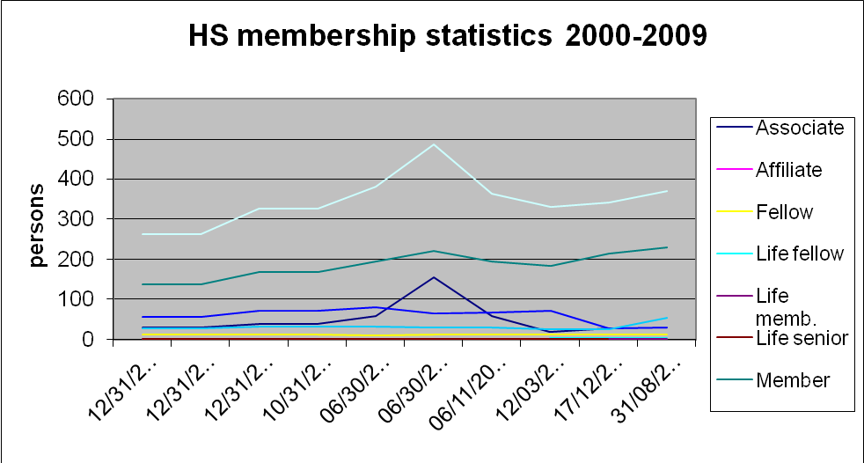

Main Event: IEEE president visit in Hungary

IEEE president John Vig visited Hungary with J. Roberto B. de Marca (IEEE Vice President, Technical
Activities, 2008). He opened the IEEE Wireless Communications & Networking Conference (WCNC - April 5-8, 2009 – Budapest, co-organized by HTE). After the opening ceremony of WCNC he visited Budapest Tech. President Vig, Imre Rudas IEEE HS Chair and István Kocsis, president of MATE signed the 3 year contract about the co-operation MATE and IEEE. IEEE has similar agreement with other MTESZ sister associations too as MEE and NJSZT. Before the lunch Peter Kadar introduced the IEEE HS structure, chapters and its activities.

Newsletter:

A 6 months newsletter was published in internet for the HS membership. Some news was sent to R8 news too.

New chapter formation

A new Student Branch chapter has been established by students of IEEE IAS & PES Society chapter in Hungary.

The members of the IEEE Hungary Section Industry Applications Society Chapter decided an expansion to Industry Applications Society / Power Electronics Society Joint Chapter (IAS/PELS).

Events organized and supported by Chapters:

IEEE Hungarian MTT/AP/ED/ComSoc Joint Chapter

The Microwave Theory / Antennas and Propagation / Electron Devices / Communication Joint Chapter of the IEEE Hungarian Section was founded in 1990: Total number of chapter members is close to 200

Officers
Chair: Lajos Nagy
Co-chair: János Levendovszky
Secretary: Eszter Udvary
Past chairs:
Tibor Berceli (2000-2008)
István Frigyes (1990-1999)

Awards:
2004: IEEE Communications Society "EAME Region Chapter Achievement Award"
2006: IEEE Communications Society "EAME Region Chapter Achievement Award"
2008: IEEE Communications Society "EAME Region Chapter Achievement Award"

Meetings in 2009:

08.09.2009. 13:30 BME, V2 building room 627 (Goldmann ter 3)
Ph.D. thesis defense entitled "Optimized SCML traffic (in Hungarian)" presented by Miklós Kozovszky, member

11.06.2009. BME, V2 building room 627 (Goldmann ter 3)
IEEE officer's visit:
Byeong Gi Lee, Commissioner, Korea Communications Commission, Candidate for IEEE ComSoc President-Elect, 2009

25.05.2009. 15:00 BME, V2 building room 627 (Goldmann ter 3)

Invited lecturer's visit from Microwave Photonics Center, Drexel University, Philadelphia, PA 19114 USA
Peter Herczfeld and Yifei Li: Can we have microwave receivers without high frequency electronics?

29.04.2009. BME, V2 building room 627 (Goldmann ter 3)
Bosch EMC laboratory inauguration

April 5-8, 2009 WCNC 2009 conference, Budapest, Hungary.
Lajos Nagy: “Indoor radio network optimization using multi level hierarchic method”

09.04.2009. 10:00-11:30 BME, V2 building room 627 (Goldmann ter 3)
IEEE officer's visit:
Professor Roberto Da Marca, IEEE R9 Director from Rio de Janeiro
Professor Ben lataief, Chair professor and Head from Hong Kong University of Science and Technology

13.03.2009 11:00 BME, V2 building room 627 (Goldmann ter 3)
technical meeting discussing the Ph.D. thesis entitled "Relationship between mechanical stress and magnetic hysteresis (inHungarian)" presented by Attila Sipeky

04.03.2009 15:00 BME, V2 building room 627 (Goldmann ter 3)
technical meeting discussing the Ph.D. thesis entitled "Application and study of Multifunctional Semiconductor Optical Amplifiers in Subcarrier Multiplexed Optical Networks (in Hungarian)" presented by Eszter Udvary, member

Power and Energy chapter

- Meeting with John Vig, President of IEEE and Robert de Marca VP in Budapest on 6 April
- Sponsorship of 2. Int. Youth Conf. on Energetics in Budapest in June
- Round table discussion and presentation during IYCE
- Participation on PES chapter chair conference in Bucharest in June???
- Participation in foundation of PES and IAS Joint Budapest Student chapter
- Participation and presentation on Nordic Conference R8 Power Chapters Leadership Workshop and Seminar in Stockholm 13-15 Sep.
- Extra High Voltage memorial conference R8 and R10 in Seoul in October 20-25 with presentations.

Instrumentation and Measurement Society & Engineering in Medicine and Biology Society Chapter's activity in 2009

PhD Minisymposium was held at Dept. Measurement and Information Systems Budapest University of Technology and Economics at 2nd of February.

Together with the Biomedical Engineering Section of Scientific Society
for Measurement, Automation and Informatics members of the Chapter
apply for the organisation of the 5th European IFMBE Conference in
2011. (Decision is due at WC2009 World Congress of IFMBE).

CIS Hungarian Chapter

During 2009, the CIS Hungarian Chapter was and will be active on the field of organizing local and international conferences and scientific symposia in the field of computational intelligence, as follows:

7th International Symposium on Applied Machine Intelligence and Informatics
(SAMI 2009) - January 29-31, 2009, Herl’any, Slovakia

13th IEEE International Conference on Intelligent Engineering Systems
(INES 2009) - April 16-18, 2009, Barbados

5th International Symposium on Applied Computational Intelligence and Informatics
(SACI 2009) - May 28-29, 2009, Timisoara, Romania

7th International Symposium on Intelligent Systems and Informatics
(SISY 2009) - September 25-26, 2008, Subotica, Serbia

Expected activities in 2009

10th International Symposium of Hungarian Researchers on Computational Intelligence and Informatics (CINTI 2009) - November 12-14, 2009, Budapest, Hungary

Hungarian Joint Chapter of Industrial Electronics and Robotics and Automation Society
Chapter Chair: József K. Tar (from 2002)
Secretary: Anikó Szakál (from 2002)
The chapter is very proud to be a parent of conference series called INES, International Conference on Intelligent Engineering Systems that was established in 1997, and is an active series since its establishment in 2009, too. The Joint Chapter step by step extended its activity that means organization of various international conference series as the SAMI (International Symposium on Applied Machine Intelligence and Informatics) normally organized in Herlany, Slovakia, in January in each year, SISY (International Symposium on Intelligent Systems and Informatics) yearly organized in Subotica, Serbia, abut September, CINTI (International Symposium of Hungarian Researchers on Computational Intelligence and Informatics), normaly oranized in Budapest, Hungary, in each November, ICCC (International Conference on Computational Cybernetics) organized in various countries, and the biannual conference series SACI (International Symposium on Applied Computational Intelligence and Informatics) regularly organized in Timisoara, Romania, in the spring season.
The Joint Chapter participates in the organization of the following events in 2009:

CINTI 2009 - 10th International Symposium of Hungarian Researchers on Computational Intelligence and Informatics
November 12-14, 2009, Budapest, Hungary, http://www.bmf.hu/conferences/cinti2009

SISY 2009 - 7th International Symposium on Intelligent Systems and Informatics
September 25-26, 2009 - Subotica, Serbia, http://www.bmf.hu/conferences/sisy2009

SACI 2009 - 5th International Symposium on Applied Computational Intelligence and Informatics
May 28-29, 2009 - Timisoara, Romania, http://www.bmf.hu/conferences/saci2009

INES 2009 - 13th IEEE International Conference on Intelligent Engineering Systems 2009
April 16-18, 2009, Barbados, http://www.ines-conf.org

SAMI 2009 - 7th International Symposium on Applied Machine Intelligence and Informatics
January 29-31, 2009, Herlany, Slovakia, http://www.sami.tuke.sk

I. Rudas P. Kadar
IEEE HS Chair IEEE HS Vice Chair
20/03/2009

