IEEE Region 8 Financial Report for the Year 2008

The Region 8 financial report for the year ending the 31st December, 2008 has been submitted to IEEE and is under review by an independent accountant and auditor.

SUMMARY:

This year the Region 8 Treasurer is reporting a deficit result arising in part from exceptional expenditures on particular Region 8 events; and in part due to a substantial loss in value of the Region 8 Long Term Investment Fund owing to the effect of the present global financial crisis.

In response to this deficit it is proposed to reduce the Region 8 cost budget for 2009 to a level that should give scope for the Region 8 position to be restored. The difficult economic climate which could affect membership renewal and income during 2009 is allowed for.

EXPENSES:

The deficit effect of particular Region 8 events in 2008 was:

 | BUDGET | ACTUAL | VARIANCE | COMMENTS
Region 8 Committee Meeting: Malta | 90,000 | 181,852 | 91,852 | Length of meeting was extended with full Region 8 Committee and Sub-Committees attending early.
Sections’ Congress in Québec | 226,400 | 292,133 | 65,733 | Budget includes MGA support given to the Region. Travel and Visa costs were high for Africa and Iraq attendees.
Student Branch Congress: London | 55,000 | 69,603 | 14,603 | Discretionary travel support to needy students was limited to $20,000
Conference Support | 6,000 | 22,000 | 16,000 | Additional funding to SIRBICON of $10,000 and advance payment for AFRICON 2009
Student Paper Contest: MELECON | 10,000 | 21,630 | 11,630 | Reason under review by Region 8 OpCom.

The cost budget deficits were offset to an extent by some additional income and under-expenditure on Region 8 News; and an agreement with Region 8 Vice Chairs to commute part of their own cost budgets for 2008 to Sections’ Congress to enable the maximum number of Region 8 delegates to attend the IEEE meetings in Québec.

The deficit on the cost expense budget has been held at $157,473:84 before including the loss on the Long Term Investment fund of $152,068:60.

During 2008 the expenditures of ISBIR (Student Branches Industry Project) were $127,654:00 ($210,927:21 over the two year period 2007 and 2008) against grants received from IEEE NIC (New Initiatives Committee) in 2008 of $115,000:00 ($215,000:00 over the two year period). These expenses are analysed to Student Activity.

CURRENCY:

A revaluation of the Region 8 currency at year end gave a year-on loss to Region 8 of $7,786:13. The revaluation loss to Region 8 through 2007 was $8,201:09; the loss through 2006 was $2,129:53 and through 2005 was $17,081:79.

PRINCIPLES OF ACCOUNTING REVIEW AND AUDIT:
In 2008 the scope of this review was extended to determine whether scanned copies of documents to support expense claim applications as sent electronically by Region 8 members would satisfy International Audit Standards. There is a non-trivial personal cost to many of our members who send these documents by surface mail or courier. The controls in place were seen to be appropriate and after consultation with IEEE MGA the acceptance of readable scanned documents for expense reimbursement purposes was confirmed.
At OpCom meetings individual project costs are reviewed against expected spends and agreed budgets. Budgets are controlled by the Region 8 Vice Chairs for Technical Activity, Membership Development, and Student Activities. They receive full transaction lists of all expenditures that appear against their budget.
The independent accountant and auditor has access to all Region 8 documents and ensures the consistency and integrity of the Sage based accounts system used; of the data; and of the reporting.

Brian Harrington
April, 2009

PERFORMANCE OF REGION 8 INVESTMENT FUND:

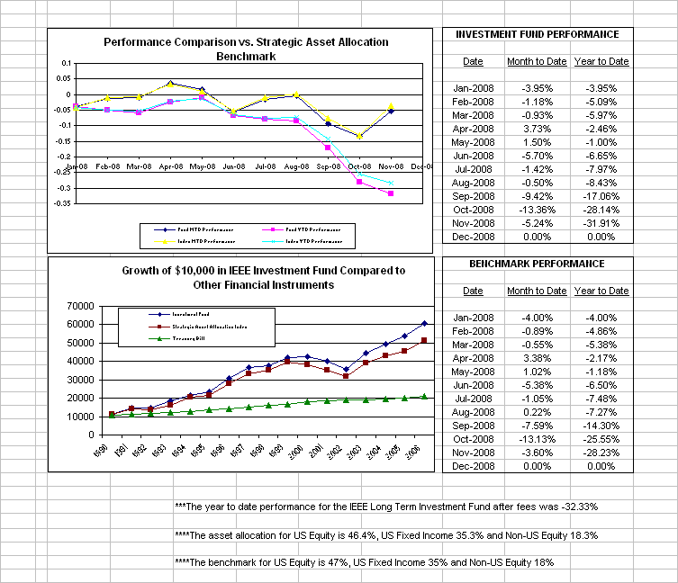
The first graphic shows how the value of the Region 8 Investment fund has declined as the global credit crises has taken hold of investments.

The loss is about 32.33% on the figures available.

A reduction from USD 30.867 to USD 21.307 in the unit share price does enable the number of shares being purchased to be increased, which should give a benefit as the markets recover.

The second graphic shows the growth over the long term.

INCOME and EXPENDITURE (USD) – 2008 year-end position:
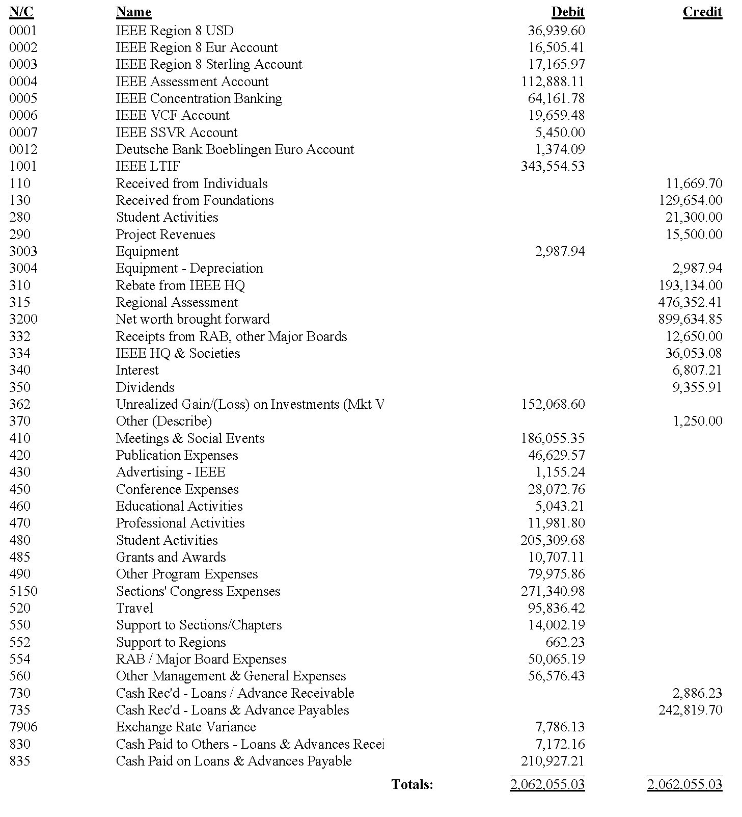

BUDGET – 2009:
