ISBIR (IEEE Student Branches Industry Relations) Program

MAIN GOALS & CONCERNS
- Match the activities of IEEE with industry collaborators
- Take initiative on finding industry sponsorship for SBCs
- Guide and take initiative on finding industry sponsorship for global IEEE student activities
- Connect companies with IEEE Job Site to fill open positions
- Establish industry connections for SBs, chapters, sections
- Secure internship opportunities
- Provide leads for industry events
- Match technical interests and projects
- Cultivate IEEE- industry relationships
- Inform corporate partners about current IEEE activities
- Pursue relationships with targeted corporations
- Identify IEEE projects to present to companies
- Inform IEEE OUs of industry opportunities
- Marketing
- IEEE Brand
- IEEE Network
- IEEE Services
- IEEE Events
- Creating/increasing volunteer workforce

ACTIONS

SC 2008
- Coordination with IEEE SAC officers from all regions of IEEE
  - Reporting about the current progress of ISBIR Initiative
  - Guiding all SAC officers in order to involve their region to this opportunity
  - Answering all questions of SAC officers about ISBIR
  - Making SAC officers acquainted with the ISBIR Portal and the concessions it gives to them
- Critical Meetings with IEEE Officers for the planning of ISBIR Permanency:
- Chance to plan cooperation with most of the participating IEEE OUs and IEEE Staff like:
- IEEE Membership Development (special promotion codes will be provided to ISBIR, new member will receive a discount over the membership fee with it.)
  - V-Tools (ISBIR will make announcements and promotion of the tools to the specific groups and will examine the tools and provide feedbacks)
  - IEEE 125th Anniversary (ISBIR will help with the organizing events and the promotion of the activity)
  - Standards Association (ISBIR will give support about making the stnadards visible to the industry)
- Taking feedback & Planning with IEEE Section Officers during:
  - 2 Workshops on Section Operations on IR
  - Participation to all IEEE Regional Meetings before SC 2008
    - It is considered as a proof of how much effort being made
    - Helping with the organization of SBCs in other regions
  - ISBIR Booth

Career Horizons
- Preparation & Organization of IEEE Career Fair
  - All logistic details of this event carried by ISBIR Task Force
  - Announcement of this fair (before, during the event)
  - Arrangement for the sponsorship and participation of Companies
  - Registration, Help Desk, Promotion of IEEE in different booths made
  - All the sessions & workshop arrangements made by ISBIR Task Force
- IR Action Planning with different countries:
  - Each ISBIR Task Force member, responsible for at least 5 different countries guiding and planing IR actions with them
  - Distribution of Local IR coordination kits to more than 30 SB officers
  - Local-focus meetings during SBC 2008 like (Portugal, Spain, UK, Lebanon, UAE)
  - Discussions on different ways of collaborations with industry during the workshops (e.g. How to involve Industry to Student Branch Activities?)

IEEE 125th Anniversary R10 Student Congress
Sponsorship Issues
- Reaching the contacts of the world’s largest companies during global events, such as at CES, and when abroad
- Consulting on how to prepare a convincing sponsorship proposal
  - Making amendments to sponsorship proposals to increase the chance of having it accepted, such as
    - Preparing different documents for different types of companies
    - Emphasizing the benefits of being a sponsor
    - Preparing a compact, easy-to-compare sponsorship offer
  - Giving guidance to the organizing committee about how to contact companies
Content
- Preparing training and workshop sessions where attendees can learn
  - how to begin working with industry
  - the ways of making cooperation permanent
  - the benefits of collaboration to both sides
- Preparing sessions for main
- Organizing a contest or event with the sponsor company [*]

[*] Waiting for confirmation

ISBIR LOCAL ACTIONS
Achievements in 2009
- Local matching for local positions
- Improved communication and coordination between sections and SBs
- Cooperation with IEEE sections during the local actions planning and industry involved meetings are strongly encouraged
- Arranged meetings with local offices of partner companies
- Training in India, Portugal, China, Singapore, Jordan
- Motivated members individually by announcing global opportunities and seeking local opportunities
- Increase in the number of SBs

ISBIR Local Teams Formed
Section | Name of Contact | Section | Name of Contact
Boston | Amanda Pratt | Colombia* | Laura Santos Oviedo
New York | Aaron Pollak | Colombia* | Oscar Javier
Canada | Elif Kırbıyık | Colombia* | Rodriguez Riveros
Finland* | Maciej Borkowski | Colombia* | Diego Alexander Dominguez
Finland* | Lauri Laakso | Colombia* | John Avila
Netherlands | Anton de Koning | Colombia* | Carlos Lozano
Germany | Alexander Kuester | Colombia* | Mauricio Rodriguez
Germany | Andreas Koltes | Colombia* | Carolina Molano Hoyos
Germany | Hamida Lansana | Colombia* | Laura Santos Oviedo
Portugal | Artur D'Assumpção | Colombia* | Nathalie Arzuza Borge
UKRI* | Mustafa Gurgen Demirag | Bolivia* | Orlando Perez
UKRI* | Parisa Cheraghi | Bolivia* | Ivan Rodrigo Carvajal Duarte
UKRI* | Selen Toplu | Bolivia* | Daniel Villegas Medrano
Egypt | Nahel Muhammad | Bolivia* | Lizzette Jeniffer Caprio Rodriguez
Egypt | Mohamed Dief | Bolivia* | Freddy Ayala Heinrich
Israel | Hador Reisman | Bolivia* | Israel Flores
Spain* | Juan Romero Raposo | Brazil | Alexandre Romariz
Spain* | Lorena Rausell | Ecuador | Jose Andres Armijos
Bulgaria | Filip Lyubomirov | India | Prerna Gaur
Austria | Stefan Rupitsch | India | Prijoe Philips Komattu
Austria | Alexander Grill | India | Jaison Abey Sabu
Italy | Cosimo Stallo | India | Arjun R Pillai
Dubai | Abdurrahman Ghaleb | India | Bhavika Kansara
Bosnia and Herzegovina | Faris Nizamic | Singapore* | Ramesh Krishnan
Saudi Arabia | Aburrahman Amin R Ghaleb | Singapore* | Murali Devaraj
Jordan* | Rami Al Dirini | Singapore* | Raghavendran
Jordan* | Fatima El Hamad | Singapore* | Vincent
Jordan* | Muhannad Abdel Aziz | Singapore* | Yam Wei Jie
Nigeria* | Ona Ata | Singapore* | Hu Xuan
Nigeria* | Oburo Chioma Nelly | Singapore* | Manit Shah
Nigeria* | Ibe Prince | Singapore* | Saumyadeep Datta
Nigeria* | Chuka Peter Eze | China* | Luo Tao
Nigeria* | Uchenna Nnamani | China* | Meng Bin
Nigeria* | Richard D Essien | China* | Liu Di
Nigeria* | Chuka Peter Eze | China* | Deng Ke
Nigeria* | Emmanuel Eyiyere | China* | Pelin Tao
Nigeria* | Odomero | China* | Hongwei Huo
Nigeria* | Okafor Ikenna | New Zealand | George Gordon
France | Balwant Godara | Australia | Fleure Stephans
 |  | Australia | Adam Ruxton

[*] states that in those countries a team has been formed from active IEEE SB members and GOLD officers and start taking action in terms of industry relations.

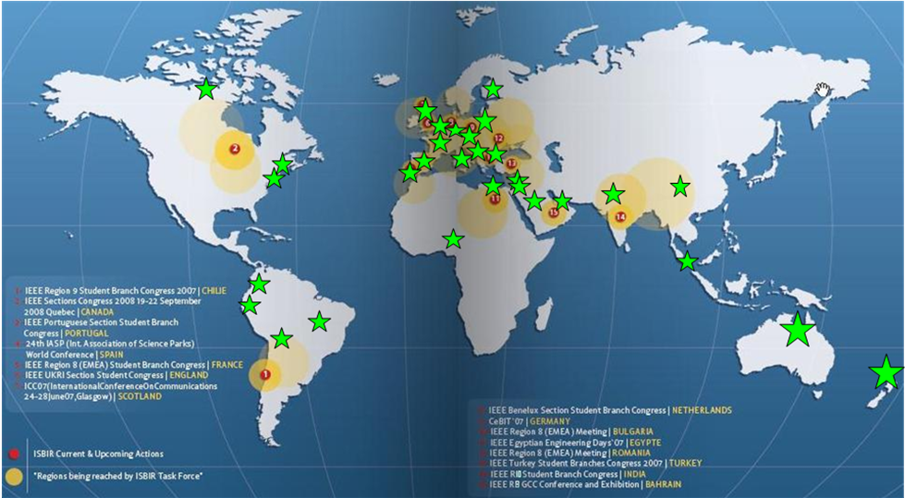
ISBIR have reached 28 countries, with 82 Local Student Contacts. Most of them have built their team and have begun taking actions. The members of these teams are not from a single SB.

Now | After
We are contacting people to build teams | Teams will be directly coordinated by and connected to regional ISBIR responsibles.
ISBIR LSCs are trained for effective IR | These trained LSCs will be able to implement their experience with their team
Sections are encouraged to work more closely with SBs and LSCs | Local ISBIR teams will have a role to implement the strategic IR planning of sections
ISBIR tries to find financial support for local and international events of IEEE | Local IEEE volunteers will have sufficient experience to find financial support on their own
Comparison of Local Operations before and after Transition

In Region 8 Meeting we are willing to reach active student branches for LSC through help of the sections. Moreover, we hope that the sections will accompany the branches with further actions.

