Electronic Communications
George Michael, Region 8 ECC

The Region 8 Electronic Communication Coordinator's job is to facilitate communication, both between members of the Region 8 Committee, and between this committee and present or future IEEE members.

IEEE Region 8 website statistics

A monitoring tool has been installed on our website (http://ieee.org/r8). Using the Google(TM) Analytics feature here are presented the statistics were obtained over a period from the beginning of this year. Over this period, 12,483 people visited the website and 34,436 pages were viewed. On an average visit, a user looks at 2.76 pages, and stays for a little over 3 minutes.

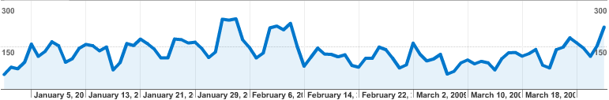
Our visitors come from 131 countries/territories all around the world, many of whom are outside Region 8. The origin of the visitors is depicted in the following map.

