IEEE Region 8 Membership Development Report – March 2009

INTRODUCTION
IEEE Region 8 membership continues to grow. After the Service Terminator Action at the end of February 2009 Region 8 had more members than any other Region in the world.

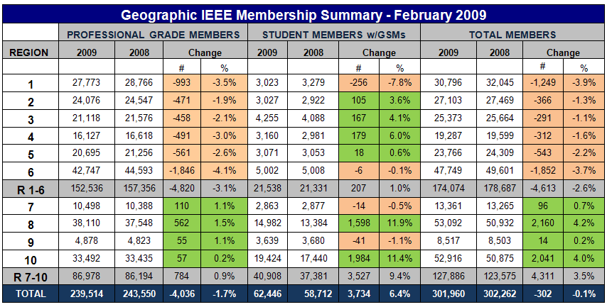

In the diagram bellow, we can see the changes in membership from month to month. The read line shows the steady growth of membership in Region 8 from year to year.
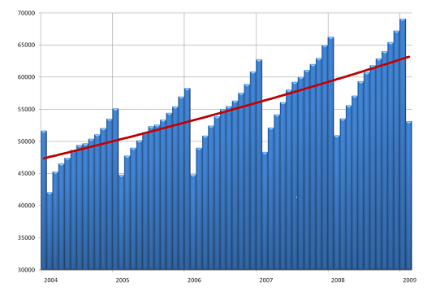

Region 8 Membership
At the end of 2008 in Region 8 we had 67,221 members. Comparing to 64,976 at the end of 2007 it is an increase of 2,245 members or 3.46%. After the Terminator Action, according to the membership statistics by 28 February 2009, Region 8 had 53,092 members, comparing to 50,875 members we had on 29 February 2008. The increase in the one year period was 2,160 members or 4.2%.

Arrears
We sent personal e-mails to all higher grade members who didn’t renew for 2009 on 12 February. Many members renewed after they received the letter and we could solve some problems they had with the renewal. We received more than 4000 answers and we learned a lot about the reasons why some members don’t renew.
After the Service Terminator Action on 28 February (Service Deactivation), the number of arrears (members who didn’t renew for 2009) was 17,847.
In March we have sent e-mails to all the Section Chairs/ Section Membership Development Officers asking them to take action concerning recovery and recruitment. On March 24 the number of arrears in Region 8 reduced to 16,682. That means that in 24 days 1,165 arrears recovered. But there is still a long road ahead of us. The percentage of recovery is always the highest immediately after the Service Terminator. So we must strengthen our efforts to further reduce the number of arrears being so high this year.
To prevent such a situation in the future we should work more in advance showing the benefits of membership, especially on the Section level, to encourage members to renew on time (during November, December, January), well before the Service Terminator.

Use SAMIEEE to Indentify the Arrears in your Section
Go to SAMIEEE www.ieee.org/organizations/vols/samieee/index.html
- Click Access SAMIeee
- Insert your IEEE User ID and Password and Login
- Click SAMIeee in Shared Folders
- Click Geographic Predefined Query and you will get the list of Predefined Queries
- Select (GEO) Arrears – Member Contact Info – By Section, By Grade
- Download to Excel and sort the Arrears data as you like!

Membership Development and Statistics in R8 Sections
For Membership Statistics visit https://analytics.ieee.org/analytics/saw.dll?dashboard
Most Sections are doing well. Only few sections have a decrease of membership. But there are also few Sections having less than 50 higher grade members! They should ask themselves how they will survive. Look into your Section Membership Statistics every month. Is your membership increasing or decreasing? Contact the arrears in your section to see what are the reasons for not renewing. Don't loose members!
To learn more about the members in your Section use the predefined Queries in SAMIEEE: www.ieee.org/organizations/vols/samieee/index.html
Register for participation in the IEEE Membership Development Community https://www.ieeecommunities.org/ieee.md.net
Some of our Sections like UK&RI, Germany, Italy, Spain, France, Benelux etc. have many members. They should take into consideration the formation of an MD Team covering different areas/towns of the country to make the MD job more easy and more efficient.

Section Membership Development Officers
We all, the members and volunteers in IEEE, should be aware that Membership Development on all levels and especially on the section level is of extreme importance if we want to have more members, new volunteers and more activity. Few sections in R8 have not appointed Section Membership Development Officers yet! We are asking these sections to appoint Membership Development Officers willing to do their job with enthusiasm and fun without sparing efforts! Report to IEEE the names of your Section MD Officers online at http://ewh.ieee.org/forms/scs/interactofficer.php
We are also asking all Sections to send us the names and email addresses of their MD Officers especially if you have new ones appointed.
All the Section MD Officers belong to our Region 8 MD Team working on Membership Recruitment, Retention and Recovery.
The work of Section MD Officers is of great importance to our Sections, Our Region and to IEEE as a whole.

The Half-Year Dues Period
The half-year dues period is a peak recruitment time. It allows people to test IEEE membership for a smaller initial monetary outlay. New members pay half-year dues when they sign up from 1 March through 31 August. Services commence immediately upon joining and continue through December 31. A member joining in April receives a bonus of 3 months of extra service above and beyond the six months they are paying for.
For Membership Development Resources visit http://www.ieee.org/mdresources and for best practices visit http://www.ieee.org/ra/md/bestpractices.html

Member-Get-A-Member Program
The payout for recruited professional members (not students) is 15.00US$ per member. Recruiters (including student members) have the option of using their reward vouchers to pay for IEEE products or services, including the membership renewal, or they can use the vouchers for a donation to the IEEE Foundation.
Announce and provide information on the Member-Get-A-Member (http://ieee.org/mgm) and Student-Get-A-Student (http://ieee.org/sgs) programs at Section, Student Branch and Chapter Meetings and Conferences. Make it a challenge within your Section to see who will be the best in Membership Development. The reward is more than a 15$ IEEE credit voucher, it's a bigger organization with better connections into industry and community. If each of us recruited just one new Member, we would double our size in one year!!! But let's increase our membership by 10%. Remember, without Membership Development, we cannot build the IEEE of tomorrow.

Don’t Forget - Graduate Student Members Have the Rights and Privileges of Members
According to the IEEE Bylaws the Graduate Student Members shall have the rights and privileges of Members. They can be Section Officers. GS Members are also qualified to sign the petition to establish a new Section – important for new section and new chapter development!
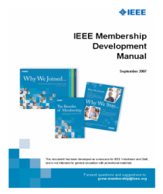
Membership Development Manual
The MD Manual is an essential overview of MD. It includes resources such as the MD calendar and
MD checklists. It helps you to coordinate your local efforts with headquarters’ programs and processes.
There is also a listing of IEEE member benefits, as well as sample letter templates for suggested
outreaches. You can download it from the IEEE MD page
http://ieee.org/web/volunteers/membership_dev/index.html .
You can also find it at our R8 MD Page visiting http://www.ewh.ieee.org/reg/8/cms/ and selecting
Membership Activities and afterwards Membership Development.

Membership Development Promotional Material
The 2009 Membership Recruitment Kits have been sent to Sections and Student Branches in August
2008. To order additional supplies visit http://ewh.ieee.org/forms/md/supplies.php

R8 MD Newsletter
IEEE Region 8 Membership Development Newsletters have been sent from time to time to all R8 Committee Members and Section MD Officers pointing out important information and MD actions to be done. It is also available at the IEEE Region 8 Membership Development Page. Visit http://www.ieee.org/r8 , select Membership Activities and afterwards Membership Development.

R8 MD Report – New!
Since November 2008 we have a new pilot project for our Region: the R8 MD Report giving detailed information about MD in our Sections. It prepared by the MGAB Staff and completed by our R8 MD Coordinator. It has been sent out to all Section MD Officers and Section Chairs.
 | Membership Development Report – February 2009  Europe, Middle East, Africa (Region 8) | 
 | This membership development report is issued on behalf of your IEEE Region, and the IEEE Member & Geographic Activities Board.

MD meetings by Webcasts/Conferences Call
Every month an MD Webcast/teleconference takes place with very informative and useful pp presentations and discussions. It is organized by the IEEE MGAB MRR Committee and the IEEE Staff. All MD Officers in all organizational units are invited to the Webcast/Conference Call by e-mails sent from Piscataway.

MD at IEEE Conferences in Region 8
We should continue to use our many conferences in R8 as a platform for IEEE promotion. There should be an IEEE booth or table at the conference with IEEE posters, brochures, magazines and application forms, and a local volunteer hosting the table. In 2007 and 2008 we had several successful events at conferences and we are going to continue with the same approach this year.
The best way of preparing the necessary arrangements is to find colleagues and friends in our local sections, who are willing to support our promotion events. May we kindly ask you, the Section Chairs and Section MD officers to select conferences in 2009 in your section for promotion, to nominate a volunteer – maybe yourself – and inform us. We will of course work with you and your volunteers to organize the event and get the material shipped from the IEEE staff. Many thanks in advance for your support.

The activity on the Section and Chapter level is of great importance for recruiting and retaining members.
Membership Development is the business of all of us!
If you have any questions concerning MD don't hesitate to ask us.
Thank you for your work as Membership Development Officers in your Sections.

Aleksandar Szabo a.szabo@ieee.org
Ali El-Mousa elmousa@ju.edu.jo

