IEEE Bosnia and Herzegovina Section Report April 2009

Officers: (Term End Date: 26 April 2009)

Executive Officers
- Chair: Dr. Branislava Drazenovic
- Chair Deputy: Dr. Kemo Sokolija
- Treasurer: Dr. Semsudin Masic
- Secretary: Mr. Sasa Mrdovic

Committee
- Educational Activities: Dr. Novica Nosovic
- Membership Development Officer: Mrs. Dusanka Boskovic
- Professional Activities: Mr. Leid Zejnilovic
- Student Activities: Mrs.Sabina Dacic
- SAMIEEE : Mr. Nedim Osmic

Affinity Groups:
- WIE Chair: Dr. Lejla Banjanovic-Mehmedovic.
- GOLD Chair: Mr. Omer Tanovic.

Chapters
- Communications Society Chapter COM019: Chair: Dr. Narcis Behlilovic,
- Joint Computing Intelligence/Computer Society Chapter: CIS11/C16: Chair: Dr. Haris Supic.
- Power Engineering Society Chapter PE31: Chair: Dr. Salih Carsimamovic.
- Signal Processing Society Chapter SP001 Chair: Mr. Elvir Causevic.

Membership:

Statistics from Membership Development indicate the following as of March 28, 2009:
The IEEE Bosnia & Herzegovina Section has in total 178 active members (222 in March 2008): 7 Senior Members, 126 Members (including 53 Graduate Student Members); 45 Student Members; and 2 Associate Members.
On 21 June 2008, the IEEE Member and Geographic Activities Board (MGA) recognized the IEEE Bosnia And Herzegovina Section as a recipient of the 2007 MGA Section Membership Growth Award for their success for Outstanding Leadership and Results in IEEE Membership Development Activities for Region 8.
We expect number of members to increase during the course of the calendar year, especially due to the numerous activities planned by the BH Section.

Meetings:
Technical meetings and Activities: (11 meetings)
Administrative meetings: (4)
Social (2)
Educational Meetings (4)

1. The Eighth IEEE Symposium on Signal Processing and Information Technology - ISSPIT 2008 was hosted by Bosnia and Herzegovina IEEE Section and took place in Sarajevo from 15 to 19 December. | 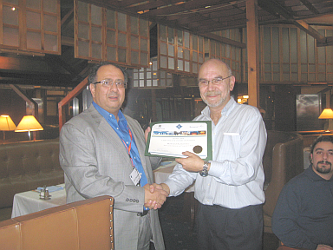
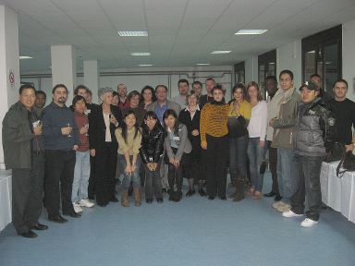 | 2. WIE event „Distinguished Women in the field of Signal Processing in BiH“ held at the University of Sarajevo, Faculty of Electrical Engineering, on 17 December 2008. The speakers at the WIE event were prof. dr Branislava Drazenovic and prof. dr Lejla Banjanovic-Mehmedovic.

Activities in the near future:

Technical Co-Sponsorship of the XXII International Symposium on Information, Communication and Automation Technologies – ICAT 2009.

IEEE 125th Anniversary activities:

Special event planned for the XXII International Symposium on Information, Communication and Automation Technologies – ICAT 2009, on October 30, 2009.s

Best practices:
We have recognized that the student members and are important to the continued growth of the IEEE and our Section and we plan to revive Student Branches that became inactive mainly due to discontinuity in volunteers work. We plan to support regular activities organized jointly by all student branches in BiH – especially workshops promoting their achievements and enabling contacts with industry representatives.

Hosting the IEEE ISSPIT 2008 conference in Sarajevo helped promoting IEEE membership among non-student members. We have established technical co-sponsorship with the organizers of the largest ICT conference in BiH – International Symposium on Information, Communication and Automation Technologies – ICAT with the same objectives. During the XXII ICAT we plan to organize the main IEEE 125th Anniversary event in Bosnia and Herzegovina.

We plan to apply for hosting some other IEEE conference in 2010.

Topics to be discussed in Venice:
-

