IEEE EGYPT Section Report - April 2009

- Officers: Election Date: 30 Jan 2008 Term End Date: 31 Dec 2009
Chair | Mohamed I Younis | myounis@ieee.org
Vice Chair | Samir I Shaheen | sshaheen@ieee.org
Chair, Alexandria Subsection | Said E El-Khamy | elkhamy@ieee.org
Secretary | Abdel-R H El-Sawy | aelsawy@seegypt.com
Treasurer | Samir I Shaheen | sshaheen@ieee.org
Secretary/Treasurer | Mohamed M Khairy | mkhairy@gmail.com
Membership Development | Ahmed F Seddik | afarag@mcit.gov.eg
Professional Activities | Samia A Mashali | samia@eri.sci.eg
Student Activities | Nevin M Darwish | ndarwish@ieee.org
Student Representative | Mohamed A Shahat | mols.eg@ieee.org
GOLD | ahmed.mikkawi | ahmed.mikkawi@ieeegoldegypt.org
WIE Women in Eng | Nevin M Darwish | ndarwish@ieee.org
- Chapter Chairs: Election Date: 30 Jan 2008 Term End Date: 31 Dec 2009
AP Chapter Chair | Hadia Elhenawy | helhennawy@ieee.org
CAS Chapter Chair | Mohamed A ABOUL-DAHAB | mdahab@aast.edu
C Chapter Chair | Mohamed I Younis | m_younis@ieee.org
ES Chapter Chair | Sohier M Fakhr | sohierfakr@yahoo.com
IA Chapter Chair | Mohamed M S Mansour | mmsmansour@ieee.org
IES Chapter | Ahmad M A Mahmoud | aasaadm@Menanet.net
MTT Chapter Chair | Ibrahim Salem | salem_ibrhm_32@yahoo.com
PELS Chapter Chair | El-Sayed M Tag Eldin | stageldin@yahoo.com
PES Chapter Chair | Soliman M El-Debeiky | seldebeiky@yahoo.com
SP Chapter Chair | Salwa H. Elramly | sramlye@netscape.net
CIS Chapter Chair NEW | Hani Hagras | hani.hagras@guc.edu.eg
COM Chapter Chair | Emad El Hussiny | emadh@eng.cu.edu.eg
E Chapter Chair | Sohir Sakir | sohiersakr@yahoo.com
CS Chapter Chair | Ahmed Elbahnasawi | abahnasawy@eng.cu.edu.eg
EMB Chapter Chair | Ahmed A. Morsy | amorsy@ieee.org
- Membership:
The active EGYPT Section membership is 1254. This includes 4 Fellows, 94 Senior Members, 262 Members, 197 Graduate Student Members, 655 Student members, 20 Affiliates, and 22 Associate Member. The membership increased this year by 4.7% compared to the last year.

Date of above results by using SAMIIIE: 12 /3/2009.

- Meetings:
  - Three Section Administrative Meetings held last year.
  - Society Chapters are encouraged to hold presentations regularly so that at least one Technical Meeting is held quarterly.
  - The annual Egyptian Student Branches Meeting (ESBM '09).
  - Annual Social Meeting and Dinner for all IEEE Volunteers and Supporters in Egypt.
- Activities in the near future:
    - Increase financial support for students and student branches.
    - Public awareness presentations about the IEEE, its role and benefits for Industry to improving the industry relations and attracting more members from the industry.
    - Applications for IEEE Milestones planned to be submitted.
    - Calling and support for Senior and Fellow Membership degrees.
    - Campaigns for new members during local conferences and expiation.
    - Chapter Chairs Workshop.
    - Egyptian Engineering Day EED’2009, Cairo, 1-3 Aug 2009; www.ieeegoldegypt.org/eed.
    - The 16th IEEE International Conference on Image Processing ICIP 2009 will be this year in Cairo, during 07-11 Nov 2009 http://www.icip2009.com.
- IEEE 125th Anniversary activities:
- IEEE 125th Anniversary EGYPT Section Celebration.
- Some of technical chapter and student branches are hosting at least one 125th year event.
Others to be planned.
- Best practices:
- The Egyptian Engineering Day EED
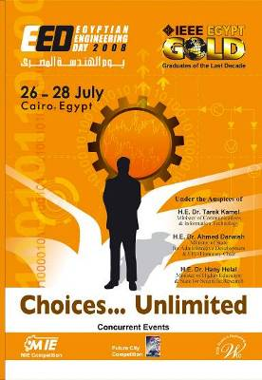
Under the Slogan “Choices…Unlimited”, The 7th Egyptian Engineering Day, EED’08 assisted fresh-grads to explore the entire market spectrum and match their talents creatively to the available market options. EED’08 was also a good starting point for innovative business ventures and relationships as it targeted to spread entrepreneurial spirit among engineers. This was fulfilled through the coexistence of different parties & delegates of different backgrounds from IEEE, industry, university, ventures, government, NGO’s, recruiters and media. EED’08 was inaugurated by their Excellencies: Minister of State for Administrative Development, Minister of Higher Education, Minister of International Cooperation and many other VIPs. EED’08 by now has become one of the major professional national days in Egypt.
In EED’08 primary on-event-statistics showed the following facts: 200 participating engineering & computer science graduation projects, 103 Job Offers, 19 Sold graduation projects, 24 To-Be-Funded graduation projects, 10 To-Be-Incubated graduation projects, and more than 4200 Visitors
EED Closing Video: http://www.youtube.com/watch?v=SGpPN7REJsY

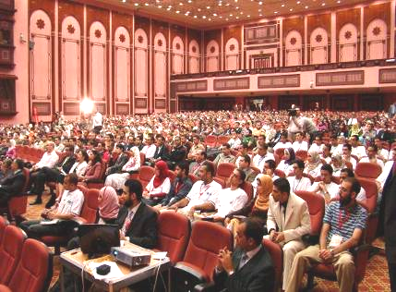
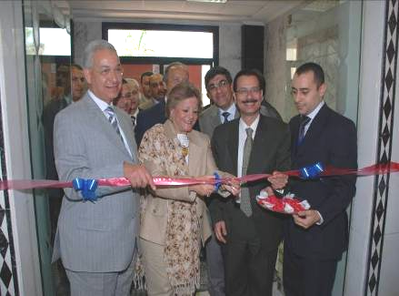

(a) (b)
(a) H.E. Minister of State for Administrative Development, H.E. Minister of Higher Education, H.E. Minister of International Cooperation in EED 2008 Opening. (b) Attendances in the opening session.
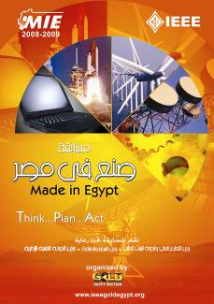
- "Made In Egypt" MIE

MIE is held among different Egyptian faculties of Engineering and in which teams of final year students all over Egypt compete to find out a solution for real industrial problems, Each project is also mentored by an expert from industry who interacts along with the project Professor, and the project team in designing and implementing a solution for the existing industrial problem or need.

- Future City Competition
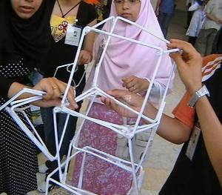
Future City Competition is a program developed for seventh and eighth grade students to help them discover and foster interests in math, science and engineering. The program is challenging and stimulating for all the involved Egyptian preparatory. The Competition is under the auspice of the Minister of Education Prof. Dr. Yousry El-Gamal, Bibliotheca Alexandrina, and the IEEE Egypt GOLD. Web: http://www.futurecityegypt.org
- The First Lego League
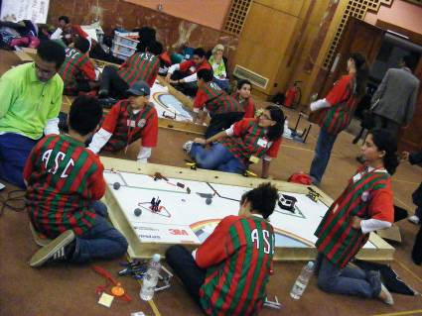
The 4th Egyptian Finals of First Lego League competition took place during 27-28 December, 2008, Alexandria, Egypt. It aims to utilizes theme-based Challenges to engage kids in research, problem solving, and engineering. For two days, 20 teams of Schools students compete to win the FIRST Lego league competition in Egypt, the First place winner will represent Egypt in the Arab Finals and International finals of the competition in USA in April.
The competition in Egypt is Under the auspices of the Egyptian Ministry of Education and the Egyptian Ministry of Communication and Information Technology, and organized by IEEE Egypt and the Bibliotheca Alexandrina, Planetarium Science Center (PSC).
- Topics to be discussed in Venice:
- We are going to present a proposal for Oct. 2010 R8 meeting in Egypt: Sharm Elsheikh.
- More benefits are needed to members in Region 8, and in particular to the students and young engineers. IEEE Members in Egypt feel that they are not getting similar benefits such as IEEE credit cards or worth their membership fees.
- Consider special circumstances of members residing in Egypt (fees and materials delivery).
- Cooperation between sections and joint activities.

