IEEE Region 8 Membership Activities Report, September 2008
IEEE Region 8 Committee Meeting, Quebec City
IEEE Region 8 Membership Activities Committee
- Chair: Marko Delimar
- Membership Development: Rolf Remshardt, Aleksandar Szabo, Eva Lang
- Professional Activities: Charles Turner, Matej Zajc (workshop coordinator), Gerald Anleitner, Martin Bastiaans, Rolf Remshardt, Aleksandar Szabo,
- Region 8 News: Roland Saam, Basak Yuksel,
- Electronic Communications: Thomas Watteyne,
- Section Congress 2008 Coordination: Tony Davies
- GOLD: Eva Lang, Pilar Molina Gaudo, Joao Figueiras
- Women in Engineering: Maryam Al Thani
- Life Members: Peter Hill
- History Activities: Jacob Baal Schem,
Region 8 Membership Activities - Goals and Objectives
- Improve the value of IEEE membership by increasing services and benefits to R8 members
- Develop non-technical IEEE activities in the Region (including contests, awards and promotion programs)
- Foster members' awareness of IEEE activities and existing benefits
- Support Region 8 initiatives and inform other IEEE organizational units about them
- Increase membership and develop retention strategies
- Develop local retention and membership programs
- Enhance member's careers
- Provide a platform for co-ordination, motivation and interaction among R8 members and organisational units
- Provide input to the IEEE RAB Membership Development Committee regarding R8 issues
- Assure IEEE membership promotion at IEEE Conferences and other events in R8
- Promote and support MA officers (MD, PA, GOLD, WIE, LM, etc.) in R8 Sections
- Provide Training & Orientations for Section MA officers
- Help in formation, organisation and development of non-technical IEEE organisational units
- Provide support to and rejuvenate IEEE organisational units
- Help with communication between existing IEEE organisational units
- Represent R8 members' interests and voice their concerns
- Introduce new ideas and proposals and implement initiatives for new activities within the membership responsibilities.
- Assure recruitment of new members and volunteers, control retention of active members and recovery of arrears.
- Promote and support member grade elevation
- Support and provide recognition to IEEE volunteers
Membership Development
Rolf Remshardt, MD Chair
Aleksandar Szabo (past chair), Eva Lang, Marko Delimar (ex-officio)

Region 8 Membership
At the end of July 2008 Region 8 had 60721 members. Comparing to the number of 59223 at the end of July 2007 this is a total increase of 1498 members or 2.5%. This increase is lower than it was before. The lower increase in membership is due to student members (including graduate student members), who have a decrease in membership of -1.5%. The higher grade members still have a respectable 4.2% increase in membership. We should intensify membership recruitment, especially among students.

IEEE Membership Summary – July 2008
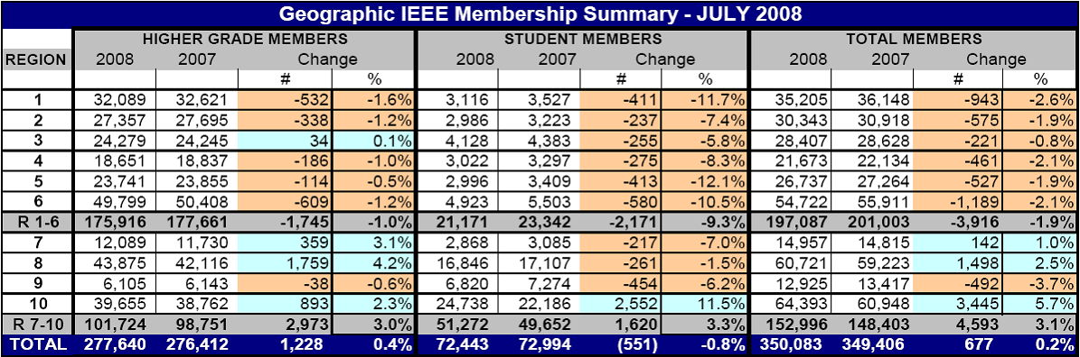

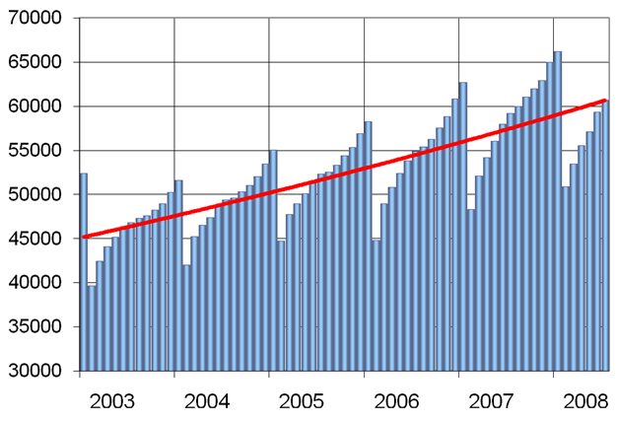

IEEE Region 8 Membership 2003-2008
Membership Statistics in R8 Sections
Most Sections are doing well. Only few sections have a decrease of membership. But there are also few Sections having less than 50 higher grade members! They should ask themselves how they will survive. Look into your Section Membership Statistics every month. Is your membership increasing or decreasing? To learn more about the members in your Section use SAMIEEE: http://www.ieee.org/samieee. Don't lose members! Recruit new members!

Section Membership Development Officers
We all, the members and volunteers in IEEE, should be aware that Membership Development on all levels and especially in our sections is of extreme importance if we want to have more members, new volunteers and more activity. Some sections in R8 still have not appointed a Section Membership Development Officer! We are asking these sections to appoint Membership Development Officers willing to do their job! To appear in the Geographic Roster, the name of the MD Officer and any changes should be reported to IEEE at http://ewh.ieee.org/forms/scs/interactofficer.php
We are also asking all Sections to send us the names and email addresses of their MD Officers especially if you have appointed new ones.
All Section MD Officers belong to the IEEE Membership Development Team.

IEEE Membership Development Conference Call/Webcast
All MD Officers are invited by e-mail to attend the Monthly Membership Development Conference Call/Webcast. The organizers of the Conference Call/Webcasts are Lee Stogner, the Chair of the IEEE Membership Recruitment and Retention AdHoc Committee and Qiana Harder, the Membership Development Manager from IEEE Staff. By participating you will get a lot of useful information about MD and learn a lot from the ongoing discussions. You can find the PP Presentations from the previous MD Webcasts in the MD Online Community https://www.ieeecommunities.org/ieee.md.net

Membership Development Kits sent to Sections
The 2009 Membership Development Kits have been sent to Sections and Student Branches on 15 August 2008, earlier than ever before. Have you received them?

Membership Development Manual Updated for 2009
The September Edition of the MD Manual has been updated and completed. It is an essential overview of MD. It includes resources such as the MD calendar and MD checklists. It helps you to coordinate your local efforts with headquarters’ programs and processes. There is also a listing of IEEE member benefits, as well as sample letter templates for suggested outreaches. You should have received it in the MD Kit. You can also download it from the IEEE MD page http://ieee.org/web/volunteers/membership_dev/index.html
You can also find it at our R8 MD Page visiting http://www.ewh.ieee.org/reg/8/cms/ and selecting Membership Activities and afterwards Membership Development.
Start the New 2009 Membership Campaign - The Full-Year Dues Period
The beginning of the full-year dues period starting on 1 September is the peak recruitment time. Services for new members commence immediately upon joining and continue through 31 December 2009. A member joining in September receives a bonus of 4 months of extra service above and beyond the 12 months he is paying for.
In 2009 we will celebrate the IEEE 125th Anniversary. The goal of our MD Team for the Anniversary is to increase our membership to be the highest in the history of IEEE.
For Membership Development Resources visit http://www.ieee.org/md and for best practices http://www.ieee.org/ra/md/bestpractices.html

Member-Get-A-Member Program
The payout for recruited professional members (not students) is 15.00 US$ per member. Recruiters (including student members) have the option of using their reward vouchers to pay for IEEE products or services, including the membership renewal, or they can use the vouchers for a donation to the IEEE Foundation.
Announce and provide information on the Member-Get-A-Member (http://ieee.org/mgm) program at Section, Student Branch and Chapter Meetings and Conferences. Make it a challenge within your Section to see who will be the best in Membership Development. The reward is more than a 15$ IEEE credit voucher, it's a bigger organization with better connections into industry and community. If each of us is recruiting just one new Member, we would double our size in one year!!! But let's try to increase our membership by 10%. Remember, without Membership Development, we cannot build the IEEE of tomorrow.

Arrears
To prevent the situation of having many arrears in the future we should work much more in advance (November, December, January), especially on the Section level, encouraging members to renew on time, well before the Service Terminator.

R8 MD Newsletter
IEEE Region 8 Membership Development Newsletters have been sent from time to time to all R8 Committee Members and Section MD Officers pointing out important information and MD actions to be done. They are also available at the IEEE Region 8 Membership Development Page. Visit http://www.ieee.org/r8, select Membership Activities and afterwards Membership Development.

MD at IEEE Conferences in Region 8
As already reported in our MD Newsletters and on previous R8 Committee Meetings, we are using our many conferences in R8 as a platform for IEEE promotion. We have an IEEE booth or table at the conference with IEEE posters, brochures, magazines and application forms, and a local volunteer hosting the table.
During the past months in 2008 we had presence with an IEEE promotion desk at seven conferences and we have made plans and arrangements for another 5-6 events during the forthcoming months.
The best way of preparing the necessary arrangements is to find colleagues and friends in our local sections, who are willing to support our promotion events. May we kindly ask you, the Section Chairs and Section MD officers to select additional conferences in 2009 in your section for promotion, to nominate a volunteer – maybe yourself – and inform us. We will of course work with you and your volunteers to organize the event and get the material shipped from IEEE staff. Many thanks in advance for your support.

Membership Development is the business of all of us!
If you have any questions concerning MD don't hesitate to ask anybody in our team:

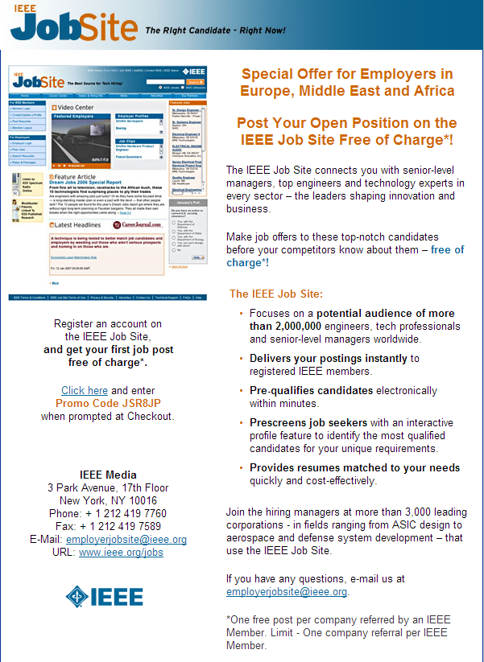

IEEE Region 8 Job site promo
Professional Activities
Charles Turner, Region 8 Professional Activities Chair
Matej Zajc (workshop coordinator), Gerald Anleitner, Martin Bastiaans,
Rolf Remshardt, Aleksandar Szabo, Marko Delimar (ex-officio)

PASC has continued to focus on the development of professional activities at Section/Chapter/Affinity Group level, urging all Section Chairs to appoint a PA Officer. PA is identified as the most significant member benefit for many members, and a positive reason to renew their membership. Organising an effective PA program requires a dedicated volunteer leading a Section team drawn from industry and academia. Only half of our 52 Sections currently have a PA Officer, and many Sections clearly do not give PA a sufficiently high priority.

To try to increase awareness of the importance of PA, the first issue of a quarterly e-newsletter was sent to all Section PA Officers following the Malta meeting. The objective is to inform them on a regular basis of new PA developments, services and products across IEEE, and to provide a list of contacts for possible collaboration.

In the past year there has been a strong growth in the use of webinars in IEEE, mostly free to members. This is rapidly becoming the medium of choice in the delivery of lectures and tutorials, for many technical organisations and societies (e.g. IET, Microwave Journal, etc.). Webinars are particularly useful in Region 8 because the wide geographical spread of our membership makes face-to-face meetings expensive. PASC believes that there are now excellent opportunities for local groups to capture the best talks at PA events and to re-package them as webinars for other Sections to use. There are logistical and cost issues to be overcome, and so some investment will be needed. The challenge for Region 8 is how to harness the vast array of expertise among our members to develop a large scale program of PA education comparable to that offered by IEEE-USA.

There are still many opportunities for in-person meetings, such as the Region 8 Workshops on Leadership Skills and Project Management given by Kurt Richter and Matej Zajc. Sections and Student Branches should consider hosting these workshops in 2009. PASC plans to add new topics, including Patents, later this year, and welcomes any other suggestions from Section Chairs. PASC needs help to identify expert presenters from across the Region to share the heavy burden of time and travel involved in delivering the workshops.

Finally, with great pleasure, PASC congratulates Kurt Richter who will be receiving the 2008 IEEE EAB Award for Continuing Education, for his pioneering work in the development of PA workshops.


GOLD (Graduates Of the Last Decade)
Eva Lang, Region 8 GOLD Chair
Pilar Molina Gaudo (past chair), Joao Figueiras,
Marko Delimar (ex-officio)

The 2008 R8 GOLD team is in full gear. Besides getting ready for the two big GOLD events this year, the biennial R8 GOLD Congress and the first global GOLD Summit, we have been very active in reaching out to GOLDies on Regional and Section level.

We have conducted several online training meetings, given support to incoming GOLD officers in different part of Region 8 and have been trying to make the IEEE members all over the Region aware of the GOLDen program.

GOLD activities will continue to have a tremendous momentum on Region 8 activities. We will:
- Support and move the GOLD Affinity Groups (AGs),
- Edit R8 GOLD Newsletter / R8 Gazette,
- Be present in R8 News,
- Be web present,
- Continue with the Transition Project proposed by MGA GOLD Committee,
- Carry out a membership benefit survey,
- Motivate more GOLDies to stay, join and be active – MGA GOLD has pledged close interactivity with Membership Development, so we are right along the lines.

Recommendations to Section Chairs:

- Identify good young volunteers, get them involved and train them to take on positions within the IEEE.
- Involve GOLD members at Section level, such as recruiting new members, reaching out to younger members, etc.

Membership:

GOLD members are identified by their first university degree. Thus GOLD includes Graduate Student Members, Members, and Senior Members.
As of August 11th, 2008 Region 8 has 5195 active GOLD-flagged members which is the highest number of GOLDies in all 10 Regions. These stats do not reflect the gross total head count as the GOLD flag is not set correctly for all members qualifying for GOLD. Also GSMs are included and need to be added to the above numbers.

Meetings:

Several online meetings were held through skype, being both strategic planning of the committee members as well as a call including all Affinity Group Chairs and GOLD Section representatives around Region 8.

Activities in the near future:

- Region 8 GOLD Congress hold in London, August 2008 along with the Student Branch Congress
  - 35 attendees in GOLD track
  - 3 day program including workshops, session on Membership Development and Volunteer Training and social events such as the Multicultural Night
- GOLD Committee online conferences
  - ieee.tv contribution by Region 8 GOLD is in the revival loop
  - Only very few entries in second call
- Affinity Groups / Section GOLD
  - Contacted Section Chairs, AG Chairs, and Section GOLD Coordinators
  - Skype conference done with many R8 GOLD Officers
    - Meet and greet and get to know new GOLDies
    - Sharing of best practices (database of distinguished speakers, cross-Section events, etc.)
    - GOLD involvement in societies and on section level
  - GOLD groups in development/reactivation in
    - Morocco
    - Finland
    - Sweden
    - Second GOLD group in South Africa
- Continued contributions to R8News
- Website update still in progress

Best practices:

- GOLD Affinity Group chairs to support formation of GOLD AGs in neighbouring sections
- GOLD members to lecture at student branches
- GOLD as organizing entity for PA events in sections
- GOLD members with responsibilities at Section level.

Topics to be discussed in Quebec:

- Support for GOLD activities
- Foster GOLD networking within the same AG and among different AGs

Region 8 News (print)
Roland Saam
Basak Yuksel
-- Co-editors

- 4 x year
- March, June, Sept., Dec.
- 12 pages/ per issue
- 50 articles each issue
- 200+ articles per year
- Cost $76,000. in 2006 per member ÷ 55,000 = $1.38 per year per member.

Benefits
- Every member receives it – tangible evidence of membership.
- Fresh news about IEEE activity.
- Also published, indexed on R8 Website
- News channel for R8 leaders, volunteers
- Attractive, public record of vitality in Region 8

We report
- Regional Membership Development
- GOLD, Student News
- Voluntary Contributions Fund, IEEE Foundation, Job Center, IEEE Benefits
- Chapter Development
- Standards in R8
- Interesting articles about members, information, quiz, Conference Calendar, amusing cartoons!

LM (Life Members)
Peter C J Hill, Region 8 Life Members Coordinator

- The Croatia Section formed a Life Members Affinity Group (LMAG) with effective start date, 2nd June 2008.

- UK&RI Section had another LMAG meeting (No 6) at the Royal Academy of Engineering (RAEng) in London on 1st July 2008.

Electronic Communications
Thomas Watteyne, Region 8 ECC

The Region 8 Electronic Communication Coordinator's job is to facilitate communication, both between members of the Region 8 Committee, and between this committee and present or future IEEE members.

IEEE Region 8 website statistics

A monitoring tool has been installed on our website (http://ieee.org/r8). Presented statistics were obtained over a period from the last meeting (01 May – 04 Sept 2008). Over this period, 10,212 people visited the website and 32,006 pages were viewed. On an average visit, a user looks at 2.34 pages, and stays for a little over 2 minutes.

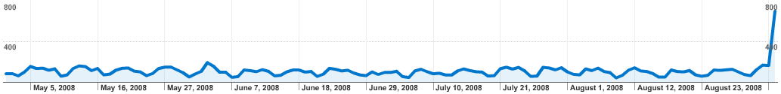

Our visitors come from 138 countries/territories all around the world, many of whom are outside Region 8. The origin of the visitors is depicted in the following map.

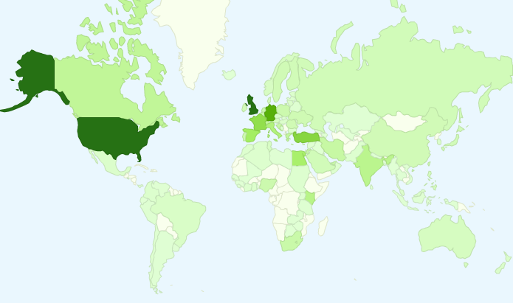


IEEE 125th Anniversary Highlights
Presidents’ Change the World competition opened for online entries on 1 September 08. First pre-registration was received from Region 8 on 4 September.

IEEE 125th Anniversary Website - ieee125.org
The website launched on 1 September. Most of the content is loaded including the submission form for the competition and a historical photo gallery. Additional material will be posted in the near future and throughout the anniversary year. Please consider posting to the message boards, register your events, upload videos and photos from your events and continue to provide us with your feedback on the website.
IEEE Global Engineering the Future Event Series
A series of eight IEEE-sponsored global events will be held during 2009. The cities which will host these events are: Austin, TX, USA; Bangalore, India; Beijing, China; Boston, MA, USA; London, United Kingdom; Munich, Germany; San Jose, CA, USA; and Tokyo, Japan.
IEEE Presidents’ Change the World Competition
This competition encourages students to change the world by using technology to solve real world problems either globally or locally. The competition officially opened on 1 September with the launch of the website. The top winner will receive US$10,000 and representatives of the top three teams will be brought to Los Angeles, California for the 2009 Honors Ceremony in June. Competition rules and preregistration form are on the anniversary website.
The Engineering Your World Video Contest
Later in the anniversary year, we will launch a video contest where we challenge individuals to show us how they have used technology to customize their living spaces – dorm room, work cubicle, car or any other space. This is later on our schedule and will be more fully developed before the end of the year.
IEEE Global Engineering the Future Day – 13 May
There are several projects in the works for the IEEE’s actual anniversary date – 13 May 2009.
  - First - our PR partner, Ruder Finn, is working with representatives in the UN to declare the date Global Engineering the Future Day. It is too soon to know if this is a successful effort.
  - Google has been approached for a custom logo for this date. We’ve made contact with several Google representatives and will be continuing to pursue this effort.
  - The 13 May date is also being entered into many media reference calendars which are used by reporters who are looking for ideas for stories.

