Treasurer’s Report
Brian Harrington
IEEE Region 8 Treasurer: September, 2008

Overview:

This report to the Region 8 Committee is an Interim report and covers the period from the 1st January, 2008 to the 31st July, 2008.

During the first three months of this year an assessment of the 2007 Region 8 finances was completed by a qualified independent auditor and accountant. The certificate of audit is filed and will be attached to the 2008 financial report to IEEE.

This year the task was extended in scope to include a review of the quality of Region 8 expense reimbursements against International Audit Standards. It was agreed that readable scanned copies of vouchers can stand as acceptable submissions in support of expense claims.

Financial Position at July month end 2008:

The Profit and Loss account as shown gives a small excess of $8.9K above expenditures for the expense claims as received at that time (2007 was a $36.1K loss).

The Region is again acting as ‘bankers’ for ISBIR and the amounts drawn off are shown against ‘Received from Foundations (New Initiatives Committee)’. The NIC allocation to ISBIR for 2008 is $115K (2007 was $100K).

A further Hotel payment of $33.7K will be posted in August to secure the Region 8 Committee Meeting to be held in Venice in April of 2009.

The Prior-Year Report:

This report gives a direct comparison with where we were at this point in time last year and so gives some indication of progress against that expected. It shows that at this point in the year our Income is $40,563 better than at this time last year and that our expenditure has been $4,469 less. This accounts for the apparent improvement of $45,033. However, as the excess of receipts is mainly as a consequence of ISBIR movements the position in comparison with last year should be considered to be about the same.

It is noted from the Prior-Year Report that:

- VCF income (Received from Individuals) is at half the level compared with previous years. It has not recovered from the set-back experienced from the installation of the new IEEE BMS system last year.

- The Region 8 Committee Meeting held in Malta in April appears to have attracted higher than usual travelling expenditures (‘Travel’) when compared to the April 2007 meeting in Sofia. This is partly due to the size of the meeting with some 150 members and guests attending the Saturday evening social.

- Additional support was given to Conferences (‘Conference Expenses’); in particular to SIBIRCON and to the Student paper contest held at MELECON.

Outlook:

It is expected that the Region 8 budget will be under increased pressure during the second half of this year with major events such as the Student Branch Congress in London and Sections’ Congress in Québec to be financed; both of which are high profile events and are strongly supported by Region 8 members and students.

A large financial commitment is also being made from the 2008 Region 8 Budget to secure the Region 8 Committee Meetings of next year in Venice and Riga.

Whilst a minor improvement is now being observed in the strength of the US Dollar against the Euro, the market value of Region 8 fixed assets as invested in the US market is seen to have fallen by some 8% during the first half of this year. Interest on US based cash investments is also much reduced.

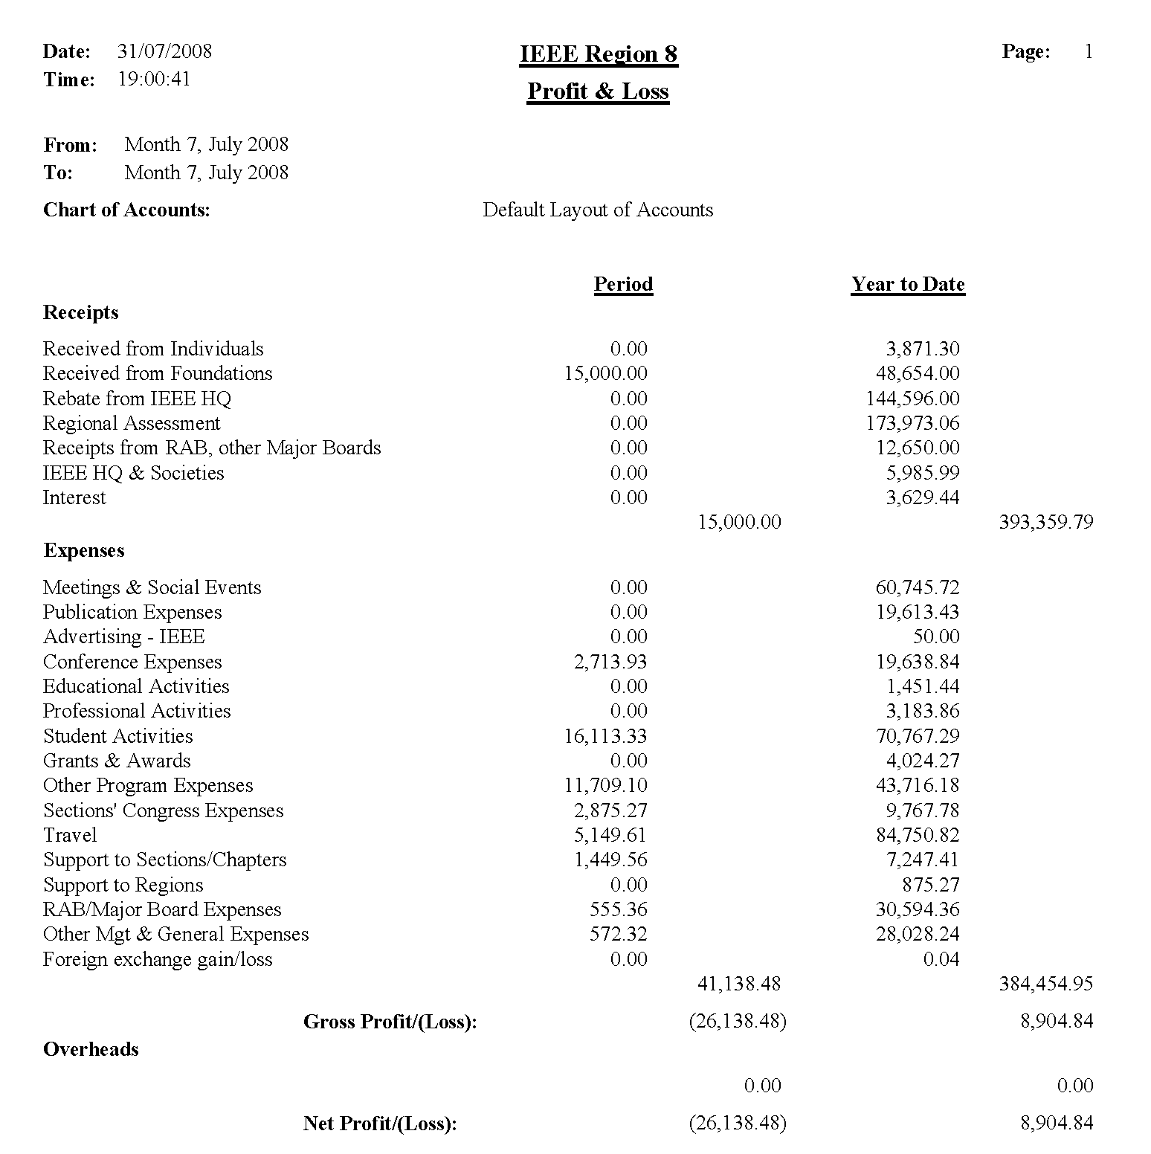

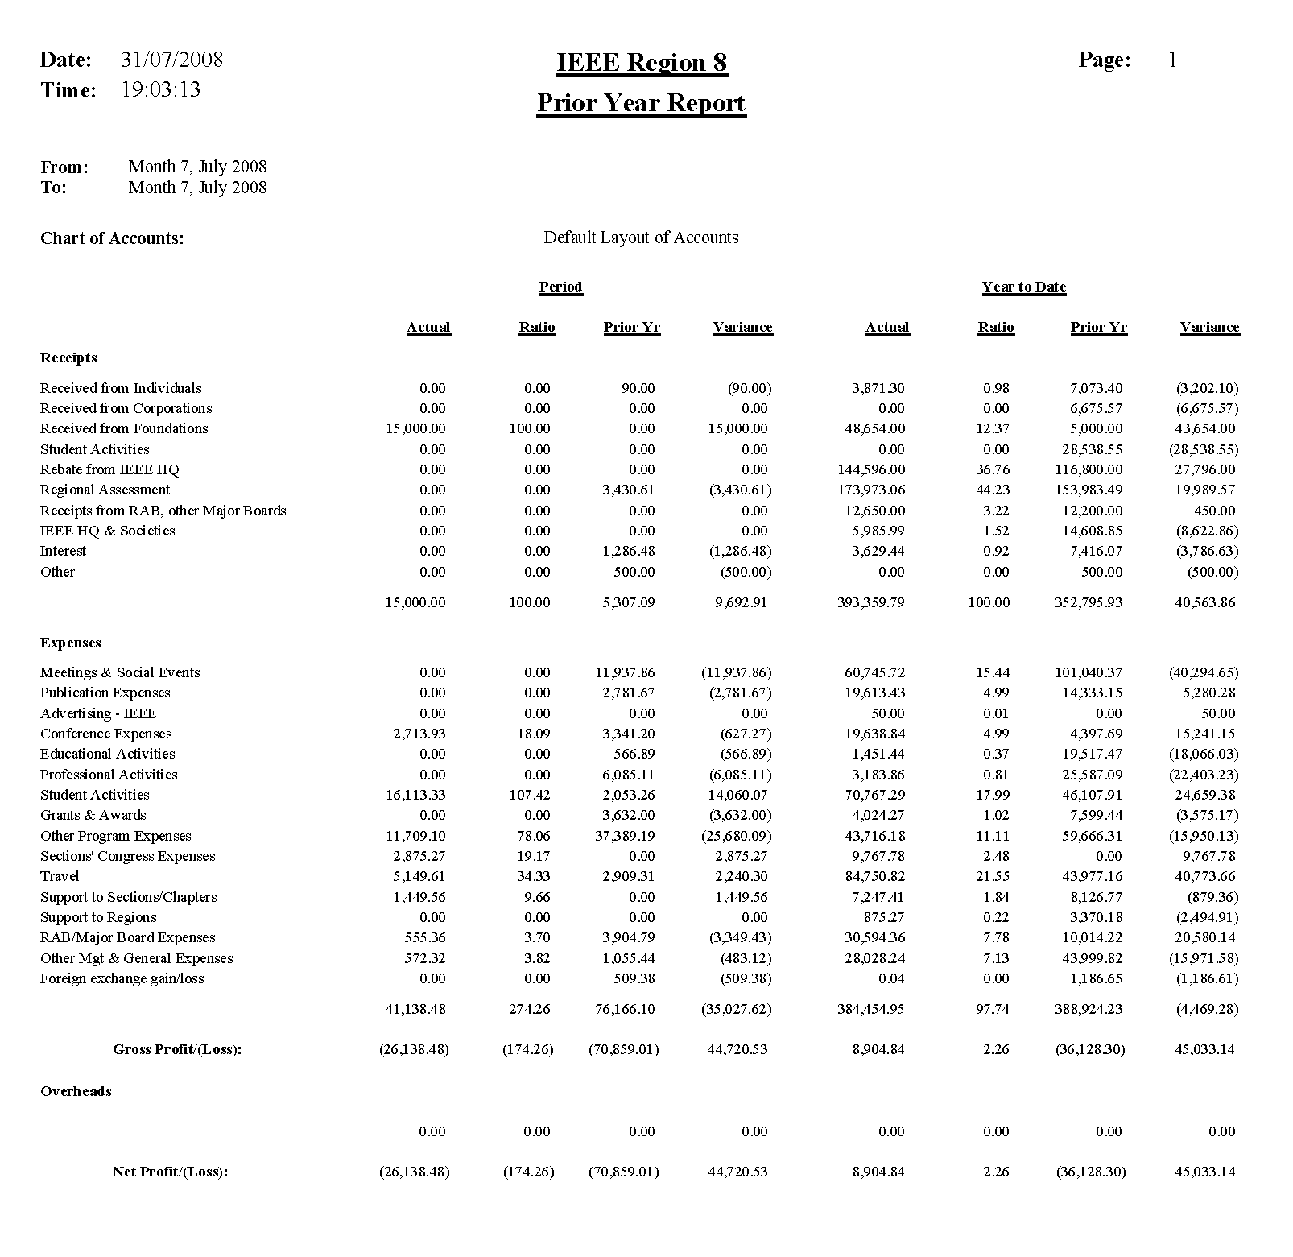
Brian Harrington
August 2008

