Group IEEE R8
April - June 2010
Tunis area

A / The transfers:

- Bus Mercedes or Man (50 seats) transfer from Tunis airport – Tunis Hotel = 6 euro / pax / way.
- Individual transfer jeep car Toyota or Nissan 05 seats : 40 Euros / way
- Individual transfer by car : 10 Euro/way
- Guide / English speaking Hostess - coordinator assistance: 50 Euros / guide / day.
- Hospitality Dest at the Airport: free of charge.

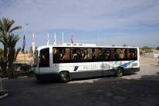
The rate includes:
- The assistance at the arrival provided by the staff of Tunisie voyages at the airport.
- The baggage transfer will be done by the busses used by the group and not separately.
- Luggage portage at the airport & hotels included

5* The Regency hotel
http://www.regencytunis.com/anglais/

B / The accommodation:

Service | Price in euro
Room rate for double use in B&B | 94
Room rate for single use in B&B | 88
Meal supplement: buffet | 24
Drink package: ½ water + ½ wine + tea or coffee | 11
Rich coffee break | 8

C / Meeting facilities & technical equipments

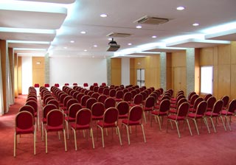
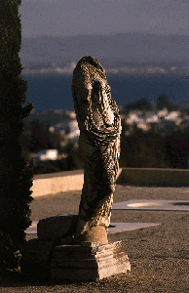

- Meeting room = FOC
- Break down room: 80 Euro / day
- Video projector multimedia 3M MP 8770 (XGA, 2200 lumens) = 140 euro / unit / day.
- Screen of projection : 2.03 M/3.1.0 m = 40 Euro / day
- Technician assistance = free.
- Label microphone =40 euro / day / unit.
- Wireless microphone = 50 euro / day / unit.
- Hospitality desk = Free of charge.
- Sonorisation of the room = 280 euro (Amplificatory, Enceintes acoustiques, Table de mixage, 02 table micros, 03 wireless micros)

C / Excursions:

Half day Bardo museum – Medina of Tunis:

The Bardo museum is situated in the old palace of the bey, in what was the countryside before, and offers both itself and and the exhibits to be admired. The tour around the museum is a a tour through Tunisian history, though dominated by Punic, Roman and Christian periods.
The best exhibits of more recent times, are the remains of the palace itself, even if this of course do not give a fair representation of general life styles of its time.
‘’It is one of the most seminal museums in the world. It displays relics from a long history stretching from remote prehistoric times to the contemporary epoch. It houses the largest mosaic collection of the world’’.
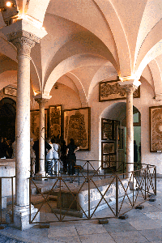
Continuation to the Medina of Tunis We suggest a guided visit through the winding streets of Tunis' old town, an opportunity to see the rich cultural heritage of old walled city and to discover the exquisite craftsmanship of Tunisia's artisans.
'Souk' is the Arabic name for market; 'medina' is the Arabic name for town. In Tunis today, the souk is also called medina. And there is a good reason: most of what once was Tunis is today like one enormous shopping centre and handicrafts factory.
Today, the medina is still inhabited, but only a small percentage of the total population of Tunis lives in these quarters.
Rate: 20 Euros

Half day Carthage – Sidi Bou Said:
Who has not heard of Hannibal and this city who dared brave the might of Rome? Now the ruins of both these great empires lay open to the sun and wildflowers. Declared a national monument the town of Carthage and nearby Salammbo abound in vestiges of the Punic and Roman empires, baths, dwellings, temples, shrines and the fabulous naval port of the Carthaginians.
For a thousand years, Phoenicians were masters of the Mediterranean and over 200 war ships and innumerable merchant vessels were sheltered in the nearby port of Salammbo. At its center the Admirals island still exists and archeologists are reconstituting the pavilion with its shrine and docks. Next to the ports the ancient sanctuary of the goddess Tanit (Tophet) a quiet, shady square of hundreds of funeral steles
festival of Carthage
Continuation to the Moorish village of Sidi Bou Said with its immaculate white and blue houses the village has managed to preserve its charm and its peacefulness.
Sidi Bou Said this lovely blue and white village, gaily perched on the cliffs overlooking the Bay of Tunis, is perhaps the most cherished in Tunisia. The legend tells of Saint Louis - coming to wage war he fell in love with a Berber princess and, changing his name became the patron saint of this village where he lived in joy and peace. Visit Sidi Bou Said, fall under its charm and the story will seem most logical

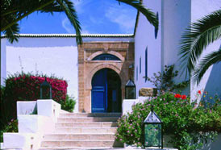

The most adventurous will have the opportunity to try the famous chicha (Waterpipe) !
Free time in Sidi Bou Saïd to sip a mint tea at Café Sidi Chabaane or stroll along the narrow streets to see the magnificent view from the cliff..
Back to the hotel
Rate: 20 Euros

Full day cap bon:

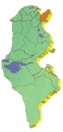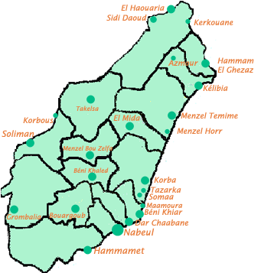

Bus departure towards Nabeul
Nabeul is the Cap Bon capital. It is known as Tunisia’s Handicraft capital and especially for its pottery. Nabeul is also known for embroidery and perfume distillation.
Visit of the market and a pottery workshop.
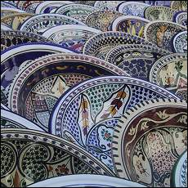
Free time
Visit of the archaeological site of Kerkouane: Listed: 1985 World Heritage Sites.
Discovered in 1952, this is the largest Punic site yet found. The town, which was founded in the fifth and sixth centuries B.C., is thought to have been devoted to the production of a purple dye made from a shellfish called murex know by the Romans as Tyrian purple after the Pheonician capital of Tyre. Abandoned in 250 B.C., almost all the houses in the town follow the same ground plan- a narrow corridor opening onto a small courtyard with a well and sometimes an altar to household gods- and are remarkable for their baths with pink and white mosaics.

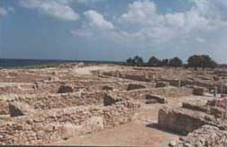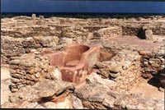
Visit of El Haouaria caves
Lunch at the very good restaurant Le Pecheur with a sea view (out of drinks)

Menu:
Soupe du pecheur + salade mixte aux fruits de mer
Tajine maison or tranche d'espadon grillé
Fruit de saison + thé
Photo Stop at Korbous thermal sources
back to the hotel
Rate: 52 Euros (lunch included).

Berber journey with 4WD & Team building activities:

Bus drive to Jradou and Sidi Jedidi:
Little Berber villages on the hill of the mountain belonging to the Atlas Chain, with a superb panorama over the Sahel region
Installation of a Berber camp (tent for tattoo, Berber bread, tea…)
A chief cook is at the disposal of the group: you will follow the entire process of preparing the typical Berber Bred “Tabouna”! The most adventurous could try it.
Or do you want to ask about the preparation of our famous “Couscous”?

The group will be shared in 6 teams with… persons each one.
The players of each team will have a « Tee shirt » in different colours.

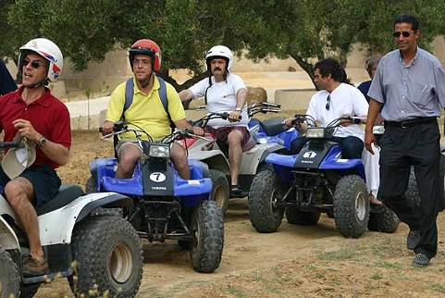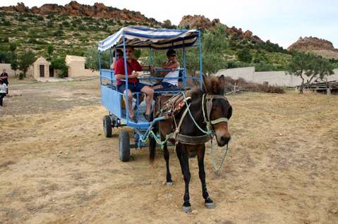

Several activities will be planned for the « Team building » such as:
- Cooking competition of a local famous plate under the watch eye of a chief cooker.
- Trekking to the surrounding mountain & botanic explanations.
- Assembly of a Berber tent
- Answering enigma of a local fortune teller

Lunch on the Berber village
Menu
Varried salad
Doigt de Fatma
Couscous royal (poulet, agneau, merguez)
Fruits de saison
Thé et makroudh
Back to Hammamet
- Price for the winner team : ‘’A Narghile (Water pipe) ’’: 18 Euros / peace

Excursion: 26 Euros / person
Quad’s challenge: 35 Euros
Camel ride: 25 Euros
Lunch: 22 Euros / person including ½ wine + ½ water + thé
D / The outside dinners:

Dinner at Dar Zarrouk: www.darsaid.com.tn
Transfer time: 15 Mins
This traditional Sidi Bou Said house has been converted into a nobility restaurant.
We suggest the famous Tunisian fish speciality “KABKABOU”.
A light musical animation will escort your dinner!
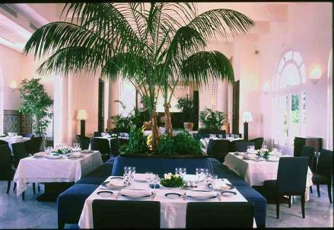
The 05 courses dinner will be composed of Tunisian dishes enlivened by a folklore troupe and a belly dancer.
Menù:
Salade tunisienne
Kabkabou with tunisina sauce: (fish)
Samsa au mile; tunisina pastry with honey
Corbeille de fruit de saison
Thé à la menthe
Price = 45 Euro / pax (including transfers, and out of drinks)

Dinner at the restaurant « Le Grand Bleu »
Transfer time: 10 Mins
Dinner at the restaurant "Le Grand Bleu’’ in Gammarth overlooking the hill of Sidi Bou Said Village (fish specialities)
A private room will be reserved for our group with a beautiful sea view

Menu:

Salade de poulpe ou calamr doré
Seiche grillée

Petites crevettes grillées sauce armoricaine

Friture de rouget
Duo de mérou & crevettes en brochettes
(Garniture : riz ou pommes frites)
Fruits de saison

Price = 48 Euro / pax (including transfers, and out of drinks)

Gala dinner at the restaurant ‘’Dar El Jeld’’

Departure to the Medina of Tunis transfer time 30 min
Dinner in Dar El Jeld converted palaces of the nobility and now among the finest restaurants in Tunisia.
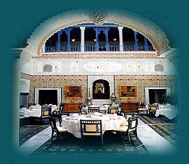

Menu :
Soupe ou Salade

Spécialité à la viande
Pâtisserie OU crème
Fruits de saison

Price = 45 euro / pax (including transfers, and out of drinks)

Golfe restaurant in la Marsa

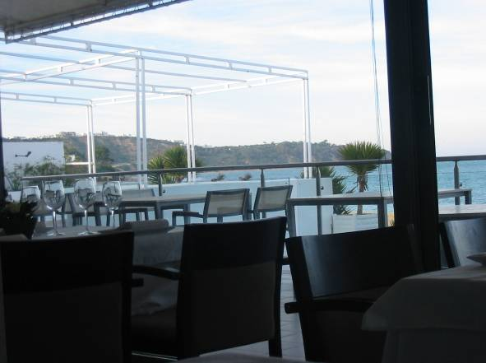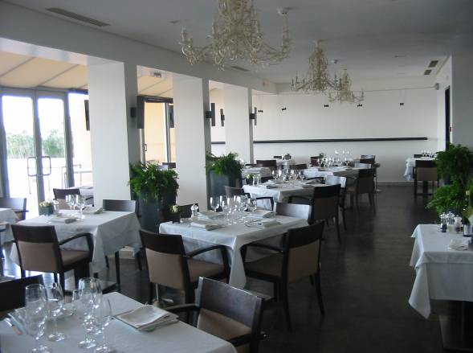

Menu :
Kemia riche a table
Calamars dorés, friture de rougets, salade mechouia, seiches grillées, merguez grillés
Tranche de poisson avec testira
Pâtisserie tunisienne
Rate: 45 Euros (in & out transfer included)

GALA DINNER AT THE St. LOUIS CATHEDRAL
Transfer time: 15 Mins
Departure to the Acropolium of Carthage, the mythical Cathedral Saint Louis will be the magical receptacle of the evening!!

This Cathedral was built in 1893 next to the Chapel of Saint Louis, King of France who died in Tunis in 1270, during the eighth Crusade
In 1993, it has been converted into a cultural and exhibition space (concerts, expositions…) It offers 1200 sqm of arcades, vaults, domes, 174 marble columns as well as 284 stained glass windows made by the craftsman Edouard Dideron.
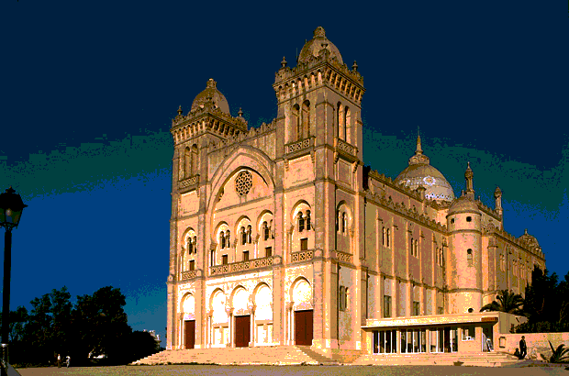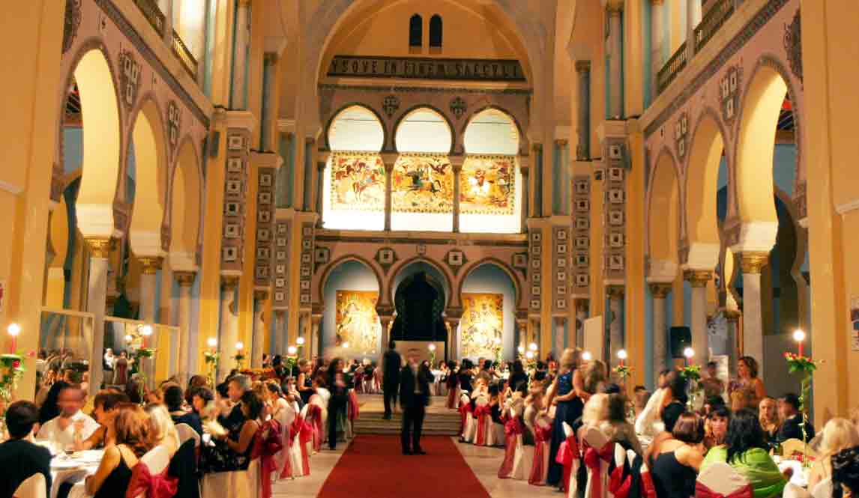

A magnificent Dinner (tables of 08) will be served in the entirely privatised Acropolium.

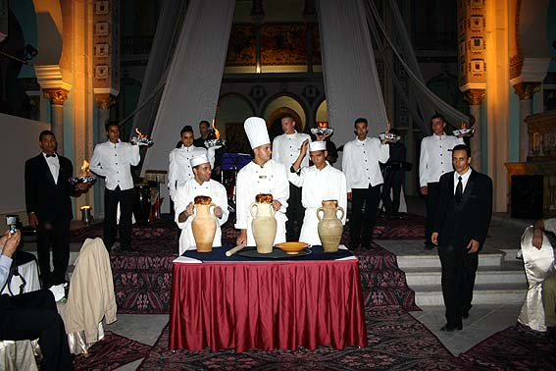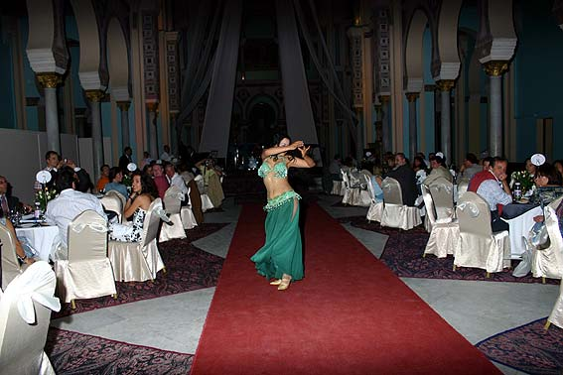

Menu:
Rich Mezza and different salads
Beef à la Guargoulette & rice or couscous
Tunisian pastries & fresh fruits
Tea or coffee!
GALA DINNER
Privatisation of the Acropolium (ex Cathedral of Carthage): 3800€ | ---
Torch lit path+Company Branding + Fire juggler + Decoration. = 250€ | ---
Dinner at Acropolium | 58
Tunisian Folkloric troupe. Package = 650 € | ---
Belly dancer. Package = 200 € | ---

Drink package: ½ mineral water + ½ local wine + tea or coffee: 11 Euros / person

