IEEE Region 8 Membership Activities Report, April 2008
IEEE Region 8 Committee Meeting, Malta
IEEE Region 8 Membership Activities Committee
- Chair: Marko Delimar, Region 8 Vice-Chair, Membership Activities
- Rolf Remshardt, Aleksandar Szabo, Eva Gutsmiedl, Membership Development
- Charles Turner, Matej Zajc (workshop coordinator), Gerald Anleitner, Martin Bastiaans,
Rolf Remshardt, Aleksandar Szabo, Professional Activities
- Roland Saam, Basak Yuksel, Region 8 News
- Thomas Watteyne, Electronic Communications
- Tony Davies, Section Congress 2008
- Eva Gutsmiedl, Pilar Molina Gaudo, Joao Figueiras, GOLD
- Maryam Al Thani, Women in Engineering
- Peter Hill, Life Members
- Jacob Baal Schem, History Activities
Region 8 Membership Activities - Goals and Objectives
- Improve the value of IEEE membership by increasing services and benefits to R8 members
- Develop non-technical IEEE activities in the Region (including contests, awards and promotion programs)
- Foster members' awareness of IEEE activities and existing benefits
- Support Region 8 initiatives and inform other IEEE organizational units about them
- Increase membership and develop retention strategies
- Develop local retention and membership programs
- Enhance member's careers
- Provide a platform for co-ordination, motivation and interaction among R8 members and organisational units
- Provide input to the IEEE RAB Membership Development Committee regarding R8 issues
- Assure IEEE membership promotion at IEEE Conferences and other events in R8
- Promote and support MA officers (MD, PA, GOLD, WIE, LM, etc.) in R8 Sections
- Provide Training & Orientations for Section MA officers
- Help in formation, organisation and development of non-technical IEEE organisational units
- Provide support to and rejuvenate IEEE organisational units
- Help with communication between existing IEEE organisational units
- Represent R8 members' interests and voice their concerns
- Introduce new ideas and proposals and implement initiatives for new activities within the membership responsibilities.
- Assure recruitment of new members and volunteers, control retention of active members and recovery of arrears.
- Promote and support member grade elevation
- Support and provide recognition to IEEE volunteers
Membership Development
Rolf Remshardt, MD Chair
Aleksandar Szabo (past chair), Eva Gutsmiedl, Marko Delimar (ex-officio)

IEEE Region 8 membership continues to grow at an impressive rate. Region 8 MD and R8 Sections’ MD officers continue to develop specific MD programs: new member promotions and retention, Region 8 MD webcast and MD at IEEE Conferences in R8. During the renewal season a large number of members reported renewal problems (online system, username/password, etc.) “The terminator” effect in 2008 was approximately the same as in previous years.

IEEE Membership Summary – February 2008

IEEE Region 8 Membership 2003-2008
REGION 8 MEMBERSHIP
At the end of 2007 Region 8 had 64976 members. Comparing to the number of 60856 at the end of 2006 it is an increase of 4120 members or 6.8%. After the Terminator, according to the membership statistics by 29 February 2008, Region 8 had 50895 members, comparing to 48338members on 28 February 2007. The increase in the one year period was 2557 members.

Arrears
The number of arrears after the Service Terminator action on 29 February was 15170, which is very high. This happened although we have sent e-mails to all the Section Chairs/ Section Membership Development Officers asking them to take action. On March 18 the number of arrears in Region 8 reduced to 14530. That means in 18days 640 arrears recovered. But there is still a long road ahead of us. The percentage of recovery is always the highest immediately after the Service Terminator. So we must strengthen our efforts to further reduce the number of arrears. To prevent such a situation in the future we have to work in advance (November, December, January), especially on the Section level, to encourage members to renew on time, well before the Service Terminator.

Use SAMIEEE to Indentify the Arrears in your Section
Go to SAMIEEE www.ieee.org/organizations/vols/samieee/index.html
- Click Access SAMIEEE
- Insert your IEEE User ID and Password (Web account) and Login
- Click SAMIEEE in Shared Folders
- Click Geographic Predefined Query and you will get the list of Predefined Queries
- Select (GEO) Arrears – Member Contact Info – By Section, By Grade
- Download to Excel and sort the Arrears data as you like!

Membership Development and Statistics
IEEE is publishing the MD Monthly Report to all chairs and MD officers in the sections, which contains the latest MD info from IEEE and includes worldwide member statistics on regions and societies. If you are interested in your latest membership statistics from your section, you will find all details under https://analytics.ieee.org/analytics/saw.dll?dashboard .
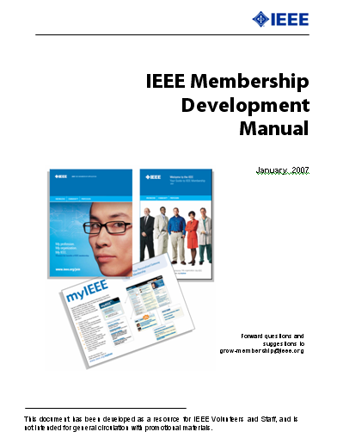
Most sections are doing well. Only few sections have a decrease of membership. But there are also few sections having less than 50 higher grade members! They should ask themselves how they will survive. Look into your Section Membership Statistics every month. Is your membership increasing or decreasing? Contact the arrears in your section to see what are the reasons for not renewing. Don't loose members!

To learn more about the members in your Section use the predefined Queries in SAMIEEE: www.ieee.org/organizations/vols/samieee/index.html
Register for participation in the IEEE Membership Development Community at https://www.ieeecommunities.org/ieee.md.net
Some of our Sections like UK&RI, Germany, Italy, Spain, France, Benelux etc. have a large amount of members. They should take into consideration the formation of an MD Team covering different areas/towns of the country to make the MD job easier and more efficient.
Section Membership Development Officers
We all, the members and volunteers in IEEE, should be aware that Membership Development on all levels and especially on the section level is of extreme importance if we want to have more members, new volunteers and more activity. Few sections in R8 ave not appointed a Section Membership Development Officer yet! We are asking these sections to appoint Membership Development Officers willing to do their job with enthusiasm and fun without sparing efforts!
We are also asking all Sections to send us the names and email addresses of their MD Officers especially if you have appointed new ones.

The Half-Year Dues Period
The half-year dues period is a peak recruitment time. It allows people to test IEEE membership for a smaller initial amount of money. New members pay half-year dues when they sign up from 1 March through 31 August. Services commence immediately upon joining and continue through December 31. A member joining in March receives a bonus of 4 months of extra service above and beyond the six months they are paying for.
For Membership Development Resources visit http://ieee.org/mdresources and for best practices http://www.ieee.org/ra/md/bestpractices.html

Member-Get-A-Member Program
The payout for recruited professional members (not students) is 15.00US$ per member. Recruiters (including student members) have the option of using their reward vouchers to pay for IEEE products or services, including the membership renewal, or they can use the vouchers for a donation to the IEEE Foundation.
Announce and provide information on the Member-Get-A-Member (http://ieee.org/mgm) and Student-Get-A-Student (http://ieee.org/sgs) programs at Section, Student Branch and Chapter Meetings and Conferences. Make it a challenge within your Section to see who will be the best in Membership Development. The reward is more than a 15$ IEEE credit voucher, it's a bigger organization with better connections into industry and community. If each of us recruited just one new Member, we would double our size in one year!!! But let's increase our membership by 10%. Remember, without Membership Development, we cannot build the IEEE of tomorrow.

Graduate Student Members (GSM) have the rights and privileges of members
According to the IEEE Bylaws the Graduate Student Members have the rights and privileges of full members. They can be Section Officers. GS Members are also qualified to sign the petition to establish a new Section – important for new section and new chapter development!

Membership Development Manual
The MD Manual provides an essential overview for MD activities. It includes resources such as the MD calendar and MD checklists. It helps you to coordinate your local efforts with headquarters’ programs and processes. There is also a listing of IEEE member benefits, as well as sample letter templates for suggested outreaches. You can download it from the IEEE MD page http://ieee.org/web/volunteers/membership_dev/index.html. You can also find it at our R8 MD Page visiting http://ieee.org/r8 and selecting Membership Activities and afterwards Membership Development.

Membership Development Promotional Material
The 2007 Membership Recruitment Kits have been sent to Sections and Student Branches in September 2007. To order additional supplies visit http://ieee.org/mdsupplies.

R8 MD Newsletter
IEEE Region 8 Membership Development Newsletters have been sent from time to time to all R8 Committee Members and Section MD Officers reporting on important information and MD actions to be done. It is also available at the IEEE Region 8 Membership Development Page. Visit http://www.ieee.org/r8 , select Membership Activities and afterwards MD.

Region 8 MD meetings by Webcasts/Teleconferences
In the November MD Newsletter issue we had proposed to hold R8 MD meetings using modern communication tools like teleconferences/webcasts. It was also thought for training & education of MD officers and we have asked you some questions with respect to your participation. Unfortunately the feedback was very low and a few responses indicated preference of more effective face to face MD meetings. We therefore did not start any webcast so far and we will try to get financial support from R8 to hold a face to face meeting.
IEEE has and still is organizing monthly webcasts with the latest membership information from IEEE and Q&A sessions. Lee Stogner (R3 MD officer) and Qiana Harder (IEEE MD staff) are holding these meetings usually on a Saturday afternoon. We will regularly invite the R8 MD officers to participate.

MD at IEEE Conferences in Region 8
As already reported in November, we are using our many conferences in R8 as a platform for IEEE promotion. We have an IEEE booth or table at the conference with IEEE posters, brochures, magazines and application forms, and a local volunteer hosting the table. In 2007 we had already several successful events at conferences and we will continue with the same approach this year. For the first part of 2008 we made arrangements with the help of local colleagues and volunteers at the following conferences:
- AISPC 2008, Student Paper Conference Aalborg, Denmark, February 2008
- ICT 2008, Cairo, Egypt, February 2008
- NOCS and ASYNC , Newcastle, UK , April 2008
- Czech and Slovak Microwave + Radioelectronic Week, April 2008, Prague
- MELECON 2008, Ajaccio, France, May 2008
- ISBI 2008, Paris, France, May 2008
- MIKON 2008, Wroclaw, Poland, May 2008
- IEEE US/EU BALTIC , Tallin, Estonia, May 2008
- IWSSIP 2008, Bratislava, Czech Republic, June 2008
- ICCS 2008, Krakow, Poland, June 2008
- ICL 2008 , Villach, Austria , September 2008
The best way of preparing the necessary arrangements is to find colleagues and friends in our local sections, who are willing to support our promotion events. May we kindly ask you, the Section Chairs and Section MD officers to select additional conferences in 2008 in your section for promotion and to nominate a volunteer – maybe yourself – and inform us. We will of course work with you and your volunteers to organize the event and get the material shipped from IEEE staff. Many thanks in advance for your support.

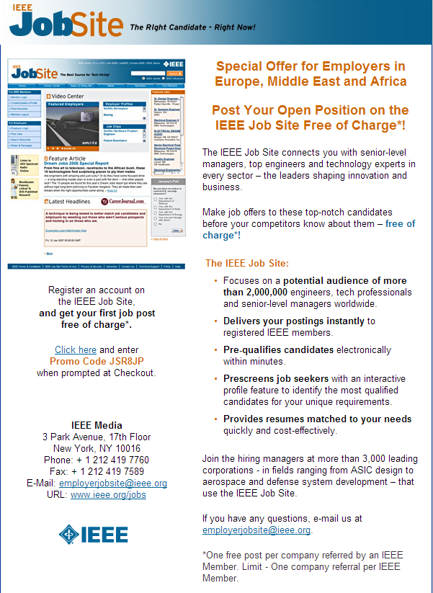

IEEE Region 8 Job site promo
Professional Activities
Charles Turner, Region 8 Professional Activities Chair
Matej Zajc (workshop coordinator), Gerald Anleitner, Martin Bastiaans,
Rolf Remshardt, Aleksandar Szabo, Marko Delimar (ex-officio)

PASC has continued to expand the program of work begun in 2007, focussing its efforts on two priority areas;
1) The development of local PA activities in Region 8;
2) The accessibility of PA products and services to individual members and groups;

The first relies heavily on Sections and Chapters finding volunteer leaders able to organise meetings and deliver services to their members. At present, fewer than half of all Region 8 Sections have a PA officer. Because most of the Section Chairs attending the Region 8 Committee meeting in Malta might not be fully aware of the work of the PASC, we will take the opportunity to emphasise the importance of professional activities to their members.
The second priority area depends directly on the availability of more presenters and materials on PA topics. PASC agreed last year to collaborate with IEEE-USA and to share resources, especially products and services designed to enhance members’ careers and employment prospects. PASC is recommending to the Region 8 Committee that a memorandum of understanding (MOU) be signed with IEEE-USA this year, to ensure that this collaboration will continue well into the future.
A key task facing PASC is the recruitment of expert presenters of PA topics. For example, Gerald Anleitner has arranged for patent lawyers from Germany to give a 4 part series in 2008 on patents, via webinar technology, in collaboration with IEEE-USA.. The target for 2008 is to build a team of experts willing to volunteer their services, across the broad field of Professional Activities, both at introductory and advanced levels. Other topics currently under consideration are standards, innovation and invention, design, ethics, and personal development.
The program of workshops led by Kurt Richter and Matej Zajc will continue in 2008, and several workshops have already been arranged. A workshop on the development of leadership skills will be organised by the GOLD Committee in Rome, April 23/24. PASC will also sponsor a session on Time Management at the Student Branch/GOLD Congress in London, August 31/September 2.
PASC intends to encourage greater collaboration with other Region 8 groups, including Students, GOLD, Industry Relations, Membership Development and Education, because Professional Activities is of interest to all members, especially those at the beginning of their careers. PASC believes that Section Chairs need to be challenged to respond more directly to the needs of their members.

Sections Congress organisation and preparation
Tony Davies, Region 8 Section Congress Coordinator

- IEEE Sections Congress, Quebec City, Canada
Quebec City Convention Center, 19–22 September 2008
- For more details see separate report and http://ieee.org/r8
Region 8 News (print)
Roland Saam
Basak Yuksel
-- Co-editors

- 4 x year
- March, June, Sept., Dec.
- 12 pages/ per issue
- 50 articles each issue
- 200+ articles per year
- Cost $76,000. in 2006 per member ÷ 55,000 = $1.38 per year per member.

Benefits
- Every member receives it – tangible evidence of membership.
- Fresh news about IEEE activity.
- Also published, indexed on R8 Website
- News channel for R8 leaders, volunteers
- Attractive, public record of vitality in Region 8

We report
- Regional Membership Development
- GOLD, Student News
- Voluntary Contributions Fund, IEEE Foundation, Job Center, IEEE Benefits
- Chapter Development
- Standards in R8
- Interesting articles about members, information, quiz, Conference Calendar, amusing cartoons!

Electronic Communications
Thomas Watteyne, Region 8 ECC
Arnaud de Beaucourt, Region 8 ECC backup

The Region 8 Electronic Communication Coordinator's job is to facilitate communication, both between members of the Region 8 Committee, and between this committee and present or future IEEE members.

IEEE Region 8 website statistics
A monitoring tool has been installed on our website (http://ieee.org/r8). Presented statistics were obtained over a 1-month period (22 Feb – 23 March 2008). Over this period, 3,712 people visited the website and 11,366 pages were viewed. On an average visit, a user looks at 2.43 pages, and stays for a little over 2 minutes. With such short visits, an effort should be done to provide easy to find and to-the-point content.

On an average day, the site receives 156 visits, with a peek of 669 visits on 18 March 2008 (see next figure, where each connected dots represents a day, the last one being 22 March 2008).

Nearly half the visitors type in the website's address directly, will ~25% used links coming from other sites and another ~25% use search engines to find our site. If using search engines, the most typed keywords are "ieee region 8" (6.57%), "pimrc 2008" (5.17%), "ieee r8" (3.53%), "iwcmc 2008" (2.79%) and "melecon 2008" (1.72%). This stresses once again the utmost importance of our conferences.

Our visitors come from 108 countries/territories all around the world. Most surprisingly, many visitors come outside Region 8. First place goes to the United States (about 13%), the come the United Kingdom (7%), France (6%), Germany (6%) and Turkey (5%). The origin of the visitors is depicted in the following map.

These are the most viewed pages since the launch of the website in January 2007:
- IEEE Region 8 Membership Activities
- IEEE Region 8 Sections and Subsections
- Committee and Contacts
- Professional Activities
- Life Members
- History activities
- GOLD (Graduates Of the Last Decade)
- Membership Development
- Documents & Bylaws
- About R8
Note that some of these pages contain little or no content. To avoid that the visitor ends up frustrated it is important to keep the content fresh and consistent. Keeping the content of the different pages fresh is the job of the whole committee. Each (sub)committee should clearly identify a person responsible for the content of this (sub)committee's webpage. This person can then contact thomas.watteyne@ieee.org to get the proper rights and training to update his page directly. Some committees are already doing this since January 2007, the others should follow.

Electronic communications for the Malta meeting
Each attendee of the Malta meeting has registered online. This has eased the job of the group of people organizing this meeting. Additionally, each attendee has been invited to create an account on the Region 8 website. Only though this account can an attendee access the Malta page (containing useful information, including the schedule) and the different files and reports. All reports and all presented material are uploaded onto the Region 8 website. They can be securely accessed by committee members and eligible attendees.

Electronic communications operation during the Malta meeting
<the information provided in this section may not be fully applicable as it is written before the meeting. Refer to the possible guidelines provided at the meeting first. >
During the meeting, the following setting will be used:

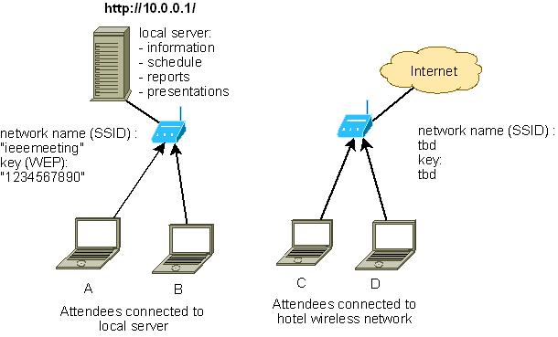

A local server will contain all necessary information about the meeting: annotated schedule, all reports constituting the agenda book and the presentations. The contents will be updated in real time so you are kindly invited to refresh your browser window from time to time (hit F5).
To see the content of the local server, connect to the wireless network called "ieeemeeting", and enter the key "1234567890" when asked. Once connected, open your browser and got to http://10.0.0.1. You will not be able to access the Internet when connected to the network called "ieeemeeting" !

If you wish to access the internet, connect to the hotel's wireless network. You will not be able to access the local server when connected to the hotel's network !

GOLD (Graduates Of the Last Decade)
Eva Gutsmiedl, Region 8 GOLD Chair
Pilar Molina Gaudo (past chair), Joao Figueiras,
Marko Delimar (ex-officio)

Pilar Molina Gaudo ceased in the position of R8 GOLD Coordinator. She will remain in the R8 GOLD Committee as the Past Chair. Newly appointed to this position in 2008 is Eva Gutsmiedl. Gerald Anleitner will remain on board as Senior Consultant / PA liason. The new face this year is Joao Carlos Prazeres Figueiras. Also, Lisa Lazareck will be along and giving ideas if time allows.

Besides that small shift in persons, we are remain highly motivated to improve GOLDen benefits and boost activities in Region 8.

GOLD activities will continue to have a tremendous momentum on Region 8 activities. We will:
- support and move the GOLD Affinity Groups (AGs),
- edit R8 GOLD Newsletter / R8 Gazette,
- be present in R8 News,
- be web present,
- continue with the Transition Project proposed by MGA GOLD Committee,
- do a membership benefit survey,
- motivate more GOLDies to stay, join and be active – MGA GOLD has pledged close interactivity with Membership Development, so we are right along the lines.

Recommendations to Section Chairs:

- Identify good young volunteers, get them involved and train them to take on positions within the IEEE.
- Involve GOLD members in Section work, such as recruiting new members, reaching out to younger members, etc.
- Send GOLD volunteers to Sections Congress!

Membership:
GOLD members are identified by their first university degree. Thus GOLD includes Graduate Student Members, Members, and Senior Members.
As of March 17, 2008 Region 8 has 4748 active GOLD-flagged members and 1738 arrears. These stats do not reflect the gross total head count as the GOLD flag is not set correctly for all members qualifying for GOLD. Also GSMs are included and need to be added to the above numbers.

Meetings:
Eva attended the MGA GOLD Meeting in Louisville, Kentucky on Feb 14-15.
Several online meetings were held through skype, being both strategic planning of the committee members as well as a call including all Affinity Group Chairs and GOLD Section representatives around Region 8.

Activities in the near future:

- Region 8 GOLD Congress to be held in London, August 2008 along with the Student Branch Congress
  - agenda almost fixed, still working on details
  - planned row of attendees: 25-40 active and future R8 GOLD Officers
- GOLD Committee online conferences
  - ieee.tv contribution by Region 8 GOLD is tentative. There were zero replies from the R8 GOLD members. Joao will work to reform the original proposal.
  - “Volunteer Greenhouse” proposal was a failure as it overlaps with existing projects according to NIC. No enthusiasm to reform / change the project.
- Affinity Groups / Section GOLD
  - Contacted Section Chairs, AG Chairs, and Section GOLD Coordinators
  - Skype conference done with many R8 GOLD Officers
    - Meet and greet
    - Sharing of best practices (database of distinguished speakers, cross-Section events, etc.)
    - GOLD involvement in societies and on section level
  - GOLD groups in development/reactivation in
    - Morocco
    - Finland
    - Sweden
- Continued contributions to R8News
- Website update still in progress

Best practices:
- GOLD Affinity Group chairs to support formation of GOLD AGs in neighbouring sections
- GOLD members to lecture at student branches
- GOLD as organizing entity for PA events in sections

Topics to be discussed in Malta:
- Support for GOLD activities
- Sending GOLD members to 1st global GOLD Summit and Sections Congress

WIE (Women in Engineering)
Maryam Al Thani, Region 8 WIE Coordinator

IEEE Region 8 WIE web page updated.

LM (Life Members)
Peter C J Hill, Region 8 Life Members Coordinator

Introduction
I was appointed Region 8 Life Member (LM) Coordinator January 2007 so this is my 3rd half-yearly LMC report to the MA committee; previous reports were delivered for the Sofia and Bucharest Region 8 meetings.
I wish to acknowledge the encouragement and help I have received from both Marko Delimar and Jacob Baal-Schem in various LM and related matters since taking on the role.

Status of Life Member Affinity Groups (LMAG) in R8
Currently we have 4 substantive groups, viz, France, Israel, Italy, United Kingdom & Republic of Ireland (UK&RI), and with Greece recently showing positive interest in forming a LMAG; unfortunately, Switzerland Section was finally unable to form one.
Reported Events
The call for information on activities went out February 2008 but only two LMAGS have reported back to me thus far, namely Israel and UK&RI.

Israel – two group meetings. (1) A reception in honour of Professor Lempel on the occasion of receiving the IEEE Medal in which of 50 participants, 15 were LM grades; (2) A meeting concerned with History activities included around 10 LMs. In addition, 3 e-notices have been sent out to 84 LMs to inform them of both LM and also History events; the Israel LMAG meetings are chaired by Jacob Baal-Schem.

UK&RI – normally the Section LMAG and HAC groups meet jointly for convenience, in London. We had a meeting in January in which the main agenda items were: minutes of our last meeting at the Warsaw EUROCON 2007, collaboration between the UK IET and our LMAG, HISTELCON 2008 Paris, possible IEEE sources of funding, collaboration between the UK Defence Electronics History Society (DEHS) and LMAG/HAC, and finally future events including EUROCON 2009 St Petersburg in May. There will be a further meeting in April timed to coincide with the Peter Lindsay Memorial Lecture at Imperial College, London; the UK&RI joint LMAG & HAC meetings are chaired by Roland Saam.

Once again, R8 Sections with viable numbers of LMs are strongly encouraged to form active LMAGs; the previous Bucharest report details the various funding opportunities.

HAC (History Activities)
Jacob Baal Schem, Region 8 History Activities Coordinator

Background
Region 8 History activities started with Region 8 Committee approval in 2006 of forming a History Activities Council and with the first meeting of HAC in Vilnius.
Actual launching of History activities were based on:
- Appointment of Region 8 History activities coordinator as from 1 January 2007.
- Provision of Grant by IEEE Foundation in addition to Region 8 Membership Budget.
- Assistance from VC Membership Activities (Budget and Guidance).

2008 History activities in R8

EUROCON session
Following the success at EUROCON 07, a Special Session on “History of Electrotechnology” was proposed and accepted by EUROCON 09

Web site
With the assistance of Thomas Watteyne, a Web site on History of Electrotechnology was set up as part of Region 8 site and relevant information was included.

History Network
With additional assistance of Thomas, a “listserv” was set up, to include all those interested in History of Electrotechnology, who signed up to become members of the network. Information on the network is on R8 Web site.

HISTELCON 08
Following a proposal approved at the HAC meeting to hold a Region 8 History Conference in 2008, a meeting was held in Paris, with the following conclusions:
- To hold HISTELCON 2008 on 11-12 Sept.08 in Paris at the Cercle National des Armees.
- To invite as co-sponsors IEEE History Center, the French SEE as well as additional Groups
- To appoint Prof. Jean-Claude Boudenot and Baal-Schem as co-chairs
Most of the 2008 activities are connected to HISTELCON 2008.
- More than 60 abstractrs have been received and reviewed
- The budget has been approved by IEEE HQ and insurance provided
- The TPC will propose a Technical Program at its meeting on 29 March
- A Gala Dinner will be held aboard a boat on the Seine
- The Conference Committee will discuss the program on April 1.
Press release
- At the proposal of Region 8 News Editor, a Press Release on Region 8 History activities was prepared and distributed.
- Additional information was printed in March 2008 issue of R8 News
- An article on HISTELCON 08 appeared on IEEE History Center News
- IEEE Conference Communications Marketing Manager has been contacted in order to assist in enlarging the audience of history events

IEEE Foundation Grant
IEEE Foundation has provided a grant of $10K for assistance to organize and hold HISTELCON 08.

Interviews
The activities schedule of the HAC included holding 3 Oral Interviews in 2007 (2 in UK and 1 in Israel). After getting the briefing by IEEE History Center Dr. Nebeker during the meeting in Warsaw, an oral interview was successfully held in Israel (with Mr. Uzia Galil) and will be sent to IEEE.

Additional information
Jacob Baal-Schem was appointed member of the IEEE History Committee and will also serve on the TPC of the 2009 IEEE History Conference.
He was also appointed as member of the Communications Society History Committee and co-chair of History Special session at Globecom 2008.

