15TH IEEE MEDITERRANEAN ELECTROTECHNICAL CONFERENCE

MELECON 2010

Malta

Dr Ing. Carl James Debono
IEEE Malta Section Chair
Department of Communications & Computer Engineering
University of Malta

Possible dates: 9 – 12th May 2010, 16th – 19th May 2010 or 12 – 15th September 2010

Venue: We can offer two possibilities:
Valletta – Phoenicia Hotel or Grand Hotel Excelsior
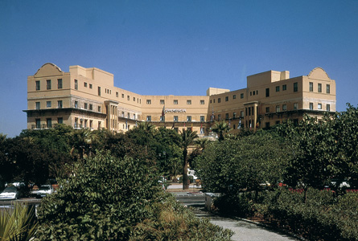
Phoenicia Hotel
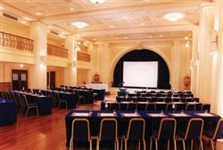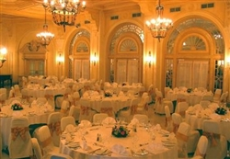
Phoenicia Hotel Facilities

The Phoenicia Hotel is an old hotel which has just changed owners.
The Grand Hotel Excelsior is a new hotel which is opening soon – no images available yet.

St. Julians – Westin Dragonara Resort
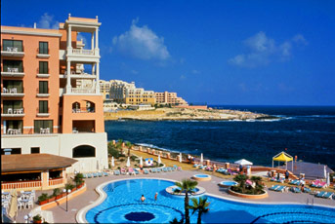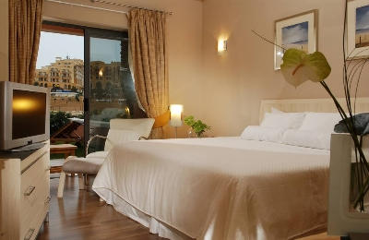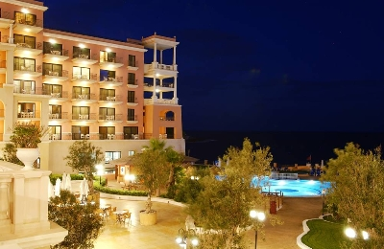
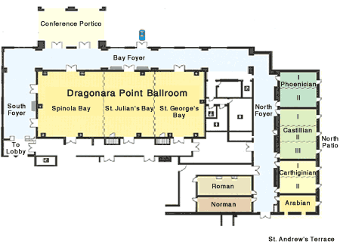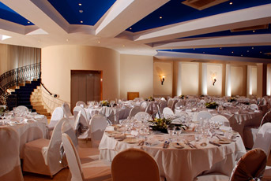
Facilities

The Westin as a ten year old hotel located in St. Julians. The area is a tourist area with extensive night life. This site has the advantage of having a lot of hotels nearby.

Travel arrangements: Air Malta (www.airmalta.com) services a lot of European destinations, however other airlines such as Lufthansa, British airways, Alitalia, and Ryan Air service Malta regularly. Further information can be obtained from http://www.maltairport.com. Visa requirements can be found at: http://www2.mfa.gov.mt/images/files/file/d2c_visa_requirements_for_foreign_nationals_as_at_010407.pdf. Currency will be the Euro.

Planned number of participants: 350 – 400 (If we take the Westin option we can increase this further)

Planned Fees (tentative): We can propose two models:
- Standard rate 500 Euro, IEEE Member rate 450 Euro, IEEE Student rate 300 Euro.
- Author standard rate 440 Euro, Author IEEE Member rate 380 Euro, Reduced rate for a limited number say 30 at 240 Euro.

Social Program: Organized tours during the conference, welcome drink, and gala dinner.

Experience in conference organization: ICECS 2001, ISCCSP 2008, ICECS 2008.

