IEEE Bosnia and Herzegovina Section Report April 2008

Officers: (Term End Date: 26 April 2008)

Executive Officers
- Chair: Dr. Branislava Drazenovic
- Chair Deputy: Dr. Kemo Sokolija
- Treasurer: Dr. Semsudin Masic
- Secretary: Mr. Sasa Mrdovic

Committee
- Educational Activities: Dr. Novica Nosovic
- Membership Development Officer: Mrs. Dusanka Boskovic
- Professional Activities: Mr. Leid Zejnilovic
- Student Activities: Mrs.Sabina Dacic
- SAMIEEE : Mr. Nedim Osmic

Chapters
- Communications Society Chapter COM019: Chair: Dr. Narcis Behlilovic,
- Joint Computing Intelligence/Computer Society Chapter: CIS11/C16: Chair: Dr. Haris Supic.
- Power Engineering Society Chapter PE31: Chair: Dr. Salih Carsimamovic.
- Signal Processing Society Chapter SP001 Chair: Mr. Elvir Causevic.

Affinity Groups:
- WIE Chair: Dr. Lejla Banjanovic-Mehmedovic.
- GOLD Chair: Mr. Omer Tanovic.
Membership:
Statistics from Membership Development indicate the following as of Mar 31 2008:
The IEEE Bosnia & Herzegovina Section has in total 222 active members (226 in Oct. 2007): 7 Senior Members, 133 Members - Including 38 Graduate Student Members (80 in Oct 2007); 80 Student Members (140 in Oct 2007), and 2 Associate Members.
There is a significant increase in regular members since the previous Committee Meeting in Bucharest. There is however a decrease in student members, what is a regular occurrence in the beginning of the calendar year. We expect number of student members to increase during the course of the calendar year, especially due to the numerous activities planned by the BH Section student branches.
Technical meetings and Activities: (7 meetings)

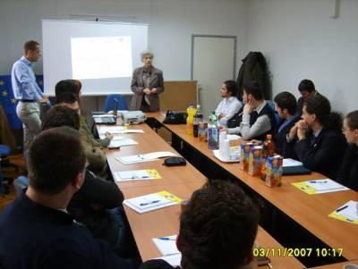 | 1. GOLD Affinity group organized workshop - training in Communication and Negotiation Skills on November 3 and 4, and introductory lecture on Benefits of IEEE membership on November 2.  2. IEEE student branches at Uni Sarajevo, Uni East Sarajevo, Uni Tuzla and Uni Banja Luka, and Uni Mostar within ISBIR (IEEE Student Branches Industry Relations) program, and with the support of IEEE BH Section organized workshop March 6 - 8, 2008, where main entrepreneurs from Bosnia and Herzegovina presented employment possibilities.
3. Joint Computing Intelligence/Computer Society Chapter organized lecture with title Role of Accreditation in Quality Assurance of High Education Institutions, especially targeting accreditation for Computer Science programs.  4. Our honourable guest, Maryam Al Thani, the WIE Coordinator for Region 8, 16 October 2007 had a lecture at the Faculty of Electrical Engineering in Sarajevo. |  | 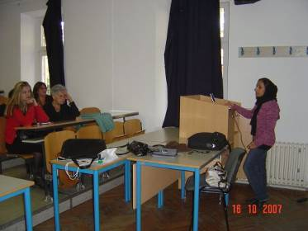

Non -Technical meetings and Activities: (6 meetings)

The meetings were mainly organized by our GOLD Affinity group members but we would like to emphasize the importance of the following two:

1. The first WIE event in Bosnia and Herzegovina, Maryam Al Thani, the WIE Coordinator for Region 8, 16-17 October 2007 visit at the Faculty of Electrical Engineering in Sarajevo. The purpose of the visit was to promote WIE membership and to help us with organizing our newly established WIE group. |  | 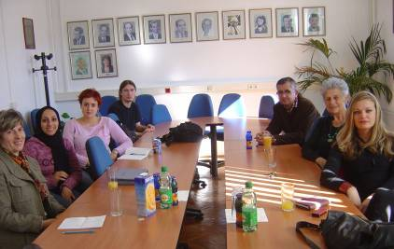
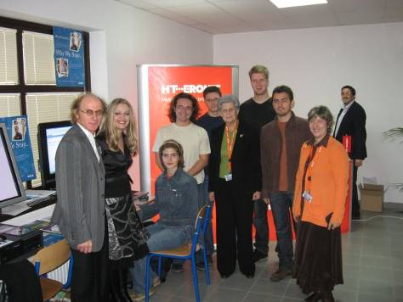 | 2. IEEE Bosnia and Herzegovina Section jointly with University of Sarajevo Student Branch was guest at the ICAT 2007 - XXI International Symposium on Information, Communication and Automation Technologies 2007 promoting IEEE membership benefits.

Administrative meetings: (14)
21 November 2007; 11 December 2007 GOLD Committee meeting; 23 November, 2007; 4 December, 2007; 6 and 17 March 2008 – Section Executive Committee meetings.
IEEE BH Section will host IEEE Conference ISSPIT 2008 on December 16 -19 2008, and in the course of preparation for the event, Committee members are meeting regularly to discuss ongoing activities – web page preparation, hotel arrangements, conference visibility, promoting ISSPIT in the region: 14 January 2008; 11, 15, 18, and 29 February 2008; 4 and 12 March 2008; 2 April 2008.

