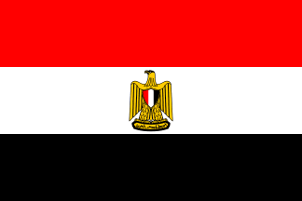
IEEE EGYPT Section Report - April 2008

- Officers: Election Date: 30 Jan 2008 Term End Date: 31 Dec 2010
Chair | Mohamed I Younis | myounis@ieee.org
Vice Chair | Samir I Shaheen | sshaheen@ieee.org
Chair, Alexandria Subsection | Said E El-Khamy | elkhamy@ieee.org
Secretary | Abdel-R H El-Sawy | aelsawy@seegypt.com
Treasurer | Samir I Shaheen | sshaheen@ieee.org
Secretary/Treasurer | Mohamed M Khairy | mkhairy@gmail.com
Membership Development | Ahmed F Seddik | afarag@mcit.gov.eg
Professional Activities | Samia A Mashali | samia@eri.sci.eg
Student Activities | Nevin M Darwish | ndarwish@ieee.org
Student Representative | Mohamed A Shahat | mols.eg@ieee.org
GOLD | Nahel M Amirah | nahel@ieee.org
- Chapter Chairs: Election Date: 30 Jan 2008 Term End Date: 31 Dec 2010
AP Chapter Chair | Hadia Elhenawy | helhennawy@ieee.org
CAS Chapter Chair | Mohamed A ABOUL-DAHAB | mdahab@aast.edu
CS Chapter Chair | Mohamed I Younis | m_younis@ieee.org
ES Chapter Chair | Sohier M Fakhr | sohierfakr@yahoo.com
IA Chapter Chair | Mohamed M S Mansour | mmsmansour@ieee.org
IES Chapter | Ahmad M A Mahmoud | aasaadm@Menanet.net
MTT Chapter Chair | Essam Abdel H Hashish | essamhh@ieee.org
PELS Chapter Chair | El-Sayed M TAG EL DIN | stageldin@yahoo.com
PES Chapter Chair | Soliman M El-Debeiky | seldebeiky@yahoo.com
SP Signal Processing | Salwa H. Elramly | sramlye@netscape.net
- Membership:
Grade | Count of Members March 2008 | Count of Members March 2007
Fellow | 1 | 1
Life Fellow | 3 | 2
Senior Member | 86 | 76
Life Senior | 11 | 9
Member | 245 | 244
Life Member | 1 | 1
Student Member (Graduate) | 639 (175) | 460
Associate Member | 18 | 12
Affiliate | 19 | 11
Total | 1023 | 816

- Meetings:
  - Section Administrative Meeting took place every month.
  - Society Chapters are encouraged to hold presentations regularly so that at least one Technical Meetings is held bimonthly.
  - Annual Student Branch meeting “Egyptian Student Branch Meeting, ESBM”.
  - Annual Social Meeting and Dinner for all IEEE Volunteers and Supporters in Egypt (Egypt Section Support this meeting last year with 30K LE)
- Student Branches:
  - 15 active student Branches
  - 4 under construction student Branches
- Collaboration with National Society:
The Section continues to collaborate actively with:
  - Ministry of Communications & Information Technology
  - Ministry of Higher Education and the State for Scientific Research
  - Ministry of Trade and Industry
  - Ministry of State for Administrative Development
  - Information Technology Industry Development Agency (ITIDA)
  - The Library of Alexandria (Biblotica Alexandrina)

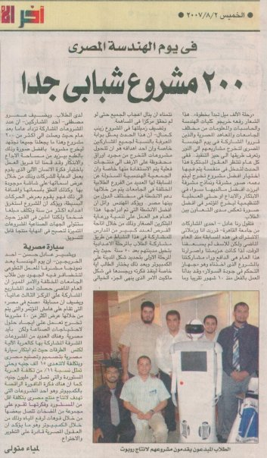
- Activities in the near future:
- Increase financial support for students and student branches.
- Campaigns for new members during local conferences and expiation.
- Calling and support for Senior and Fellow Membership degrees.
- Egyptian Engineering Day EED’2008 next July.
- More Announce IEEE in local newspapers and TV.
IEEE and EED
in widely known Egyptian News paper

- Best practices:
- EED
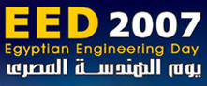
Higher Education and Scientific Research Dr. Hani Helal and Minister of State for Administrative Development Dr. Ahmed Darwish inaugurated the 6th Egyptian Engineering Day (EED) at the Cairo International Conference Centre on July 29, 2007.
In 2007, the slogan of the Egyptian Engineering Day is "Your Next Step" which emphasizes the idea of entrepreneurship and staring up your own business. It is an invitation for all who believe they can make a difference in our community and join forces towards our goals
The Egyptian Engineering Day is the annual nexus for engineers in Egypt. It is being organized by the IEEE Egypt GOLD for the 6th year in a row. This event is an opportunity for all engineering professionals to meet new associates in the field, share ideas, collaborate on projects and learn something new.
EED 2007 is being held with a focus on small and medium enterprises, entrepreneurial development and start-up companies in the engineering field. It is time for young engineers to take control of their career, lead the industry, and market dreams.
Graduation projects exhibition, projects exhibition is a chance to get exposure for academic projects in the industry. This is an excellent way to promote new gradates students skills and give an edge in the job market, or maybe even develop a project into a practical product or service in the real world. Many projects by young engineering and IT students from Egyptian universities nationwide are due to show case their graduation projects during the two-day event. Ten winning projects will be picked up for many awards including: MICT Awards, Egypt Section Award, I2P-Egypt Award.
EED2007 site: www.ieeegoldegypt.org
EED 2007 Opening Vedio: http://www.youtube.com/watch?v=g-Yh-gWoq6s
EED 2007 Volunteers Vedio: http://www.youtube.com/watch?v=IjJoHu_RS9g

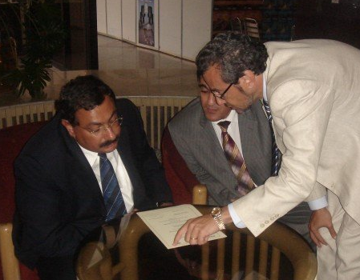  Minister of Communications and Information Technology Dr. Tarek Kamel signed an award certificate with Prof. Muhammad Abo Eldahab and Prof. Ahmed Elshebeny from EED Orgnizing Commettee | 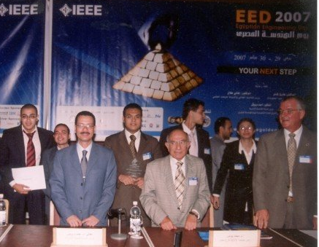  (On the left) Minister of State for Administrative Development Dr. Ahmed Darwish, Dr. M. Younis, Egypt Section Chair in the center and Key note speaker: Eng. Mohamed Omaran - CEO ITIDA.
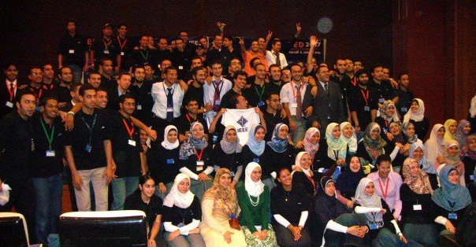
EED 2007 Volunteers

- MIE

In the 1st Made-In-Egypt (MIE) Competition that was held in the 2005-2006 academic year there was about 40 projects, 12 sponsors, 7 Engineering Fields over 9 universities. Since then the Competition becomes one of the main Industry University linkage' activity in Egypt. The IEEE GOLD Egypt started Made-In-Egypt (MIE) Competition with a plan to transfer the experience to all so that each country should have its local competition.
"Made In Egypt" (MIE) is a competition that aims to bridge the gap between university researchers, professionals and business community towards a better impact on the industrial and economic development of Egypt and creating opportunities to enrich national industry and production by engineering students, researchers and professionals. The competition also aims at orienting Research and Development activities in Egyptian universities to tackle real needs and problems, foster business-oriented results, and develop prototypes for new products with the signature "Made In Egypt".
MIE 2007-2008
Number of projects | 118
Number of Universities | 17
Winners will receive financial support prizes and some selected Winning projects will receive commercialization efforts including support to polish their Business Plan, Marketing through Investment programs and visibility with investment entities.
Creating a sustainable program such as Made-In-Egypt (MIE) Competition is a rich experience requires establishing a vision, identifying the skills needed, determining incentives for the stakeholders, marshalling the resources to create the program, and developing a comprehensive action plan for implementation.
- Topics to be discussed in Malta:
- Promote the reduction of member Fees for member in the Egyptian Universities sector since all universities have now full access to IEEE publication.
- More benefits are needed to members in Region 8, and in particular to the students and young engineers. IEEE Members in Egypt feel that they are not getting similar benefits or worth their membership fees.
- More support to the WIE, and Student Branches is needed.
- Consider the special circumstances of student members residing in Egypt and provide them with reduced membership fees and value-added services suitable to their situation.
- Egypt section likes to share its winning programs like: EED, MIE, Industry University Link … est. with all sections in Region-8 and looking to have support to higher its young volunteers to join R8 committees.
- Effective participation in next Sections Congress.

