IEEE Egypt/Alexandria Subsection Report April 2008

Officers: Name Affilation e-mail Election Date: Term End Date:

- Chair: Said E El-Khamy, Alex. Univ., elkhamy@ieee.org, 6/2006, 6/2008
- Vice Chair: Mohamed N El-Deriny, Alex. Univ., elderini@ieee.org, 6/2006, 6/2008
- Secretary: Nadder Hamdy, AAST, nhamdy@ieee.org, 6/2006, 6/2008
- Treasurer: Mohamed E Khedr, AAST, khedr@aast.edu , 6/2006, 6/2008
- Membership Development: Mohamed R Rizk, Alex. Univ., mrmrizk@ieee.org, 6/2006, 6/2008
- Professional Activities: Ahmed A Lotfy AAST alotfy@aast.edu , 6/2006, 6/2008
- Student Activities: Mohamed I El‐Banna Alex. Univ. mbanna@ieee.org, 6/2006, 6/2008
- Educational Activities : El‐Sayed A El‐Badawy AIET sbadawy@hotmail.com, 6/2006, 6/2008
- Awards : Ahmed A Hossam‐Eldin Alex. Univ. hossamudn@yahoo.com , 6/2006, 6/2008
- Nominations & Appointments: Roshdy A AbdelRassoul AAST roshdy@ieee.org, 6/2006, 6/2008
- Webmaster: Hossam H Shalaby Alex. Univ. shalaby@ieee.org, 6/2006, 6/2008
- AAST SB Counselor: Roshdy A AbdelRassoul AAST roshdy@ieee.org , 6/2006, 6/2008
- Alex. Univ. SB Counselor: Essam A Sourour Alex. Univ. sourour@ieee.org , 6/2006, 6/2008
- AIET SB Counselor : Mohamed S Khalil AIET msekhalil@hotmail.com, 6/2006, 6/2008
- WIE: Hoda ElMikaty Bib. Alex. hoda.elmikaty@bibalex.org, 6/2006, 6/2008

Membership:

Members: 166
Associated Members: 18
Graduate Students: 29
Students: 503
F | LF | LS | M | SM | AM | GS | St
1 | 1 | 1 | 127 | 18 | 18 | 29 | 503
Details:

Main Activities:
- Scientific and professional meetings
- Social Meetings
- Supporting and sharing the 4 Student branches Activities
- Supporting and Sharing in WIE Activities
- Supporting Egypt/Gold Activities in Alexandria
- Membership Development of Students and Members
- Organizing the Best Paper Award Contest in cooperation with Alex. Univ. Student Branch

Alexandria Student Branches:
- Alexandria University Student Branch
- Arab Academy of Science & Technology (AAST) Student Branch
- Alexandria Institute of Engineering and Technology (AIET) Student Branch
- Aboukeer Institute for Computers (Under Construction)

Meetings:
10 Technical Meetings have been reported in 2007:
Prof. Abbas Omar, is an IEEE Fellow, Germany
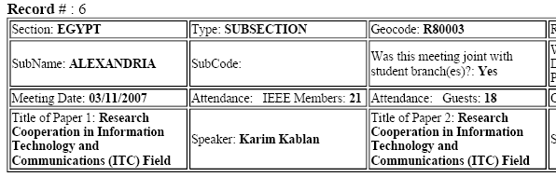
(Prof. Karim Kablan is with American University, Beirut, Lebanon.)
(Prof. Louis Beex is with Virginia Tech, USA )
( Eng. Makarem Huessien, is with INTEL , Oregon, USA)
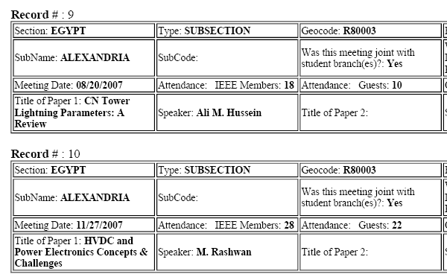

(Prof. M Rashwan is a Fellow of IEEE, TransGrid Solutions (TGS), Canda. )
(Prof. Ali M. Hussien is with Ryerson University and Univ. of Toronto, Canada.)

Collaboration with National Society:
The Section continues to collaborate actively with Scientific and Educational Institutes:
The Library of Alexandria (Biblotica Alexandrina)
Alexandria University
Arab Academy for Science and Technology (AAST)
Alexandria Institute for Engineering and technology (AIET)
Higher Institute for Computers and information Technology (Aboukeer Institute)

Supportring Student Branches Activities:

- Alexandria University Student Branch:

i- Courses:
Basic Electronics and Embedded System Design using ATMEL
Matlab (Level I & II)
Electronic CAD Tools
ii- Electronics Fair: An annual exhibition of projects
iii- Events:
Technical:
Topics of interest for EE students of both specialties
AlexScope series,
Come to Know series
S-PACs:
Main goal is preparing students for the professional world
Most Recent: IEEE Introductory Event 2007
Joint Events (with Local Section):
EED (Egyptian Engineering Day)
iv- - Study Groups
Web Design: initiated our first team of web developers
Graphic Design
v- Field Trips
Industrial:
Bahgat group
SUMED
Fairs and Exhibitions:
EED (Egyptian Engineering Day)
Electrix
vi- Contests
Student Paper Contest:
Electronics Fair Contest:
Matlab Contest

2. AAST Student Branch:

Annual Events:
Leading your career, leading your society - Since 2004
Robo-Adventure- A robotics competition
Exclusive Events:
CarTronics
Map your mind

For more details: Check website: www.ieee-aast.org

3. AIET Student Branch:

- Courses:
PhotoShop course
Basic Electronics training course
The 8051 Microcontroller training course
Why Linux seminar
AVR Microcontroller training course
- Basic Electronics training course projects fair
- Field Trips
EED (Egyptian Engineering Day) trip on July, 30
Electrix fair trip
- Discover the benefits of IEEE seminar
- Join IEEE seminar
- The recycling campaign held by WIE chapter
=================================================================

