IEEE Switzerland Section Report April 2008

Officers: Election Date: 2007 Term End Date: 2008
- Chair: Dr. Urs Röthlisberger
- Vice Chair Dr. Patricia Sagmeister
- SecretaryTreasurer: Dr. Volker Koch
- Membership Dev. Dr. Predrag Habas
- Past Chairman Karl Schenk
Membership:
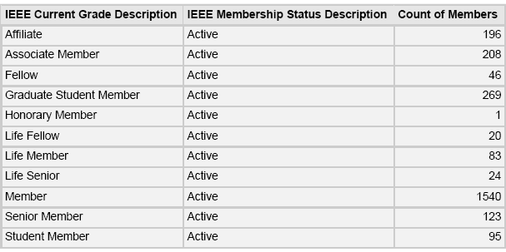

Meetings:
12 October 2007: IEEE Netw. Series: "Qualcomm on wireless communication"
17 October 2007: ISCAS 2007, Session II, Inst. of Microelectronics, Windisch
23 October 2007: AP/MTT/EMC Chapter Distinguished Lecturer Prof. W. Hoefer
24 October 2007: ISCAS 2007 Talk Re-Runs, Session III, Inst.ME Windisch
31 October 2007: AP/MTT/EMC Chapter Distinguished Lecturer Prof. W. Hoefer
22 January 2008: Electromagnetic hypersensitive subpopulations ETHZ.
8 February 2008, General Assembly 2008, IBM Research Lab, Rüschlikon (ZH)
10 March 2008, Council Chamber of CERN, Presentation by Dr. Robert Cailliau: Some highlights from the development of the Web from 1989 to now
11 March 2008, MOS Compact Modeling for Future Generation CMOS. EPFL

Collaboration with National Society:
The Section continues to collaborate actively with Electrosuisse/ITG.

Activities in the near future:
Campaign for new members, Senior- and Fellow-Membership degrees.
New Student Chapter at EPFL

Best practices:
Increasing the number of EXCOM members from industry.
Improved web based services for section members.

Topics to be discussed in Malta:
Legal status of sections

