IEEE Ukraine Section Report April 2008

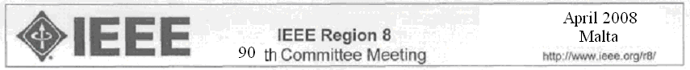

Officers: Election Date: 10.09.2007 Term End Date: 10.09.2009
Chair: Yandulsky Oleksandr Memb.# 2033595
Vice Chair: Teriaiev Vitalii Memb,# 90249725
Treasurer: Volodarsky Eugeniy Memb,# 2034148
Responsible for:
Membership development: Shostak Volodymyr Memb.# 4149001
Industry Relations: Bondarenko Yuriy Memb.# 2033512
Student Branch: Yuri Golovach Memb.# 85014688

Chapter Chairs:

- AP03/ED15/MTT17/CPMT21/SSC37 (code 08187,West-Ukrainian Chapter, Lviv – city) – Isayev Igor;
- AP03/NPS05/AES10/ED15/GRS29/MTT17 (code 08199,Kharkiv – city) – Nosich Alexander, Memb.# 04370094;
- SP01/AP03/C16/EMC27 (code 08364, Kharkiv-city) – Kolchigin Mykola, Memb.# 40329823;
- LEO36 (code 08342, Kharkiv-city) - Sukhoivanov Igor , Memb.# 40064632;
- CAS04/IM09/C16/MTT17 (code 08302, Vinnitsa-city), - Doobovoi Volodymyr, Memb.# 41547373;
- IE13/PE31/PEL35 (code 08233, Kyiv-city), - Yandulsky Oleksandr , Memb.# 2033595;
- ED01/MTT17/COM19/CPMT21/SSC37 (code 08219, Kyiv-city), – Poplavko Yuriy, Memb.# 40163779;
- ED/MTT (code 08242, Georgian Chapter, Tbilissy – city), – Kakulia David.
Membership: IEEE Section Ukraine at the end 2007 included in total 287 members (including 3 Fellows, 53 Senior Members and 68 Student Members). But this year the number of active members is less (approximately 200 members) due to internal problems of payment for the membership and periodical issues.
Meetings: 56 technical meetings and 5 international conferences have been held from October 2007 to March 2008.
Collaboration with National Society: The section continues to collaborate actively with the Ukrainian Union of Power Engineering Specialists and the Ukrainian Union of Engineers.
Problems and Activities in the near future:
- Problems with reception by the Ukrainian members IEEE of subscription editions proceed.
- In our opinion, existing procedure of preparation of financial reports is very complicated and not clear as for officers of Section and for our bank employees.
- The future activity this year will be directed on the decision of problems on service of our members.
Topics to be discussed in Malta:
The creation of the independent Georgian Section of IEEE instead of the Georgian Chapter of the Section Ukraine. The political events affect the normal communication of Section officers and Georgian Chapter.

Oleksandr Yandulsky, 1 April, 2008

