ISBIR Accomplishment Report

- Corporate Relations:
- Microsoft
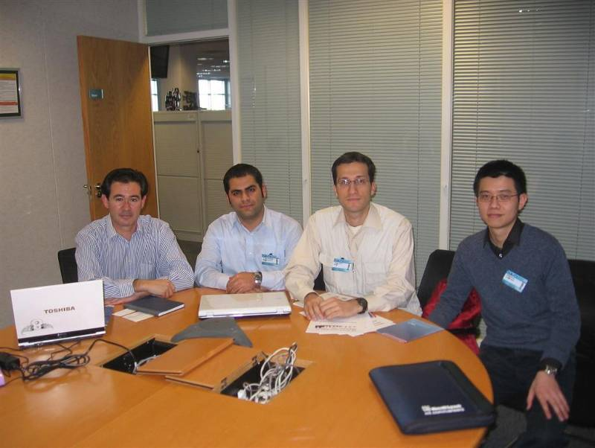
  - Contact: Mauricio Ulargui | Academic Director | Microsoft Corp. | +44 781 771 6850 | mulargui@microsoft.com
  - Background Info:
- We talked with Eminay Yurtseven from MS Academic to provide additional membership advantages for IEEE Student Membership. Now, we have launched a pilot program, giving the access to IEEE Student Members, all the licensed products of Microsoft for their student membership period. This benefits are planned to be available to all IEEE student members in EMEA region (namely, R8) if the pilot implementation reaches success.
  - Deliverables agreed on:
- Minimum support to R8 SBC Gold Sponsorship will probably be £ 6.000 = $ 12.000
- Free / Small amount Microsoft products to IEEE Student Members to be provided (Vista , Office , SQL Server, Visual Studio and other development tools. Approximate reduction in ammount of these softwares are nearly 800$ per person. It will be provided for 1000 copies which are worth $ 800.000 in total.)
- Microsoft has about 1560 global partners from all over the world.These companies are mostly from the IT sector. Microsoft’s S2B Programme is aiming to connect students with these companies.
- S2B & IEEE Student Branches Partnership – Internship & Job Opportunities from Microsoft partner companies to IEEE Student & GOLD members. This way we are aiming to support our student members for finding Internships and Part-Time or Project based job opportunities.
- Microsoft also has a programme called Microsoft Student Partners. Every year they choose students for this programme. They support these students and give them many oppotunities. We are aiming to have an impact on the MSP elections so some MSPs will be chosen from IEEE Student Members.
- Microsoft will give Xbox development kits and other technical equipment worthing more than $ 50.000 for game & animation technologies.
- Another Project that we will be in partnership with Microsoft is .Net Clubs. With this Project students will have a development office at their university and Microsoft will support them for their innovative projects. We will be the coordinator of this Project at the universities. By this way IEEE Student Members will have an important opportunity for developing their technical projects. IEEE Student Branches will also encourage students for setting up their startup companies with the help of .NET Clubs Project.
  - Work to be done on ISBIR Side:
- Specifying the pilot countries and universities
- Set communication rapidly between determined universities' student branch chairs and inform them about these partnerships
- Informing all related IEEE officers & staff about these partnerships and asking for their full support.
- IEEE Student Branches will propose 10 MSP applicant to MS.
  - Work to be done on Company Side:
- Individual meetings at country level to define working plan
- How to promote IEEE brand in the Microsoft portal to all MS users and partners?
- .NET clubs pilot destinations with student branches
- Free/small amount software through student branches
- Empower program for entrepeneur IEEE Student & GOLD members interested on start-ups
- New internship Positions from Microsoft S2B partners:

AVANADE Microsoft Dynamics AX  Milano / Italy | Marketplace  Roma / Italy | Technology Portal  Roma / Italy
Sviluppo applicazioni e progetti .NET  Milano / Italy | Applicazioni .NET Crm/offerte/analisi dati  Milano / Italy | AVANADE ACADEMY  Milano / Italy
HYPERCRM Mobile  Fermo / Italy | Migrazione .Net  Milano / Italy | Sviluppo Moduli Applicazione Web Risorse Umane  Rho / Italy
My Share - MS Sharepoint 2007 MOSS  Milano / Italy | Object Model Development  Redmond / Philippines | Object Model Development  Redmond / Croatia
.Net Developer  Istanbul / Turkey | Object Model Development  Istanbul / Turkey | Cruscotto per sistema ERP  Treviso / Italy
.Net Developer  Redmond / Philippines | .Net Developer  Redmond / Croatia
  - Cooperation Status Report (till March 2008)
- 4 Teleconferences have been held between Microsoft S2B Responsible & ISBIR Team
- Pilot Regions for S2B Cooperation have been determined: Turkey, Germany, India, UK and especially Balkans (Bosnia and Herzegovina,Crotia,Macedonia,Romania)
- ISBIR Local Student Contacts have been informed about the local arrangements to be done for S2B Cooperation
- Announcements of Microsoft Student Partner Program will be put into ISBIR Portal for the benefit of IEEE student members.
- Licenced Products of Microsoft (MSDN AA) will be provided for IEEE Student Members free of charge
- Microsoft software development projects will be put into implementation in the near future by IEEE Student members as graduation projects.
- IEEE R8 SBC Logo and banner will be put into Microsoft S2B program website www.s2bprogram.com

- Google
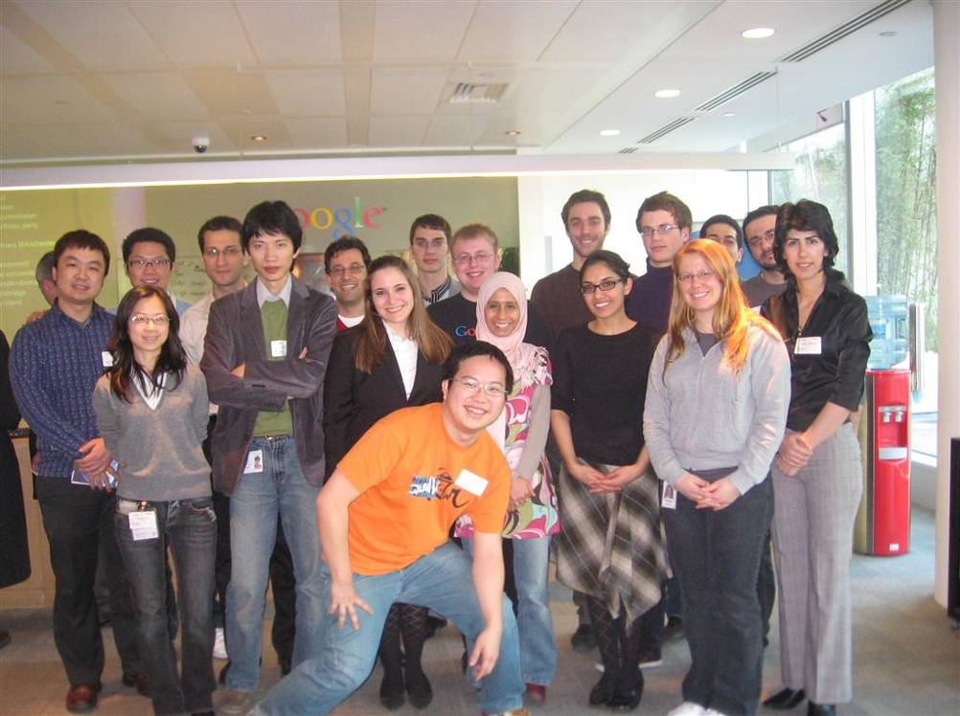
  - Contact: Vicky Greaves University Programmes Specialist Google UK Belgrave House 76 Buckingham Palace Road London SW1W 9TQ
T: 020 7881 4659 E: vgreaves@google.com
  - Background Info:
- We have maintained the participation and support of Google to many IEEE events like, IEEE UKRI Student Congress, SBC 2008, Campus Development Days 2007. Now, we are planning career events in different destinations with Google in order to reach target students with the help of SBs. During Campus Development Days, hundreds of CVs were collected in order to give them to Google Recruitment Officers. We also made collaboration with Google in order to inform students about Anita Borg Scholarship Program just for the participation of female engineering students. Many IEEE SB volunteers apply for this program. We are now contacting with Google University Programs Coordinator and planning future collaborations like Android Challenge.
  - Deliverables agreed on:
- Maximum support to R8 SBC Gold Sponsorship could be £ 6.000 = $ 12.000
- Possibility of involvement to IEEE Xtreme 24 Hour Programming Challenge
- Announcement of Android Developer Challenge, to related IEEE & CS members and entities which will provide $10 million in awards for great mobile apps built on the Android platform.
- Continue Google Open House Events for IEEE SBs (as for Imperial & York IEEE SBs)

  - Work to be done on ISBIR Side:
- Talk with related IEEE responsibles for the involvement of a company to Xtreme Challenge (like having a banner, announcement, questions...etc)
- Talk with related IEEE responsibles in order to agree on what Google requires for GOLD sponsorship package which could include one tech-talk presentation from Google. We will learn for the possibility of collecting CVs from participating student branches and contacts of congress participants.
  - Work to be done on Company Side:
- Determination of announcement alternatives requested for Android Challenge (like web site banners, e-mailings, posters and informative seminars in universities or science parks to interested students and entrepreneurs)

- Yahoo
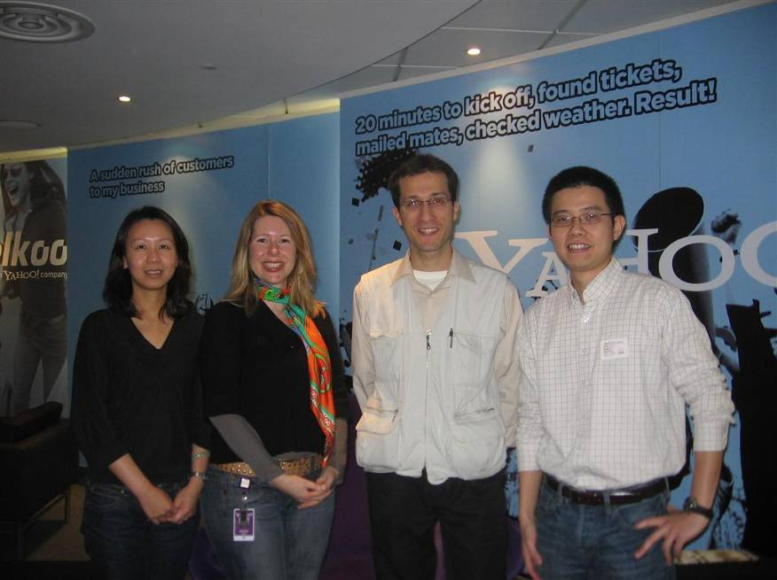
  - Contact: Sophie Major <smajor@yahoo-inc.com>; Zhengxi Danard <zdanard@yahoo-inc.com> Yahoo! Europe Ltd 125 Shaftesbury Ave, London, WC2H 8AD, United Kingdom Tel: +44 20 7131 1000
  - Deliverables agreed on:
- Agree on ISBIR support for placing IEEE student members to related Yahoo Internship Positions. Details of these positions will be provided as soon as possible
- Agree on Yahoo Support & Participation to IEEE Student Branch events in Eastern Europe at 2008 first and second quarter

  - Work to be done on ISBIR Side:
- Calendar for the events of IEEE SBs especially from in Eastern Europe

  - Work to be done on Company Side:
- Who they can send for career events of IEEE Student Branches as a speaker?
- Internship Position Details for Yahoo offices in different destinations

- Intel
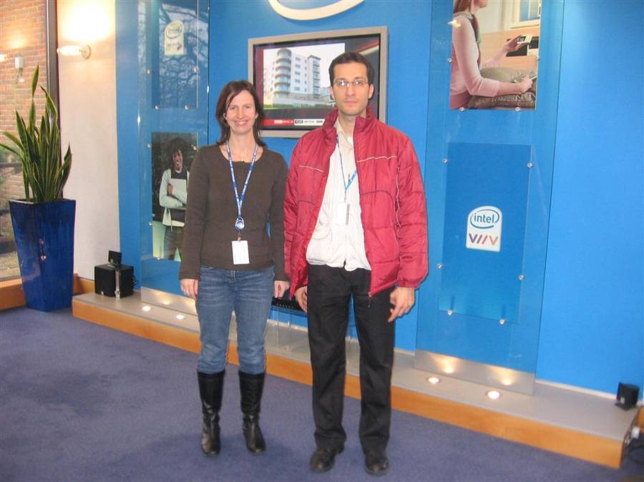
  - Contact: Bernd Holthaus EMEA Recruitment & College Team Lead Intel GmbH Dornacher Strasse 1 D- 85622 Feldkirchen/München
tel.: +49-89-99143-0 fax: +49-89-9914-3921 email: bernd.holthaus@intel.com
Stephanie Lee UK & Poland College Program Manager EMEA HR Staffing
UK3 2nd Floor Pole C14 * Tel 01793 403031 *INET 281 - 3031
* Stephanie.lee@intel.com
  - Deliverables agreed on:
- Probable financial support to R8 SBC 2008 as Silver Sponsorship (£ 3.000 = $ 6.000)
- Agree on ISBIR support for placing IEEE student members to related Intel Internship Positions.
- Possibility to post Intel job offers in IEEE Job Site
- Technical and Equipment Support for the fields of simulation, game development ($ 66.000 worthy technical equipments will be provided for research on game technologies)
- 3 servers already donated to universities for IEEE SB projects and laboratories (5 more on its way for 2008)
  - Work to be done on ISBIR Side:
- Find the right person from IEEE student & GOLD members for the urgent 5 internship positions of Intel Germany, Munih
- Intern Technical Prod. Support
Location: Munich, Germany/#546807
- Internship Intel Inside
Location: Munich, Germany/#543615
- Marketing Placement
Location: Munich, Germany/#544467
- Student – Retail Marketing
Location: Munich, Germany/#543385
- Technical Sales Internship
Location: Munich, Germany/#546572

24 Internship, 2 RCG (Recently College Graduate) Positions available to be applied through ISBIR Web Portal

Company | Duration |  | Title |  | Code |  | Key Skills
Intel Germany | 12 months |  | Human Resources |  | 541360 |  | English & German fluency  legal background, interest in HR & German legal system
Intel Germany | 6 or 12 months |  | Intel Inside Program |  | 543615 |  | English speaking  Marketing background  attention to detail  Strong comm skills
Intel Germany | 6 months |  | Technical Sales |  | 546572 |  | Combination of technical skills & sales  English skills a must, German skills a plus  Computer Science or Informatiks/Marketing background
Intel Germany | 6 months |  | Market Analyst |  | 531699 |  | English or German skills  Excellent Excel or SPSS knowledge  Marketing/analysis background  Very strong attention to detail
Intel Germany | 12 months |  | Consumer Marketing |  | 547815 |  | English + EU language a plus  Marketing background  Consumer focus  Advanced Excel & MS office knowledge
Intel Germany | 12 months |  | Retail Marketing |  | 543385 |  | English + EU language a plus  Marketing background  Communication skills  Advanced Excel & MS office knowledge
Intel Germany | 6 or 12 months |  | Tech Prod. Support |  | 546807 |  | Combination of technical skills & PR  PR or tech background with strong communication focus  English a must, German a plus  functioning knowledge of PCs, their components & ability to relate this information with customers in a PR focus
Intel Germany | 12 months |  | Intel Inside Program |  | 546811 |  | English a must, + another EU language preferred  Excellent Excel & MS office skills  Communication & customer focus  Marketing background
Intel Germany | 12 months |  | Strategic Engagement |  | 546155 |  | English & German skills  Customer & comm focus  Knowledge about digital media & software enabling services  Marketing /Computer Sci/PR background
Intel Germany | 12 months |  | Business Development |  | 547420 |  | English a must, German a plus  Heavy communication/influencing focus  Attention to detail & professional attitude  MS office & project management skills
Intel Germany | 12 months |  | Sales & Marketing (2 positions) |  | 547265  546569 |  | English a must in both positions, German a must for one of these positions  Marketing background  Excellent Excel & MS office applications  Comm focused & Strong attention to detail
Intel Germany | 12 months |  | Finance Support |  | 546567 |  | English language skills a must  High proficiency in Excel & MS office  Strong attention to detail  Finance/Marketing or related background
Intel Germany | 12 months |  | Internet Marketing |  | 547810 |  | English Skills + another EU langauge, if possible  Interest in Internet/www  Marketing background
Intel Germany | 12 months |  | WW Sponsorship Marketing |  | 547817 |  | English skills  Communication & enthusiasm  Marketing background  Strong attention to detail
Intel Germany | 12 months |  | Public Relations (upcoming position) |  | n/a |  | German & English skills  Project management  Marketing background
Intel UK |  | 6 or 12 months |  | Application Engineering |  | 540483 |  | We are looking for excellent students enrolled in bachelor's, master's, or doctoral programs in engineering, science, and business-related fields.  Excellent communication and interpersonal skills, former internship and work experience, demonstrated leadership ability, and team-building skills are all advantages. Versatility and the flexibility to adapt to new situations are essential.
Intel UK |  | 6 or 12 months |  | Customer Business Operations |  | 540351
Intel UK |  | 6 or 12 months |  | Engineering |  | 540487
Intel UK |  | 6 or 12 months |  | Engineering Business Analyst |  | 540488
Intel UK |  | 6 or 12 months |  | Finance |  | 540235
Intel UK |  | 6 or 12 months |  | IT Business |  | 540065
Intel UK |  | 6 or 12 months |  | IT Technical |  | 540067
Intel UK |  | 6 or 12 months |  | Logistics |  | 540360
Intel UK |  | 6 or 12 months |  | EMEA Finance Analyst |  | 547357
Intel UK |  | 6 or 12 months |  | RF System Architect |  | 541648
Work to be done on Company Side:
- Work Descriptions and Priority Regions for Intel Internship Positions will be provided with more concrete details. The current details about priority regions and qualifications are stated as below:
  - - Germany, UK, Spain, Nordics, Ireland, Russia, Turkey, Middle East, Africa
- Computer Sciences: Programming under C / C##, etc. / Electrical Engineering: Analog / Digital Design, etc. Further Job description will follow

- Vodafone

  - Contact: Dr. Nigel jefferies Technical Manager R&D Berkshire / England nigel.jefferies@vodafone.com (44) 7768 670 282

  - Background Info:
- We have been contacting with Vodafone executives for ten months. We have the chance to talk with R&D department executives and Vodafone Int. CEO Arun Sarin during IEEE International Conference on Communications 2007. We are now offering them ISBIR Corporate Partnership Packages to make the collaboration more concrete. Besides, we are now at the point of collaborating with them about the recruitment process for the 2008 internship positions of Vodafone. Thus, we can maintain career opportunities to talent IEEE student members working on mobile communications.
  - Deliverables agreed on:
- Probable financial support to R8 SBC 2008.
- Agree on ISBIR support for placing IEEE student members to Vodafone Internship Positions.
  - Work to be done on ISBIR Side:
- Search for the possibilities in reaching IEEE Communications Society members
  - Work to be done on Company Side:
- Contact with Vodafone HR for possible participation & support to R8 SBC 2008.
- R&D and HR departments decide on which positions could be posted on IEEE Job Site
- Work Descriptions and Priority Regions for Vodafone Internship Positions worldwide will be provided with more concrete details

- Lockheed
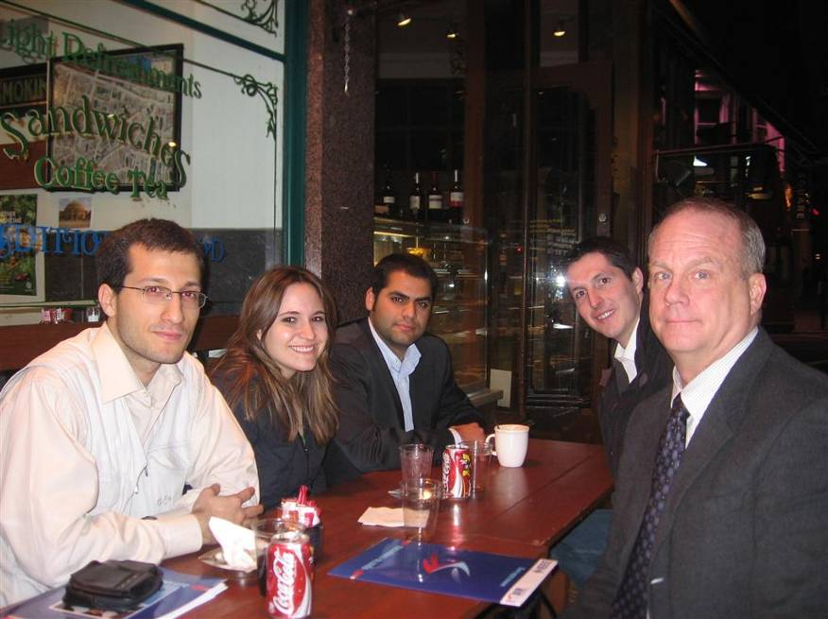
  - Contact: Charles (Chuck) Gill Lockheed Martin Systems Engineer charles.w.gill@lmco.com +44 7792 332 930

  - Background Info:
- This company was one of the main sponsors of UK Student Congress. They really want to work with students and they want to make more joint activities with IEEE Student Branches.
  - Deliverables agreed on:
- Minimum support to R8 SBC Silver Sponsorship will be £ 3.000 = $ 6.000
- Possible participation to IEEE Job Fair in London organized by IEEE Job Site

  - Work to be done on ISBIR Side:
- Send them the details of services to be provided within each sponsorship package of SBC 2008.

  - Work to be done on Company Side:
- Informing us about the exact sponsorship package they decide, and details from HR department to be provided.

7. Phoenix Contact: We contacted with the manager of Phoenix Contact Xplore Contest, Klaus Hanksbach and they wanted IEEE SBs to participate to this contest and we took their request and one of IEEE SBs participated to this contest and qualify for final stage to be supported with 3000 Euro technical project equipment. We have taken the promise of designing an automation lab for one of IEEE SBs.
8. Turkcell: A new mobile application development platform giving students the opportunity of implementing their ideas in this area called Univercell has recently launched and there are 5 seminars in different destinations to teach the practical approach. After that, all IEEE SBs involved has a quota for SMS, MMS, GPRS, 3G technologies implementation. They are also supporting IEEE SBs whose project groups are making technical projects for disabled & needy people. They will also provide internship more than 10 IEEE student members for this summer term.
9. Arcelik & Beko: These companies are top household goods producers of Europe. They have provided 10 internship positions for each which will be available via ISBIR Portal next weeks.
10. Ericsson: We make a collaboration with Ericsson in order to announce their Education & Scholarship Program called “Ericsson Crea Academy” and many IEEE student members had applied for this program.

Our meetings with Siemens, BMW, Barclays continues in order to achieve concrete outcomes in terms of cooperation.

- ISBIR Portal:

- All online meetings have been held via ISBIR Online Meeting System. These include:
  - ISBIR Task Force Meetings
  - ISBIR Local Contacts meeting from different regions of IEEE (like India, Balkans, Germany, Turkey, UK, China, New Zealand, Gulf Region..)
  - Meetings for determining cooperation details with companies (like Microsoft, Google...)
  - Webinars about career, engineering and latest technology for IEEE Volunteers are on the way
  - In all the online meetings, presentations, chat board, visual communication, white board, instant file upload are available.
- CV Submission System. What you can do basicly are:
  - Update your CV details anytime
  - Upload your CV, cover letter or other personal documents for the intention of companies
  - Give detailed info about your Education, Language, Work Experience, Organizations Involved, Awards Gained
  - Select the internship offers available through ISBIR Portal
  - CVs can be categorized, browsable and searchable by company HR responsibles
- Internship Position Posting System
- News Posting System about recent improvements
- Profile Pages for individuals and organizations are on the way

