

Sections Congress 2008, Québec City, Canada, 19-22 September 2008

Theme: “Celebrating Volunteer Achievements Worldwide”.

Information update, 10 March 2008 from
Prof. Tony Davies (R8 Sections Congress Coordinator)

This is a minor update to documents dated 12 January 2008 and 23 February 2008 which were on the R8 website

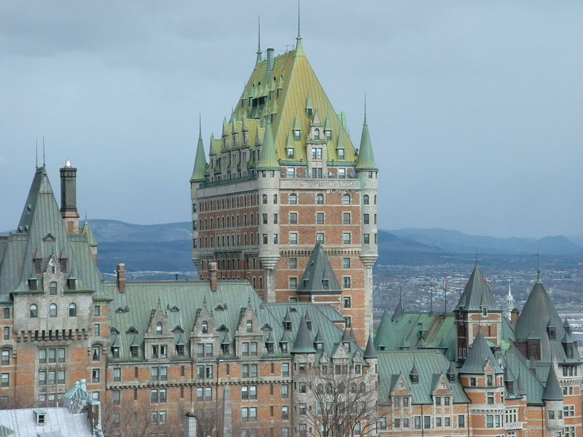

R o a g j p f H A z

The organizers of Sections Congress 2008 request that delegates should register (using the on-line website) as soon as possible.

All R8 Sections Chairs (or their representatives) are expected to attend the R8 Sections Congress Planning meeting scheduled for Friday 25th April 2008 in Malta. During this meeting it is the intention to discuss and agree issues of interest to R8 to be taken by delegates to Sections Congress for possible development into Sections Congress Recommendations.

R o a g j p f H A z

Each active Section† is invited to send one Primary Delegate, who is exempt from the Registration Fee of $US 400. This does NOT cover sleeping room cost or travel, and the SC’08 organisers do not provide any financial support for these aspects to anyone.
Primary Delegates are allocated to the Hilton Hotel, which is the most expensive of the recommended hotels (expected to be $CAN 261.95 per room per night including taxes).
Note that non-delegate accompanying persons also have to pay a Registration Fee of $US 225.
[† Sections which are not up to date with their financial and other end of 2007 reporting might NOT be invited, except by special arrangement]

Choice of Primary Delegate:
In the past it has usually been considered that the Section Chair should be the Primary Delegate: however, this year the Organisers are strongly recommending that the Primary Delegate should be someone who has never before attended a Sections Congress, and preferably should be a young or GOLD member.
This decoupling of the Primary Delegate from the Section Chair is a new development – but is in line with encouragement previously given to the Region 8 Committee for Sections to choose SC’08 participants who have not attended previous Sections Congresses.

Choice of SC’08 Team:
Despite the recommendation to send delegates who have never been to a Sections Congress, there will no doubt be a strong wish from many Section volunteers who were in Tampa or some other previous Sections Congress to go again, as Secondary Delegates, and no doubt most Section Chairs will also want to be there, whether they are young or old. Therefore all Sections should plan to invest in sending as large a team as they can afford. Naturally those Sections with large reserves should be able to send larger teams. As an example, discussion is underway within the UKRI Section to try to finance a team of up to ten delegates. The SC’08 organisers do not set any upper limit to the number of delegates per Section.

Hotel Choice:
The two other recommended hotels are Chateau Laurier and Loews Le Concorde. Cost for the Chateau Laurier is expected to be $CAN 227.90 per room per night and for Loews Le Concorde $CAN 261.95 – in each case inclusive of taxes.
Previous reference to the Delta hotel by the SC’08 organisers seems to be a mistake, and they also sometimes misspell Loews as Lowes.
There are many small hotels in the vicinity which should be available for about $CAN 150, and it may not be essential to use one of the three recommended hotels. The registration website allows delegates to register without reserving a hotel.

R8 Committee Meeting:
The R8 Committee meeting will be on the days immediately before Sections Congress, and it makes economical sense for those attending the Committee meeting to stay on for Sections Congress since their travel cost will already have been covered from the R8 budget. Those attending both will typically arrive 17th September and depart 22nd September (e.g. 5 hotel nights) and those attending only Sections Congress will typically arrive 19th September and depart 22nd September (e.g. three hotel nights).

Track Chairs and Program:
Track 1: Section Management: Lee Stogner: Region 3 Taylors, SC
Christopher James: Region 8 Southampton, UK

Track 2: Membership: Bill Kennedy: Region 7 Calgary, Canada
Ron Tabroff: Region 1 Peabody, MA

Track 3: Section/Chapter Activities: YW Liu: Region 10 Hong Kong
Kalyan Sen: Region 2 Monroeville, PA

So far, information about the detailed program has not been supplied and it may still be possible for suggestions to be accepted, although the deadline has passed.

Social events and Ceremonies:
Region Dinners will be held on Friday evening and it is intended that they will all be together in the same room to encourage interaction between Regions. The IEEE Honors Ceremony will take place on Saturday and the voting on Recommendations and the Closing Ceremony will be on Monday morning. Sunday evening will be free to enable delegates to explore Québec City

Preparation for Sections Congress:
In order to be effective in the creation of the list of Recommendations and to increase the probability of topics of interest and importance to Region 8 getting into the final list with high priority, the Region 8 delegates need to be well prepared and to understand what proposals are realistic and are likely to get the support of other Regions.

Travel:
Travel to Canada from Region 8 is often more expensive than to USA from Region 8, because of a partial monopoly among the airlines. However open-skies negotiations may yield some reductions soon.
It is not easy to find direct flights into Québec City. From some places it may be better to fly into Montreal, from where there are trains to Québec City. There are some airlines which specialize in Charter flights or have a limited but cheaper service, for example, Zoom, Air Transat, etc. and these should not be overlooked. Flights via USA generally appear much more expensive, but this may change. There are many flights from Europe to Newark, New Jersey, and travel on Continental Airlines via Newark should be checked since Continental flies direct from Newark to Québec City

Registration for Sections Congress:

The Registration Site should be live from the end of February 2008:

http://www.ieee.org/web/services/mps/sc08/index.html

The online form allows the selection of events to attend, the optional selection of a hotel, and specification of hotel requirements, partner details, and so on. Although a credit card has to be entered to complete the process fully, there is a promise from IEEE that no payment will be taken from the card at this stage. It is possible to do a ‘test registration’ to see all the details, and to stop before selecting the final SUBMIT step. However, the Sections Congress organizers are hoping that as many as possible will resister early.

The SC’08 website can currently be accessed via:

http://www.ieee.org/web/services/mps/sc08/

Recommendations about the number of delegates to Sections Congress who may prudently be funded from the R8 budget will be made by the R8 Treasurer and by the R8 OpCom, and at the Malta meeting the R8 Committee will be able to discuss and decide the priorities for using this support. Sections will, of course, also be expected to allocate financial support to as many delegates as possible from their Sections.

