IEEE Region 8 Membership Activities Report, October 2007
IEEE Region 8 Committee Meeting, Bucharest, Romania
IEEE Region 8 Membership Activities Committee
- Chair: Marko Delimar, Region 8 Vice-Chair, Membership Activities
- Rolf Remshardt, Aleksandar Szabo, Pilar Molina Gaudó, Membership Development
- Charles Turner, Matej Zajc (workshop coordinator), Gerald Anleitner, Martin Bastiaans,
Rolf Remshardt, Aleksandar Szabo, Professional Activities
- Roland Saam, Basak Yuksel, Region 8 News
- Thomas Watteyne, Electronic Communications
- Tony Davies, Section Congress 2008
- Pilar Molina Gaudo, Eva Gutsmiedl, Gerald Anleitner, GOLD
- Maryam Al Thani, Women in Engineering
- Peter Hill, Life Members
- Jacob Baal Schem, History Activities
Region 8 Membership Activities - Goals and Objectives
- Improve the value of IEEE membership by increasing services and benefits to R8 members
- Develop non-technical IEEE activities in the Region (including contests, awards and promotion programs)
- Foster members' awareness of IEEE activities and existing benefits
- Support Region 8 initiatives and inform other IEEE organizational units about them
- Increase membership and develop retention strategies
- Develop local retention and membership programs
- Enhance member's careers
- Provide a platform for co-ordination, motivation and interaction among R8 members and organisational units
- Provide input to the IEEE RAB Membership Development Committee regarding R8 issues
- Assure IEEE membership promotion at IEEE Conferences and other events in R8
- Promote and support MA officers (MD, PA, GOLD, WIE, LM, etc.) in R8 Sections
- Provide Training & Orientations for Section MA officers
- Help in formation, organisation and development of non-technical IEEE organisational units
- Provide support to and rejuvenate IEEE organisational units
- Help with communication between existing IEEE organisational units
- Represent R8 members' interests and voice their concerns
- Introduce new ideas and proposals and implement initiatives for new activities within the membership responsibilities.
- Assure recruitment of new members and volunteers, control retention of active members and recovery of arrears.
- Promote and support member grade elevation
- Support and provide recognition to IEEE volunteers
Membership Development
Rolf Remshardt, Region 8 MD Coordinator
Aleksandar Szabo, Pilar Molina Gaudó, Marko Delimar (ex-officio)

IEEE Region 8 membership continues to grow at an impressive rate. Region 8 MD and R8 Sections’ MD officers continue to develop specific MD programs: new member promotions and retention, Region 8 MD webcast and MD at IEEE Conferences in R8.

Table 1. IEEE Membership Summary – July 2007

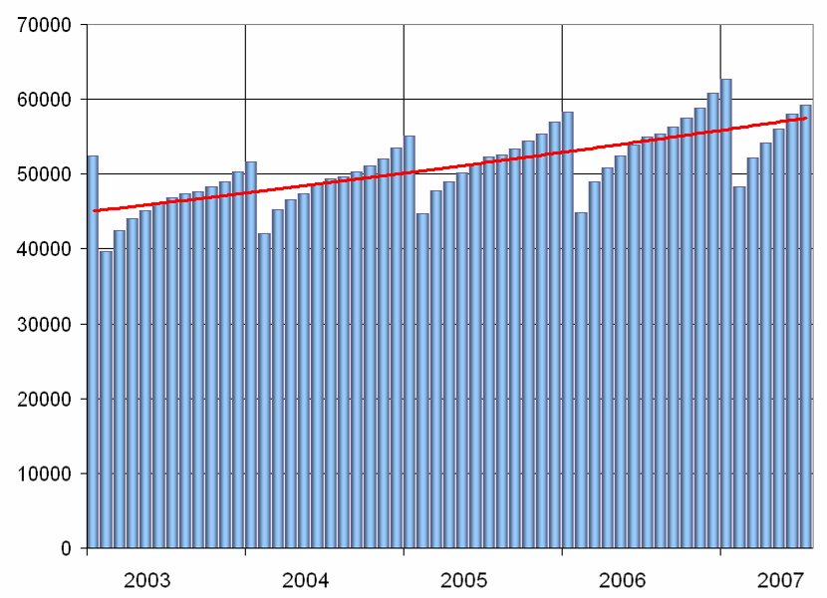

Figure 1. IEEE Region 8 Membership 2003-2007
Region 8 Membership
At the end of July 2007 in Region 8 we had 59,223 members. Comparing to the number of 54,920 at the end of July 2006 it is an increase of 4,303 members or 7.8%. In the whole IEEE at the same time the increase was only 2%.

Membership Statistics in R8 Sections
Most Sections are doing well. Only few sections have a decrease of membership. But there are also few Sections having less than 50 higher grade members! They should ask themselves how they will survive. Look into your Section Membership Statistics every month. Is your membership increasing or decreasing? To learn more about the members in your Section use SAMIEEE: http://www.ieee.org/samieee !
Contact the arrears in your section to see what are the reasons for not renewing. Don't loose members!

Section Membership Development Officers
We all, the members and volunteers in IEEE, should be aware that Membership Development on all levels and especially on the section level is of extreme importance if we want to have more members, new volunteers and more activity. Some sections in R8 still have not appointed a Section Membership Development Officer! We have about 20% of Sections in R8 not having MD Officers! We are asking these sections to appoint Membership Development Officers willing to do their job with enjoyment and without sparing efforts!
We are also asking all Sections to send us the names and email addresses of their MD Officers especially if you have appointed new ones.
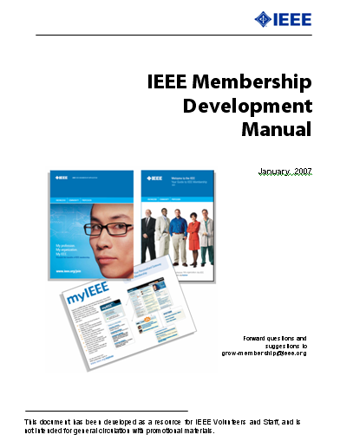
2007 Membership Development Manual
Many Region 8 volunteers have asked for a concise guide to introduce them to the membership development processes and tools that are available from IEEE. The MD Manual is an essential overview of MD. It includes resources such as a MD calendar and MD checklists. It helps you coordinate local efforts with headquarters’ programs and processes. There is also a listing of IEEE member benefits, as well as sample letter templates for suggested outreaches. It can be downloaded from the IEEE Region 8 web page (http://ieee.org/r8) by selecting Membership Activities and afterwards Membership Development.

Graduate Student Members Rights and Privileges
According to the IEEE Bylaws the Graduate Student Members shall have the rights and privileges of Members. So GS Members are also qualified to sign the petition to establish a new Section – important for new section and new chapter development!

Arrears
To prevent the situation of having many arrears in the future we should work much more in advance (November, December, January), especially on the Section level, to encourage members to renew on time, well before the Service Terminator.
Table 3. IEEE Region 8 Membership Density per Section – July 2007
Section/Country | Population (2007) | Members | Members per million
Malta | 407 000 | 172 | 423
Iceland | 311 396 | 126 | 405
Switzerland | 7 508 700 | 2 488 | 331
UAE | 4 380 000 | 1 246 | 284
Cyprus | 855 000 | 180 | 210
Sweden | 9 150 000 | 1 851 | 202
Norway | 4 770 000 | 874 | 183
Israel | 7 171 600 | 1 293 | 180
Finland | 5 292 192 | 914 | 173
Qatar | 841 000 | 145 | 172
Greece | 11 147 000 | 1 830 | 164
Lebanon | 4 099 000 | 647 | 158
UK & Republic of Ireland | 64 888 300 | 10 116 | 156
Slovenia | 2 030 000 | 315 | 155
Croatia | 4 555 000 | 605 | 133
Denmark | 5 550 000 | 705 | 127
Austria | 8 316 487 | 1 041 | 125
Benelux | 27 305 000 | 3 075 | 113
Bahrain | 753 000 | 79 | 105
Portugal | 10 623 000 | 940 | 88
Jordan | 5 924 000 | 514 | 87
Germany | 82 314 900 | 6 215 | 76
Spain | 45 116 894 | 3 381 | 75
Italy | 59 131 287 | 4 069 | 69
Macedonia | 2 038 000 | 131 | 64
Estonia | 1 342 409 | 79 | 59
Bosnia and Herzegovina | 3 935 000 | 228 | 58
Serbia & Montenegro | 10 456 000 | 528 | 50
France | 64 102 140 | 3 157 | 49
Kuwait | 2 851 000 | 128 | 45
Hungary | 10 030 000 | 348 | 35
Romania | 21 438 000 | 746 | 35
Czech Republic & Slovakia | 15 696 709 | 541 | 34
Oman | 2 595 000 | 88 | 34
Bulgaria | 7 639 000 | 253 | 33
Saudi Arabia (both Sections & Subsections) | 24 735 000 | 796 | 32
Lithuania | 3 390 000 | 102 | 30
Turkey | 74 877 000 | 1 842 | 25
Poland | 38 125 479 | 787 | 21
Egypt | 75 498 000 | 1 594 | 21
South Africa | 48 577 000 | 819 | 17
Iran | 71 208 000 | 771 | 11
Ukraine | 46 205 000 | 371 | 8
Belarus | 9 689 000 | 64 | 7
Nigeria | 148 093 000 | 1 031 | 7
Russia - Three Sections | 142 499 000 | 939 | 7
Morocco | 31 224 000 | 123 | 4
Kenya | 37 538 000 | 66 | 2
Tansania Subsection | 40 454 000 | 26 | 1
The Full-Year Dues Period
The beginning of the full-year dues period starting on 1 September is the peak recruitment time. Services for new members commence immediately upon joining and continue through 31 December 2008. A member joining in September receives a bonus of 4 months of extra service above and beyond the 12 months he is paying for.
For Membership Development Resources visit http://www.ieee.org/md and for best practices http://www.ieee.org/ra/md/bestpractices.html

Member-Get-A-Member Program
The payout for recruited professional members (not students) is 15.00 US$ per member. Recruiters (including student members) have the option of using their reward vouchers to pay for IEEE products or services, including the membership renewal, or they can use the vouchers for a donation to the IEEE Foundation.
Announce and provide information on the Member-Get-A-Member (http://ieee.org/mgm) and Student-Get-A-Student (http://ieee.org/sgs) programs at Section, Student Branch and Chapter Meetings and Conferences. Make it a challenge within your Section to see who will be the best in Membership Development. The reward is more than a 15$ IEEE credit voucher, it's a bigger organization with better connections into industry and community. If each of us recruited just one new Member, we would double our size in one year!!! But let's increase our membership by 10%. Remember, without Membership Development, we cannot build the IEEE of tomorrow.

MD Promotional Material – Recruitment Kits sent to Sections
The 2008 Membership Recruitment Kits have been sent to Sections and Student Branches in September 2007. Have you received them?

R8 MD Newsletter
IEEE Region 8 Membership Development Newsletters have been sent from time to time to all R8 Committee Members and Section MD Officers pointing out important information and MD actions to be done. It is also available at the IEEE Region 8 Membership Development Page. Visit http://www.ieee.org/r8 , select Membership Activities and afterwards Membership Development.

Region 8 MD Meetings by Webcast
Part of our Membership Development campaign is to plan for online meetings with our Section MD officers using modern communication tools via Internet. In the past R8 has held several Training and Education meetings for MD officers and volunteers in several sections of our large Region. The cost of these face to face meetings was considerable. We therefore think of having one hour online meetings (webcasts or webinars) with section officers from time to time to report on the latest information from IEEE, in particular on MD activities in IEEE and R8, and provide them with ideas and material for MD activities in their section. We could also use this opportunity as training and education sessions for new MD officers and other new volunteers, include a Q&A part, and help in any case of local problems.
The technical solution could be either:
- a Internet conference system with Voice over Internet, provided a high speed connection to Internet (DSL) is available for all participants,
- or a standard conference system with telecon for voice and online access for PowerPoint slide display.
We intend to form 3-4 groups of Sections with 12-15 participants each pending on availability and time difference.
We would like to get your opinion on this proposal before we are going to start implementing it. We will ask the R8 Committee in Bucharest during the MD presentation the following questions:
- Do you like this idea in general for your section or would you still prefer face to face meetings?
- Do your officers have a high speed connection to Internet?
- Would you or your colleagues participate in a MD webcast at late afternoon or evening or even on Saturday?
Please be prepared for these questions and respond either by email to R8 MD asap or directly during the R8 Committee meeting in Bucharest. Many thanks for your cooperation.

MD at IEEE Conferences in Region 8
During the MD presentations in Sofia we reported that R8 is planning for a large membership development campaign in 2007 - 2008. The major plan is to use the many IEEE Society conferences, which are held in our R8 countries as a platform for our efforts. It is an ideal opportunity for promoting IEEE and recruiting new members, since many non-members are attending our conferences in the region as well.
We plan to have an IEEE booth or table at the conference with IEEE posters, books, brochures, magazines, and application forms, including a local volunteer hosting the booth by answering questions and giving explanations on IEEE. A supporting presentation should be held at the conference opening or dinner by the conference or section chair, or the MD officer. In order to make the event happen with the necessary arrangements, we have to rely on the support of our local section chairs, MD officers, volunteers and friends.
We have already selected several conferences from our R8 Conference Calendar – which are also co-sponsored by R8 – and made plans for arrangements with our local colleagues ( see below list ).

ICC 2007 Glasgow, June 2007 ICSPC 2007 Dubai, 24 November
EMBC 2007 Lyon, 22 August ICECS 2007 Marrakesch, 11 Dec
EUROCON 2007 Warsaw, 9 September ICM 2007 Cairo, 29 December
ICL 2007 Villach/Austria, 26 September ISCCSP 2008 Malta, 12 March 2008
AFRICON 2007 Windhoek, 26 September CCGrid 2008 Lyon, 18 May 2008

At the time you read this, we will have already accomplished several promotion events. The first pilot project was held successfully at the large ICC 2007 in Glasgow / UK and others like EMBC in Lyon, EUROCON 2007 in Warsaw, ICL 2007 in Villach/Austria, and AFRICON 2007 in Namibia have followed. We thank all our friends who supported these events.
May we kindly ask all of you, the Section Chairs and MD officers, as well as the R8 Conference Committee to select conferences in your countries/sections for MD promotion events in 2008, nominate a volunteer (or yourself) to prepare the necessary local arrangements, and to inform us. Of course R8 MD will work with you and your volunteers to organize the event including the support from IEEE staff.
Membership Development is the business of all of us! Many thanks for your support.
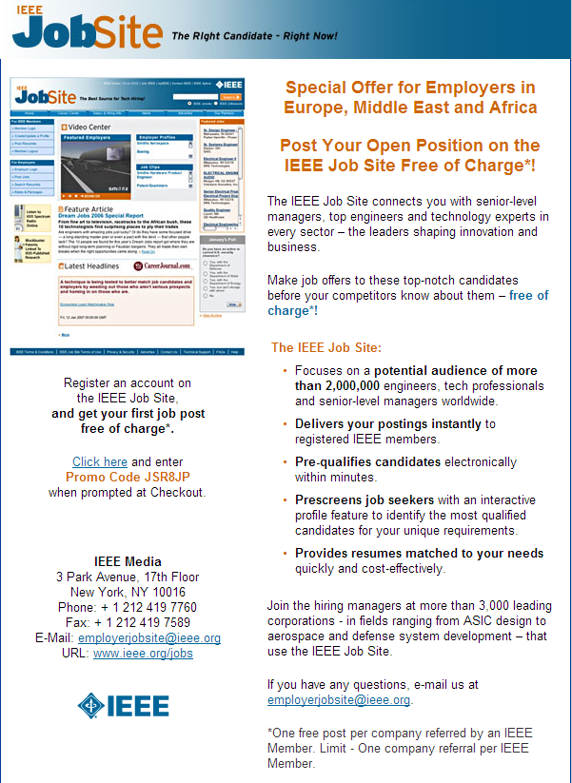

Figure 2. IEEE Region 8 Job site promo
Professional Activities
Charles Turner, Region 8 Professional Activities Coordinator
Matej Zajc (workshop coordinator), Gerald Anleitner, Martin Bastiaans,
Rolf Remshardt, Aleksandar Szabo, Marko Delimar (ex-officio)

IEEE Region 8 Professional Activities Subcommittee (PASC) has held two teleconferences, on May 14th and July 11th, since the Region 8 Meeting in Sofia. The main priorities have been identified as (1) increased collaboration with IEEE-USA, and (2) further development of the successful workshop program in professional skills.
IEEE-USA Collaboration
The Chair and two other members of the Sub-Committee held a meeting in Philadelphia, at the June IEEE Board Series, with John Meredith, 2007 President IEEE-USA, and his staff colleagues, to continue to explore the potential costs and means of delivery of IEEE-USA products and services for use by members in Region 8. This followed earlier discussions in 2006/7 which have produced agreements on the free use of some IEEE-USA products. The management of IEEE-USA is very supportive of the initiative of Region 8 in forging closer links and working towards sharing products and services.
It was agreed that Gerald Anleitner would attend the Annual Meeting of IEEE-USA in Phoenix, Arizona, held on September 1st and 2nd 2007. He has reported from that meeting a list of items under active consideration. These include:
Webinars These are now available for use from IEEE by Sections and other groups at a cost of $89, and need to be publicised in R8.
ExpertNow The list now includes some modules on professional skills and is available free on a trail basis for the remainder of 2007.
e-Books These are available on a restricted downloadable basis free to R8 members
Workshops Those currently offered in R8 can be developed in collaboration with IEEE-USA, and could include ExpertNow modules.
Patent and Intellectual Property Rights R8 experts in this field are being identified, and an online R8/IEEE-USA conference is being planned. It is hoped to be able to offer new courses and workshops in 2008.
IEEE Job Site More publicity will be launched to encourage greater interest from members and employers in R8.
Continuing interaction on these topics with IEEE-USA is planned for the rest of 2007.
Professional Skills Workshops
The PASC has continued to support the program of workshops conducted by Kurt Richter, Margaretha Eriksson, and Matej Zajc, reported separately in the Agenda Book.
Currently these cover Leadership Skills, Project Management, and the training of future workshop leaders. PASC wants to expand the list of topics to include Design Management, Intellectual Property, and other career and employment-related issues.
Section PA Issues
Many Sections have not appointed PA officers or do not yet have truly active officers. Further reminders will be sent shortly, emphasising that PA is a personal priority for many members, especially those in industry. PASC aims to encourage more activity at Section level, making use of resources that R8 already offers, and helping to develop new areas. PASC also aims to improve its publicity, including expanding its website and producing a new edition of the PA Newsletter.
Future events
PA events using webinars are planned in Germany and Denmark, and also in conjunction with the Germany/Benelux GOLD meeting in October 2007. Sections intending to organise PA events should contact Gerald Anleitner (geribald@mac.com).

IEEE Region 8 Workshops on

Development of Leadership & Project Management Skills

Report: April - October 2007
Matej Zajc, Kurt R. Richter

The document reports on IEEE Region 8 Workshop programme for the period from April 2007 to October 2007 (Q2 and Q3 of 2007). In this period a 3 workshops in 2 Sections were conducted. In 2007 up to now 9 workshops in Austria, United Arab Emirates, Croatia and Cyprus were successfully organized and presented. The workshops in Denmark are planned for November 2007.  The workshop programme consists of two workshops, namely Development of Leadership Skills (LS) and Project Management Skills (PM). The workshops are full-day events but their modular content can be customised to the audience needs. More information can be found at http://ieee.org/r8 .  These workshops were also used to get new trainers for the workshop programme. The main objective of the network of trainers is to continuously organize the events locally together with the trainers from neighbouring Sections.  The workshop programme, now part of Professional Activities sub-committee, will integrate with other professional activities in Region 8. | 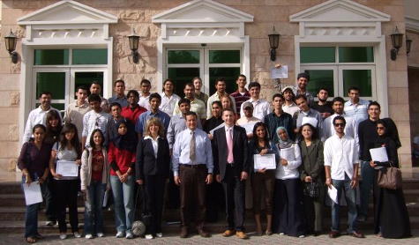  American University of Dubai, March 2007  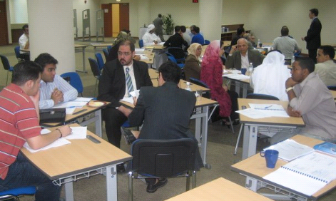  Petroleum Institute, Abu Dhabi, March 2007
Report on events in Q2 and Q3  Cyprus Section: Protaras, June 16, 2007  title: Project Management and Leadership skills  duration: Half day workshop  conducted by: M. Zajc and E. Kyriakides  participants: 32, IEEE student members and IET student members  level: basic  Cyprus Section: Paphos, June 20, 2007  title: Project Management: An Engineering Perspective  duration: Half day workshop  conducted by: M. Zajc  participants: 18, IEEE and IET professionals  level: advanced  Croatia Section: Opatija, May 20, 2007  title: Development of Leadership Skills  duration: Full day workshop  conducted by: K.R. Richter  participants: 30+  level: intermediate
  Events 2007
  Cyprus Section
  → Paphos: PM
  → Protaras: PM & LS
  Croatia Section
  → Opatija: LS
  UAE Section
  → Dubai: PM
  → Sharjah: LS
  → Adu Dhabi: PM and LS
  Austria Section
  → Graz: PM and LS
Development of Leadership Skills will introduce participants into interpersonal, group, team and leadership skills.  Project Management workshop will introduce participants into project management techniques and how to apply them.  Both workshops are highly interactive, illustrated with several team assignments and individual exercises.  Workshops are organized and sponsored by R8 together with R8 Sections and Student branches.  Workshops can be organized as part of the conference programs, student events, IEEE promotional activities, etc. Workshops are especially appropriate for, but not limited to, senior students and young professionals. | 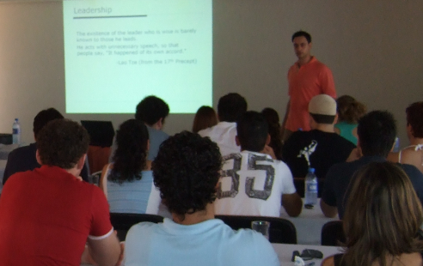  Protaras, June 2006
Review of events in Q1

Austria Section: Graz, March 2007, 2 workshops

UAE Section: Dubai, Sharjah, Abu Dhabi, March 2007, 4 ws
The detailed report of Q1 was published in the 88th IEEE Region 8 Agenda book, Sofia, Bolgaria.

Planned events in Q4

Denmark Section: Copenhagen and Aalborg, November, 2007

... goals for 08  - offer help to local trainers to organize events in sections  - introduce additional professional activities topics  - integrate ExpertNow modules into the workshop programme | Contacts  web: http://ieee.org/r8  mail:  m.zajc@ieee.org  k.richter@ieee.org

Sections Congress organisation and preparation
Tony Davies, Region 8 Section Congress Coordinator

- IEEE Sections Congress, Quebec City, Canada
Quebec City Convention Center, 19–22 September 2008
- For more details see separate report and http://ieee.org/r8
Region 8 News (print)
Roland Saam
Basak Yuksel
-- Co-editors

- 4 x year
- March, June, Sept., Dec.
- 12 pages/ per issue
- 50 articles each issue
- 200+ articles per year
- Cost $76,000. in 2006 per member ÷ 55,000 = $1.38 per year per member.

Benefits

- Every member receives it – tangible evidence of membership.
- Fresh news about IEEE activity.
- Also published, indexed on R8 Website
- News channel for R8 leaders, volunteers
- Attractive, public record of vitality in Region 8

We report

- Regional Membership Development
- GOLD, Student News
- Voluntary Contributions Fund, IEEE Foundation, Job Center, IEEE Benefits
- Chapter Development
- Standards in R8
- Interesting articles about members, information, quiz, Conference Calendar, amusing cartoons!

Electronic Communications
Thomas Watteyne, Region 8 ECC

The Region 8 Electronic Communication Coordinator's job is to facilitate communication, both between members of the Region 8 Committee, and between this committee and present or future IEEE members. The IEEE R8 ECC 2007-2008 is Thomas Watteyne (thomas.watteyne@ieee.org).

Dear members of the Region 8 committee,

It's a real pleasure to tell you that the Region 8 website launched in January is a real success. There were over 6,000,000 visited pages the two first months of its launch, and numbers keep piling up. There are currently 320 registered users, 211 IEEE events announced in the Calendar, and news items appear on the first page on a weekly basis.

For your information, these are 10 most visited pages:

1. IEEE Region 8 Membership Activities
2. Professional Activities
3. Life Members
4. History activities
5. IEEE Region 8 Sections and Subsections
6. Committee and Contacts
7. Membership Development
8. GOLD (Graduates Of the Last Decade)
9. Documents & Bylaws
10. Women in Engineering

You will have noticed that we are experimenting with online registration for this meeting. This tool has really helped the organizing team share the information about the attendees. The process appears to have gone smoothly for the vast majority of the attendees.

Another novelty of this meeting is the online Agenda book. On the main page about the Bucharest meeting (Committee > Meetings > Bucharest), you will find a link to a "browseable" version of it. This means that you do not need to download the complete Agenda book, unnecessarily inflating your computer's hard-disk. Instead, you are now able to consult a specific report from any computer in the world. This offers, we believe, a lot of flexibility.

Please note that we intend to put each presentation online in real-time during the meeting. You will thus be able to download a speakers presentation by clicking on a link on the Bucharest meeting as he speaks, giving you the possibility to browse through the presented slides at your speed, or the annotate the presentation.

I would finally like to tress once more the your importance. You, as OpCom member, Section Chairs, conference organizers or any other IEEE related position, are the source of the information provided by the Region 8 website. Don't hesitate to upload your news and calendar items, or just to drop me an e-mail with the information you would like to see online.

Remember also that there are video tutorials on how to use the Region 8 website under Documents > r8webtutorials.

WIE (Women in Engineering)
Maryam Al Thani, Region 8 WIE Coordinator

IEEE Region 8 WIE web page updated. No activity reported.


GOLD (Graduates Of the Last Decade)
Pilar Molina Gaudo, Region 8 GOLD Coordinator
Eva Gutsmiedl, Gerald Anleitner, Marko Delimar (ex-officio)

Executive Summary

Team formed by Pilar Molina Gaudo (R8 GOLD coordinator) together with Eva Gutsmiedl and Gerald Anleitner is in full gear now. In the past months several important projects and initiatives have taken place. These are explained in detail in the Report part. The most important event after the meeting in Sofia has been a two day working session of the GOLD volunteers together with Marko Delimar (Vicechair MA) and Martin Baastians (Vicechair SA). As a result of this meeting, outside funding will be pursued for a volunteer rejuvenation project and an idea to create content for a special IEEE.tv program of special interest to Region 8 GOLD members. During this meeting, an online Affinity Group Chair meeting was conducted.

Actions Required
- Approval of a motion to include a GOLD member in the Region 8 N&A committee.
- Volunteer rejuvenation in Sections throughout Region 8 by several means. A new project in this line is bound to be started. This project would include the possibility of sending GOLD volunteers to Sections Congress 2008.

Resources Required
  - Web meeting resources. Skypecast tool was tested and is not mature enough to conduct voice meetings with all the quality needed.

Report
- GOLD coordination team met in Sofia during the 2007 Spring Region 8 meeting. Minutes of the meeting are available upon request.
- GOLD reception and GOLD track during the Engineering in Medicine and Biology Society flagship conference held in Lyon, France in August 2004. This initiative was led by Lisa Lazareck, GOLD coordinator to the Society and active GOLD volunteer. This will be the subject of a R8 News article and GOLD Rush one.
- Contacts made with runners of several GOLD activities throughout Region 8. To provide some examples:
  - Egypt Engineering Day, initiative, very successful. Subject of R8 News future article and GOLD Rush one.
  - Lebanon AG formed and approved
  - Greece AG formed and approved
  - Survey sent out to R8 GOLD CASS members by region 8 coordinator with this Society. Contacts made with this volunteer to establish successful programs.
- Graduation Reception to be held by South Africa Section.
- Graduation Letter project:
  - Personalized letter to be sent to those graduating student members of the Section.
  - Special template subject of additions or translation to local language.
  - SAMIEEE database results available upon request
  - Several pilot Sections to sent out the letter shortly.
- GOLD Working Retreat meeting in Zaragoza Spain. Minutes of the meeting available upon request. As part of the meeting:
  - Strategic Planning Session for GOLD in the next two years was made
  - Idea for a rejuvenation project let by R8 GOLD was started and funding is being obtained from sources outside Region 8.
  - Idea and implementation steps of an IEEE.tv program with special content for R8 members (specially young professionals)
  - Chat session with all Region 8 GOLD AG chairs.
    - Skypecast was tried as web meeting tool
    - Technology seems promising but preparation of the meeting needs to be carefully planed and tested (all participants)
    - Meeting was interesting and several AG chairs were present. Ideas exchanged and personal contacts established.
  - GOLD congress 2008 basics started.
  - Agenda for Bucharest meeting organized.
  - Several other business.

HAC (History Activities)
Jacob Baal Schem, Region 8 History Activities Coordinator

Background
Region 8 History activities started with Region 8 Committee approval in 2006 of forming a History Activities Council and with the first meeting of HAC in Vilnius.
Actual launching of History activities were based on:
- Appointment of Region 8 History activities coordinator as from 1 Jan‏ 2007
- Provision of Grant by IEEE Foundation in addition to Region 8 Membership Activities Budget.
- Assistance from VC Membership Activities (Budget and Guidance).

2007 History activities in R8
Sofia HAC meeting
A meeting of the HAC was held in Sofia before the Region 8 Committee meeting in order to discuss further activities.
EUROCON session
Following a proposal brought up at the Sofia meeting a Special Session on “History of Electrotechnology” was proposed and accepted by EUROCON 07
The session included 6 papers, all reviewed and accepted and they were presented in front of an audience of 30 participants and well received.
Web. Site
With the assistance of Thomas Watteyne, a Web site on History of Electrotechnology was set up as part of Region 8 site and relevant information was included.
History Network
With additional assistance of Thomas, a “listserv” was set up, to include all those interested in History of Electrotechnology, who signed up to become members of the network. Information on the network is on R8 Web. Site.

Model to History activities in IEEE Region
At the request of the Chair of IEEE History Committee a paper describing the Model of activities on History that was set up in Region 8 was prepared.
A copy of the paper is attached.

HISTELCON 08
Following a proposal approved at the HAC meeting to hold a Region 8 History Conference in 2008, a meeting was held in Paris and decide:
- To hold HISTELCON 2008 on 11-12 Sept.08 in Paris.
- To invite as co-sponsors the French SEE as well as additional Groups
- To appoint Prof. Jean-Claude Boudenot as Conference Chairman.
Unfortunately Prof. Boudenot became ill and Baal-Schem will co-chair
The first Call for Papers for HISTELCON 08 has been distributed at EUROCON 07 and will be provided at the Bucharest meeting.

Press release
At the proposal of Region 8 News Editor, a Press Release on Region 8 History activities was prepared and distributed.

Grant request
According to a decision of the Paris meeting, a Grant request was sent to the IEEE Foundation for assistance to organize and hold HISTELCON 08.

Interviews
The activities schedule of the HAC included holding 3 Oral Interviews in 2007 (2 in UK and 1 in Israel). After getting the briefing by IEEE History Center Dr. Nebeker during the meeting in Warsaw, we will prepare and intend to hold these interviews.

HAC Meeting in Warsaw
During EUROCON 07, a meeting of the HAC was held at the University of Technology of Warsaw (with great assistance of Prof. Jozef Modelski). The meeting included:
- A report of past activities by R8 History coordinator
- A report by R8 VC Membership Activities on History Committee
- A presentation by IEEE Senior Research Historian, Dr. F. Nebeker on the IEEE History Center and on how to conduct oral interviews.
- A discussion on future History activities in Region 8 (mainly the holding of HISTELCON 08)
- A discussion on organizing a History Session at EUROCON 09 on St. Petersburg.
LM (Life Members)
Peter C J Hill, Region 8 Life Members Coordinator

There has not been much reported progress by the Region Life Member (LM) groups since last time. We are still only 4 strong with affinity groups in the France, Israel, Italy and UK&RI Sections; Switzerland, and possibly others not yet known to us, is currently forming one.
It has been extremely difficult to extract activity information from the LM affinity groups. We are currently seeking statements on items such as:
- LM membership numbers and growth
- LM meetings, workshops and seminars held
- Student education promotion – secondary & tertiary
- Technical milestones initiated
- Visits to establishments of interest
- Other LM related activities
- Future plans

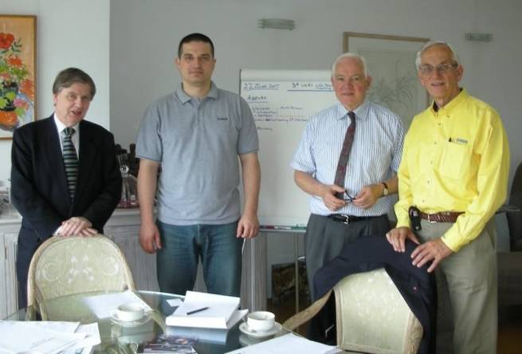
It has been MAC policy to decouple LM activities from those involving history although it is of course inevitable that Life Members will get involved in some of these; for example the recent R8 EUROCON 2007 in Warsaw. However, we do encourage groups to establish dialogue and actively collaborate with similar institutions where possible. The UK&RI LMAG is starting to do this by talking to organisations such as IET and DEHS. Despite the above policy, in the UK for convenience, the LM Affinity and History Affinity groups meet together in London from time to time; the last meeting, chaired by Roland Saam, was on 22nd June 2007.
LMAG Meeting: B. Harrington, M. Delimar,
C. Turner & R. Saam

A formally recognised IEEE LM Group (LMG) is a non-technical subunit of a Section, which has 100 Life Members or more. The goal, set by the central LM Committee (LMC), is to have all Sections, which satisfy this criterion, to form a LMG; you only need to obtain six signatures (preferably LMs) to start the process. Groups which conduct at least 2 meetings annually, can receive funding from the RAB; extra funding might be available from the LMC on application.

I encourage our larger R8 Sections, as a start, to consider forming a LM affinity group.

