Optional programs

1. DANUBE BEND EXCURSION (full day)
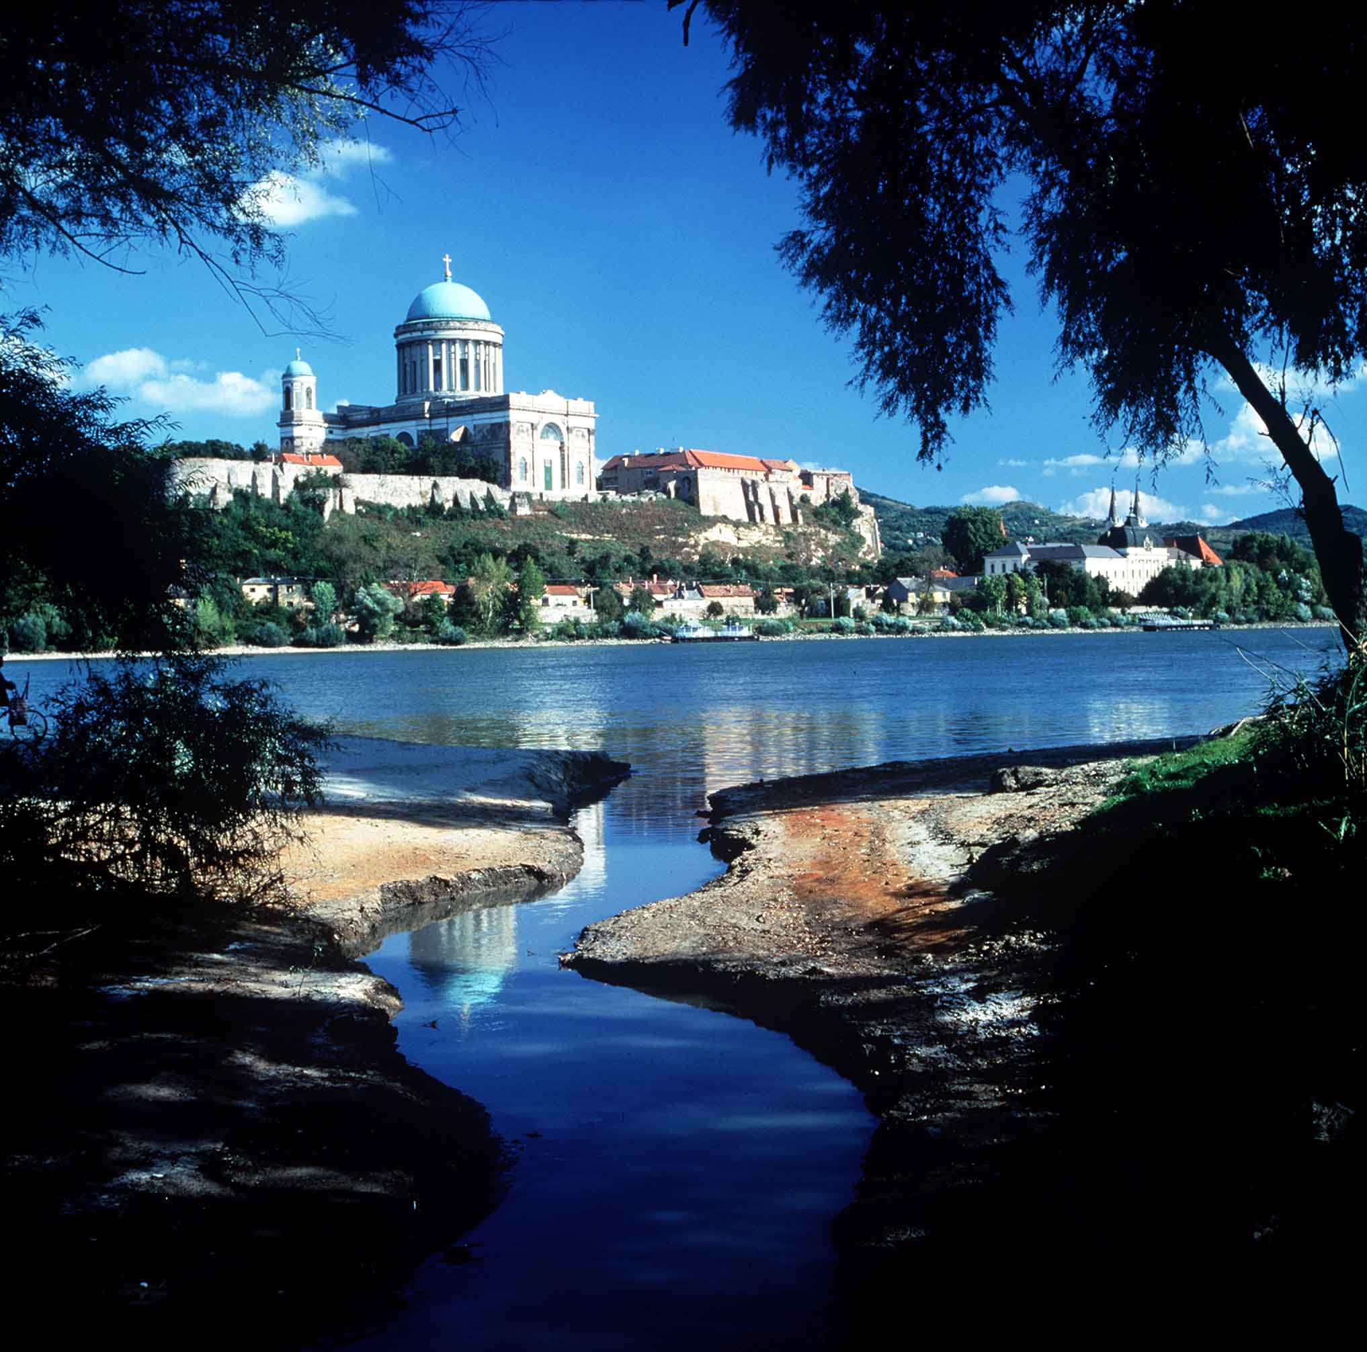
The tour begins with an approximately 75 minute coach ride, along the Danube river, driving north to ESZTERGOM, the cradle of Hungarian history. Once the capital of medieval Hungary, Esztergom today is a midsize rural town, but still the country's ecclesiastical center. The huge Esztergom Cathedral is the largest church in Hungary, it is also the Archbishop's seat in this predominantly Catholic country. Inaugurated with Liszt's Inauguration Mass in 1856, it also houses a stunning Treasury, full of richly decorated clothing and old artifacts. Esztergom is also home to Hungary's most interesting Museum of Christian Art and a medieval Castle, from the ramparts of which, you will see a circular panorama. Neighboring Slovakia is just over the river, a couple of miles from where you stand.

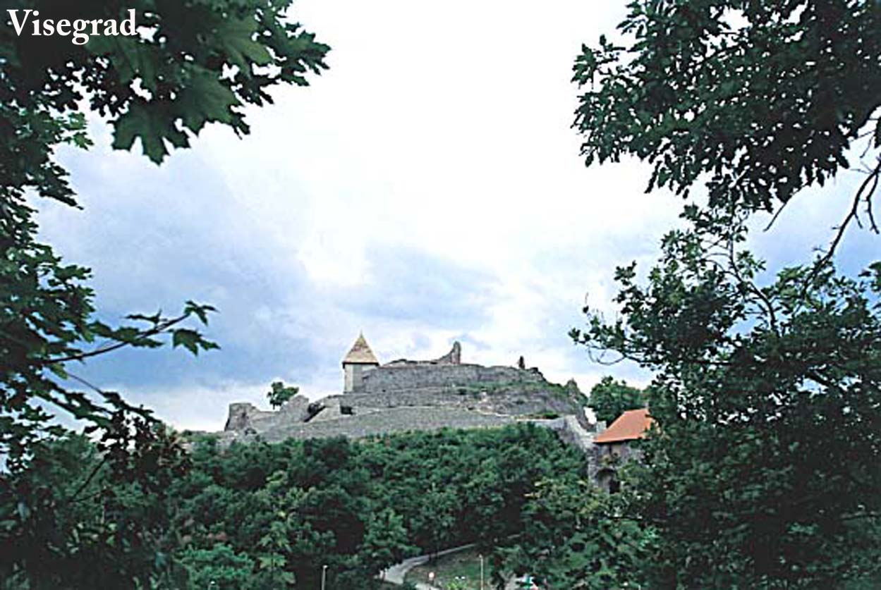
From Esztergom, you will proceed back towards Budapest for the next stop: VISEGRAD, a steep bluff with the renovated ruins of one of the earliest Hungarian forts, the castle of our King Bela IV from the mid-13th century. The Citadel offers an unsurpassed view over the Danube Bend, a sharp turn in the course of the mighty river below where it hits the north-eastern mountain range and is, thus, forced to detour from its eastern course to the south. The medieval Royal Palace of Hungary's most beloved, flamboyant ruler, King Matthias, was one of the largest Renaissance palaces of the contemporary Europe.

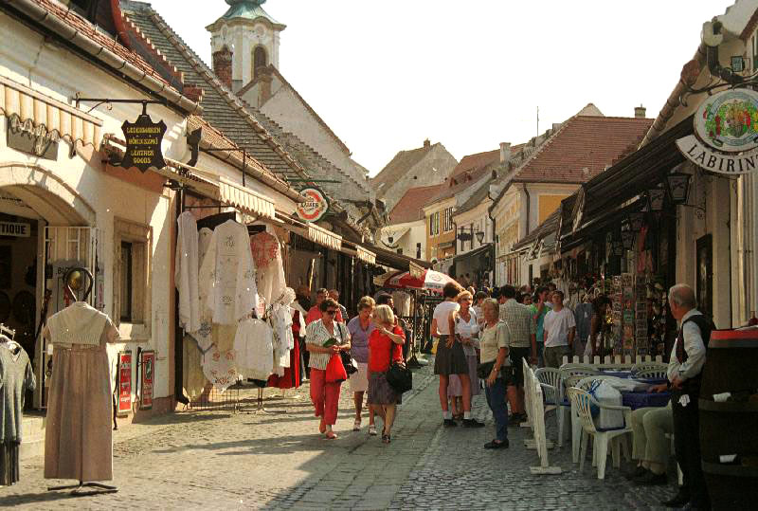
After lunch in Visegrad you will visit SZENTENDRE, this jewel of a Baroque town, also one of the most exciting artist colonies in the country, only 10 miles north of Budapest, in the picturesque Danube Bend region, right on the river. Founded by fleeing Serbian settlers who left their homeland in fear of the oncoming Ottoman Turkish armies in the 16th century, present day Szentendre is a charming town with cobble stone streets, an armada of galleries, quaint little museums, cafes and excellent shopping. In the immediate vicinity of the town, Hungary's largest outdoor Ethnographic Museum is to be found, which, essentially, is a collection of peasant farmsteads and community buildings from the different regions of the country, arranged like an early 19th century village.

After arrival, you will walk from the parking lot along the main shopping street of Szentendre to visit the Margit Kovacs Ceramic Museum, this unique collection of the late artist’s best creations. Unlike most ceramic galleries, the Kovacs collection offers mostly earthen figures and genres that bring the rural traditions of Hungary to life, full of humor and candid observations.
Duration: 8 hours

Rate (in case of min. 10 pax): 70,00 EUR/pax (incl. 19-seater coach, English speaking guide, entrance fees, 3-cours lunch with unlimited consumption (wine, soft drinks, mineral water, coffee)

2. Balaton and Herend (full day)
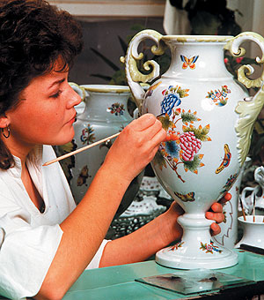
Leave Budapest in the morning, for a two-hour drive thru the picturesque Transdanubian countryside, west of the capital. Upon arriving at Herend, you will be taken to the Porcelanium, which is a showcase of the world-famous Herend China Manufactory. First you will watch a film, telling the story of Herend from its opening in 1826 to the present day. Then watch live as skilfull hands shape the lifeless earth mass into fragile porcelain, by first shaping it, then painting it with exhilarating patience and precision. After the visit, you will have time to make that special Herend purchase on the spot in the huge factory outlet store.
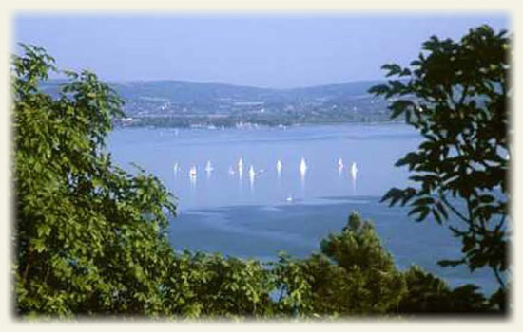
Next, we drive to Lake Balaton, also known as 'the Hungarian Sea', is Central Europe's largest fresh water lake is located in the middle of the country's western part, called Transdanubia. It is 5O miles long and both shores are dotted with resorts and vineyards. Some of the best white wines in Hungary come from here. We will visit Balatonfüred. Following a 3-course lunch with wine tasting in a “csárda”.
After it we will visit Tihany Abbey, one of the oldest churches in Hungary, dating back to the mid 11th century, when it was founded by our king Endre I. See the tomb of King Endre, as well as the founding document of the Abbey, which is the first known (Latin) document also containing Hungarian words. After it transfer back to Budapest.

Duration: 8 hours
Rate (in case of min. 10 pax): 110,00 EUR/pax (incl. 19-seater coach, English speaking guide, entrance fees, 3-cours lunch with beverage, wine tasting (6 kind of wines), ferry tickets)

3. Excursion to Hollókő (UNESCO Word Heritage) and Eger
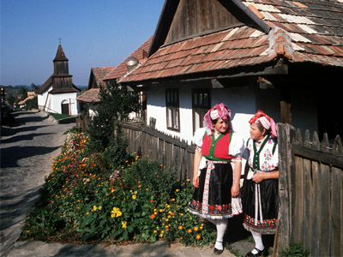
Hollókő, a living museum village, is nestled in picturesque, hilly surroundings about 100 kms from Budapest in the North of Hungary. It is also part of the UNESCO World Heritage. Lifestyles also reflect ancient traditions. Women dressed in their regional costumes welcome the groups with brandy (pálinka) and traditional Palóc cottage cheese pie at the barnyard at the entrance of the Old Village. While enjoying the home-made culinary delights, you'll witness an unforgettable performance as the women revive the atmosphere of the age-old spinning houses. The fast-spinning spools accompanied by the women's singing, the entertaining jests and merriments and the sounds of popping corns are simply unforgettable. The women will also show their beautiful traditional costumes, and an adventurous couple is dressed up in the festive attire of newlywed women and men. Guests are farewelled by a joint circle dance. This is followed by a guided walk in the Old Village, getting acquainted with its folk architecture, history and present life. Along the way the guests will visit the wood-shingled Church, now the symbol of the village, the Village Museum that evokes the life of XIX century houses and the living workshop of folk handcrafts, the Weaving House.
You will have time to walk and visit the various shops and see crafts being made as they were over 100 years ago.
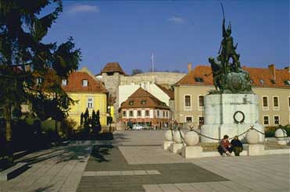
Then we will visit Eger EGER, this beautiful Baroque town among the gentle hills of north-eastern Hungary, is our best preserved monument from the times of the Turkish occupation of the country that lasted for some 150 years in the 16th and 17th centuries. Eger became famous for the unprecedented machismo of her defenders, 2,000 of whom, retreated to the fortified castle of Eger, withstood the siege of the entire Ottoman army of some 100,000 troops in 1552 for more than a month. Eger, like most of the rest of the country, finally fell, and the Turks built and left behind impressive forts and towers, to be seen also today. Eger, beyond her famous Castle, also boasts a Cathedral, one of the most beautiful Baroque basilicas anywhere in Hungary, as well the Lyceum with its meticulous wrought iron gate, great library and quaint colonnade.
Eger is also the center of a wine growing area. Her wines are fiery and some of them, like the wineries that offer visits and wine tasting

Duration: 8 hours
Rate (in case of min. 10 pax): 110,00 EUR/pax (incl. 19-seater coach, English speaking guide, entrance fees, 3-cours lunch with beverage, wine tasting (4 kind of wines))

4. Excursion to Gödöllő and Domonyvölgy

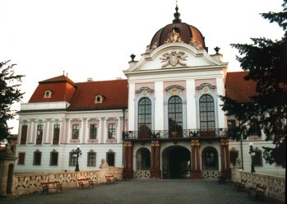
Leave Budapest in north-eastern direction for GODOLLO, only 18 miles outside of Budapest to see the Royal Palace, one of Hungary's great palaces. Also known as Grassalkovich Palace after its commissioner, Count Antal Grassalkovich, confidant of Empress Maria Theresa, the Royal Palace was completed in the 1760s. After the formation of the Austro-Hungarian Dual Monarchy in 1867, it was enlarged as a summer retreat for Emperor Franz Joseph and became the favorite residence of his wife, Queen Elizabeth. After serving for 40 years as barracks to the Soviet occupying forces as well as an old people’s home, the renovation of the palace began in 1994 and today several rooms are open to the public including Franz Joseph’s suites, Elizabeth’s private apartments and the impressive Decorative Hall.
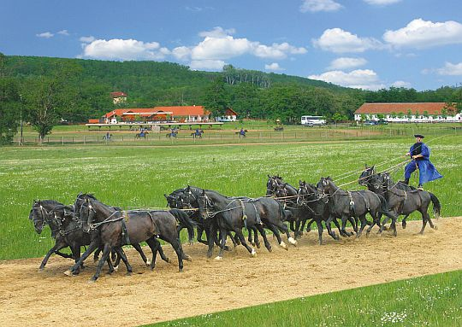
Continue to nearby Domony valley to visit Lazar Equestrian Park, combining the atmosphere of Hungarian villages with the flavor of a horse farm of European excellence and outstanding Hungarian hospitality. Upon arrival, guests are offered fresh-made scones along with Hungarian palinka and mineral water. After the greeting, proceed to the tribune to watch an exciting display of horsemanship in which local cowboys show their unique skills. After the show carriage drive and walk in a Hungarian village yard to see ancient Hungarian domestic livestock breeds and visit the stables.

Lunch at the csárda

The menu consists of goulash soup, served right off the open fire in kettles, then a spectacular wooden platter laden with 5 different meats, rice and potatoes, also a separate bowl of a myriad pickles. The dessert is a pie with apricot preserve, served flambée.

Duration: 6 hours
Rate (in case of min. 10 pax): 80,00 EUR/pax (incl. 19-seater coach, English speaking guide, entrance fees, 3-cours lunch with beverage, horse-show)

More information:

Erika Denk
Welcome Touristics Budapest, Kristóf tér 3, 1052 Budapest, Hungary
T +36 1 327 06 00 / F +36 1 266 95 27
erika.denk@columbus-budapest.com
www.columbus-dmc.com

