IEEE Conference Coordination Subcommittee Report August 2014 Jan Haase

The CoCSC coordinates financially or technically co-sponsored conferences. Currently it consists of Jan Haase (Germany, CoCSC chair), Dirk van Hertem (Benelux), and Stefano Zanero (Italy).

Present and Future R8 Conferences
- EUROCON 2013 was held on July 1-4, 2013 in Zagreb, Croatia
- AFRICON 2013 was held on September 9-12, 2013 in Mauritius
- MELECON 2014 was held in April 2014 in Beirut, Lebanon
- ENERGYCON 2014 was held in May 2014 in Dubrovnik, Croatia
- HISTELCON 2015 will be held in April 2015 in Israel
- EUROCON 2015 - will be held in Salamanca, Spain
- AFRICON 2015 - will be held in Addis Ababa, Ethiopia
- MELECON 2016 - decision phase
- ENERGYCON 2016 - decision phase
- EUROCON 2017 - looking for candidates
- AFRICON 2017 - looking for candidates

CoCSC sessions at R8 committee meetings
* CoCSC session on Friday at R8 meeting in Budapest in April 2014. Due to time constraints (the shortened R8 meeting because of the immediately following Sections Congress) there's no CoCSC session in Amsterdam.
* Follow-ups and timelines monitoring of flagship conferences has been initiated, Stefano Zanero is responsible for this action.

IEEE Panel of Conference Organizers
Jan Haase participated at the IEEE Panel of Conference Organizers (POCO) 2014. There, new tools, new rules, new plans, and new ideas for the increase of paper quality at IEEE conferences were presented and discussed.

Conference Organizer’s Handbook
The CoCSC prepared a handbook (or “howto”) for conference organizers to be sure which steps to take and which forms to submit when and where. This handbook was created mostly by the work of Dirk van Hertem.
The handbook itself can be downloaded from the R8 CoCSC webpage at http://www.ieeer8.org/category/technical-activities/conference-coordination/

Webinars
Free webinars are being organized to allow conference organizers to familiarize with IEEE procedures and gain knowledge on organizing successful conferences.
A webinar explaining the basic topics to conference organizers of conferences in R8 and section chairs took place in September 2013. It was presented by Jan Haase (CoCSC) and Kevin Hanft (IEEE Conference Services) with 15 participants and covered the following topics:
- How to start a conference
- Timelines
- Committee lists
- Financial vs. technical co-sponsoring
- Memorandums of understanding (MoUs)
- The process of applying for co-sponsoring
- IEEE Conference Exchange (ICX)
- IEEE Xplore and how do I get my proceedings published there?
- Where can IEEE staff help me?
- What does co-sponsoring cost?
- Specifics of IEEE Region 8
- Questions and answers

A second webinar took place in December 2013, focusing on conference finances. Speakers were Kevin Hanft (IEEE Conference Services), Ray Borgone (IEEE Finances), Jan Haase (CoCSC), with 8 participants.
Topics were:
- Conference Finance Topics
- Budgeting and Use of the IEEE budget template
- Conference Bank Accounts – Concentration Banking (CB) versus Local Accounts – Pros & Cons
- Taxes – Handling conference taxes; How can IEEE assist with VAT refunds?
- Audits: When is it needed? What is required to fulfill audit requirements? How/Who should perform the audit?
- IEEE Staff Resources & Services: (10 minutes)
- Overview of how IEEE staff can help the organizer: Contract review and approval, negotiating lower prices, IEEE buying power; other
- Who are the relevant people at IEEE staff?

Similar webinars are planned for September and November 2014, dates TBA.

Financially and Technically Co-sponsored R8 Conferences
The number of technically co-sponsored conferences increases, which leads to additional income for R8 due to the general administrative fee of $500.00 for R8 involvement.
The sub-committee will try to attract more conferences in 2015. Emails have been sent to all IEEE registered conference organizers that will be organizing conferences in the Region for partnership. Jan Haase is coordinating this activity. The current statistics are:

- 21 MoUs processed and signed in 2010.
- 25 MoUs processed and signed in 2011.
- 36 MoUs processed and signed in 2012.
- 33 MoUs processed and signed in 2013 (less FCS, since flagship conferences still TBD)
- 23 MoUs processed, 7 in progress in 2014 - as of beginning of July 2014

The figure below shows the Financial (in red) and Technical (in blue) MoUs signed in the years.
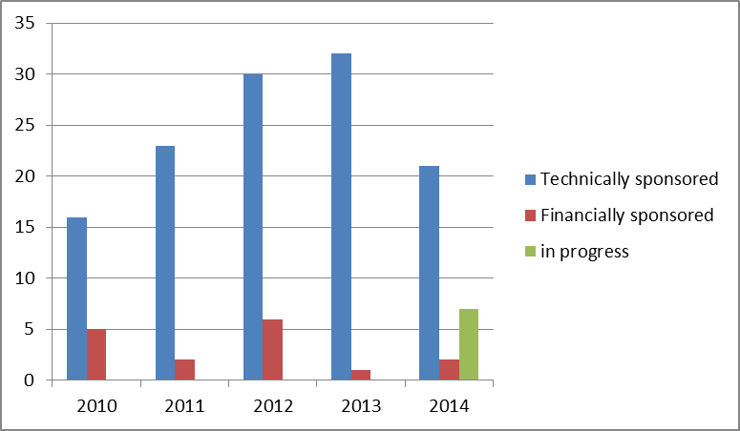

Changes in IEEE Conference Organization
- Flagship conference bids are now using the developed templates facilitating the process. http://www.ieeer8.org/category/technical-activities/conference-coordination/
- e-Notice IEEE service is used for R8 conference advertisement (e-mails go only to R8 members), see: http://www.ieee.org/organizations/vols/e-notice/
- Proceedings of conferences co-sponsored by IEEE will not automatically go into Xplore anymore. Papers have to pass quality checks. This means that technical and financial IEEE sponsors have to increase their involvement in conferences and make sure that quality is maintained.
- Post-conference reporting requirements have been posted online

Rules in R8 Conference Sponsorship and Technical Co-Sponsorship
- Requirements and standard Application Forms are available. Non-IEEE conferences (i.e. no IEEE entity is involved financially) are charged a general administrative fee of US $500 for R8 Technical Co-Sponsorship. Templates for financial and Technical co-sponsorship Memorandum of Understanding are available here: http://www.ieee.org/conferences_events/conferences/organizers/mou.html#sect2
- The new conference management tool, IEEE Conference Exchange (ICX) is to be used to produce the MoU automatically while registering the conference with IEEE. More information here: http://www.ieee.org/conferences_events/conferences/organizers/icx.html

