IEEE R8 MD Subcommittee Report August 2014 Antonio Luque

MDSC composition for 2014
- Antonio Luque, Spain Section, Chair
- Andreas Koltes, UK&RI Section, Member
- Adeel Sultan, UAE Section, Corresponding member
- Vincent Kaabunga, Kenya Section, Corresponding member

General status of MD in R8

At the end of June 2014, membership in our Region was at 69,252, with an YoY gain of 0.47% , compared to global YoY loss of -0.56%.

In the first half of 2014, Region 8 was, together with R10, the only Region in IEEE to have a positive increase in membership YoY.

Regarding retention, in R8 it increased from 70.2% in June 2013, to 70.5% in June 2014. The only other Regions with an increase in retention were R4 and R7, with a global decrease from 70.7% to 70.1%. First-year retention, however, continues to be a place for improvement, having decreased in R8 from 36.5 to 36.3% (smaller decrease than IEEE-wide which was from 30.2 to 28.6%).

Recruitment lost the momentum since the beginning of the year. The cumulative recruitment from September 2013 through June 2014 was 15,394 new members, 502 members less (or -3.2%) than during the same period one year ago. All Regions outside USA had an even larger decrease in recruitment (as high as -5%).

A first elevation of student members to full members took place in June, which meant a significant decrease in Student Members, like every year. The elevation will take place again in August.

Activities carried out since last report
- Recovery campaigns took place after the deactivation and have been running until beginning of summer, when efforts were moved towards recruitment again.
- The June R8 MD newsletter was created and distributed to all MD officers and other volunteers within the Region, including a detailed analysis of retention rate as a function of the number of membership years. It is available online at http://www.ieeer8.org/download/18493/
- We plan to continue to increase the recruitment of higher grade members at conferences along the Region.
- A special webcast addressing arrear members in Nigeria took place on May 14th, with participation of the Staff and the R8 MD Chair. This was a part of a new campaign from the HQ to reach members in arrears in large Sections and show them with benefits that are specific in their Sections. Nigeria was selected as the pilot Section for R8.
- Conference calls with MD officers and MRRC calls with other Region MD chairs and members of the MRRC in early August.
- The MD workshop took place in Dubai, UAE, on March 8th (see Budapest report).

Membership statistics

In the monthly membership variation (zig-zag graph) we can see that the forecast for the end of the 2014 membership year is to be slightly better than 2013 in R8.

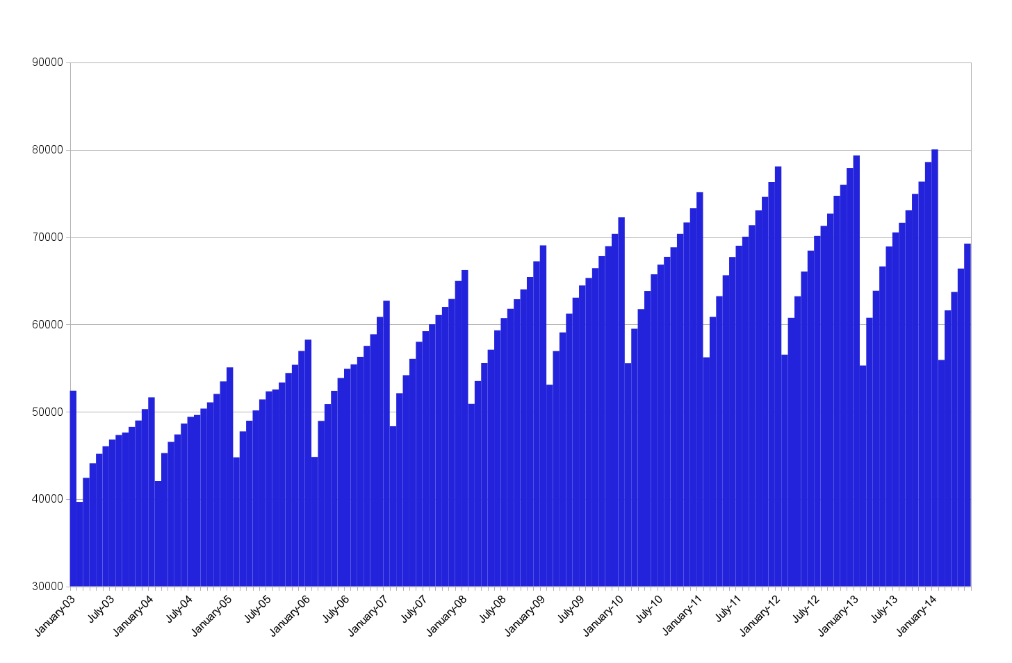
R8 Membership at the end of June 2014 was 69252, distributed as
 | Jun 2014 | '14 vs '13
TOTAL | 69252 | +324
Higher-grade w/o GSM | 49565 | +893
GSM | 11265 | -541
Students | 8422 | -28

Membership per Section

Updated membership per Section, as of July 22nd, on the following page. Totals do not include Affiliates.

 | Aff | Assoc | StM | GSM | M | LM | SM | LSM | F | LF | H | TOT
Austria Section | 82 | 41 | 117 | 250 | 749 | 12 | 76 | 10 | 10 | 4 | 0 | 1269
Bahrain Section | 3 | 0 | 5 | 1 | 57 | 0 | 15 | 0 | 0 | 0 | 0 | 78
Belarus Section | 2 | 1 | 1 | 10 | 30 | 0 | 6 | 0 | 0 | 0 | 0 | 48
Benelux Section | 186 | 60 | 142 | 733 | 2083 | 58 | 292 | 29 | 76 | 34 | 1 | 3508
Bosnia And Herzegovina Section | 1 | 8 | 63 | 63 | 115 | 0 | 7 | 0 | 0 | 0 | 0 | 256
Bulgaria Section | 2 | 10 | 36 | 46 | 167 | 1 | 20 | 0 | 0 | 0 | 0 | 280
Croatia Section | 6 | 5 | 113 | 176 | 402 | 12 | 68 | 5 | 0 | 1 | 0 | 782
Cyprus Section | 5 | 3 | 59 | 46 | 169 | 0 | 26 | 2 | 1 | 1 | 0 | 307
Czechoslovakia Section | 26 | 14 | 30 | 95 | 396 | 2 | 52 | 1 | 1 | 1 | 0 | 592
Denmark Section | 26 | 17 | 30 | 161 | 534 | 23 | 67 | 9 | 8 | 2 | 0 | 851
Egypt Section | 11 | 19 | 817 | 285 | 523 | 7 | 121 | 24 | 2 | 3 | 0 | 1801
Estonia Section | 2 | 1 | 16 | 25 | 88 | 1 | 6 | 0 | 0 | 0 | 0 | 137
Finland Section | 45 | 23 | 50 | 236 | 618 | 15 | 82 | 9 | 14 | 5 | 1 | 1053
France Section | 206 | 186 | 340 | 465 | 2396 | 44 | 380 | 20 | 72 | 13 | 0 | 3916
Germany Section | 496 | 196 | 300 | 1640 | 4592 | 86 | 570 | 39 | 94 | 50 | 0 | 7567
Ghana Section | 12 | 7 | 44 | 25 | 140 | 0 | 2 | 0 | 0 | 0 | 0 | 218
Greece Section | 49 | 36 | 532 | 230 | 856 | 13 | 151 | 8 | 18 | 2 | 0 | 1846
Hungary Section | 12 | 11 | 40 | 45 | 304 | 3 | 28 | 4 | 7 | 8 | 0 | 450
Iceland Section | 1 | 2 | 20 | 9 | 46 | 3 | 8 | 0 | 1 | 0 | 0 | 89
Iran Section | 5 | 30 | 470 | 549 | 476 | 0 | 92 | 2 | 3 | 0 | 0 | 1622
Iraq Section | 1 | 3 | 15 | 55 | 106 | 0 | 19 | 0 | 0 | 0 | 0 | 198
Israel Section | 40 | 23 | 39 | 122 | 564 | 46 | 196 | 41 | 32 | 25 | 0 | 1088
Italy Section | 227 | 131 | 188 | 621 | 2688 | 66 | 559 | 17 | 115 | 31 | 0 | 4416
Jordan Section | 2 | 6 | 416 | 14 | 165 | 1 | 39 | 3 | 0 | 1 | 0 | 645
Kenya Section | 3 | 2 | 18 | 19 | 119 | 0 | 9 | 1 | 0 | 0 | 0 | 168
Kuwait Section | 6 | 7 | 27 | 135 | 120 | 0 | 16 | 1 | 0 | 1 | 0 | 307
Latvia Section | 2 | 2 | 10 | 21 | 68 | 1 | 7 | 0 | 0 | 0 | 0 | 109
Lebanon Section | 3 | 21 | 434 | 36 | 242 | 1 | 48 | 3 | 1 | 0 | 0 | 786
Lithuanian Section | 2 | 3 | 6 | 20 | 64 | 1 | 16 | 0 | 0 | 0 | 0 | 110
Malta Section | 2 | 2 | 23 | 35 | 91 | 1 | 7 | 0 | 0 | 0 | 0 | 159
Morocco Section | 2 | 5 | 49 | 40 | 80 | 0 | 11 | 0 | 0 | 0 | 0 | 185
Nigeria Section | 19 | 16 | 172 | 154 | 927 | 0 | 26 | 2 | 0 | 0 | 0 | 1297
Norway Section | 49 | 20 | 8 | 110 | 686 | 20 | 84 | 13 | 7 | 0 | 0 | 948
Oman Section | 3 | 2 | 54 | 14 | 89 | 0 | 16 | 0 | 0 | 0 | 0 | 175
Poland Section | 32 | 21 | 67 | 90 | 658 | 3 | 143 | 13 | 14 | 3 | 0 | 1012
Portugal Section | 47 | 19 | 316 | 270 | 575 | 4 | 111 | 5 | 11 | 0 | 0 | 1311
Qatar Section | 5 | 9 | 94 | 11 | 176 | 1 | 31 | 0 | 2 | 0 | 0 | 324
Reg 8-Countries Outside Sections | 30 | 60 | 356 | 99 | 605 | 1 | 46 | 4 | 0 | 0 | 0 | 1171
Region 8 - Apo/Fpo | 7 | 4 | 11 | 7 | 66 | 0 | 5 | 0 | 0 | 0 | 0 | 93
Republic Of Macedonia Section | 1 | 0 | 35 | 39 | 68 | 0 | 32 | 1 | 2 | 0 | 0 | 177
Romania Section | 22 | 12 | 73 | 90 | 692 | 3 | 77 | 5 | 1 | 1 | 0 | 954
Russia (Northwest) Section | 6 | 8 | 51 | 33 | 133 | 0 | 27 | 1 | 1 | 0 | 0 | 254
Russia (Siberia) Section | 6 | 8 | 14 | 29 | 175 | 0 | 19 | 0 | 1 | 0 | 0 | 246
Russia Section | 40 | 50 | 48 | 86 | 525 | 1 | 28 | 0 | 1 | 1 | 1 | 741
Saudi Arabia Section | 26 | 26 | 104 | 75 | 578 | 1 | 86 | 5 | 1 | 0 | 0 | 876
Serbia And Montenegro Section | 5 | 14 | 66 | 163 | 450 | 3 | 30 | 3 | 4 | 0 | 0 | 733
Slovenia Section | 14 | 10 | 10 | 28 | 214 | 8 | 16 | 5 | 0 | 0 | 0 | 291
South Africa Section | 16 | 14 | 141 | 139 | 754 | 6 | 97 | 4 | 3 | 3 | 1 | 1162
Spain Section | 141 | 64 | 367 | 461 | 2047 | 34 | 465 | 14 | 34 | 2 | 0 | 3488
Sweden Section | 83 | 49 | 35 | 464 | 1246 | 41 | 240 | 37 | 28 | 14 | 1 | 2155
Switzerland Section | 155 | 79 | 75 | 427 | 1895 | 121 | 196 | 23 | 64 | 26 | 1 | 2907
 | Aff | Assoc | StM | GSM | M | LM | SM | LSM | F | LF | H | TOT
Turkey Section | 28 | 47 | 680 | 367 | 919 | 4 | 121 | 6 | 15 | 3 | 0 | 2162
U.K. & Rep Of Ireland Section | 327 | 176 | 457 | 1837 | 6160 | 135 | 934 | 61 | 133 | 44 | 1 | 9938
Ukraine Section | 5 | 12 | 52 | 63 | 258 | 1 | 64 | 1 | 3 | 1 | 0 | 455
United Arab Emirates Section | 16 | 20 | 509 | 138 | 620 | 1 | 110 | 1 | 1 | 1 | 0 | 1401
Western Saudi Arabia Section | 15 | 13 | 47 | 40 | 260 | 2 | 27 | 0 | 0 | 0 | 0 | 389
Zambia Section | 2 | 9 | 1 | 1 | 105 | 0 | 2 | 0 | 0 | 0 | 0 | 118
TOTAL R8 | 2574 | 1655 | 8612 | 11645 | 40139 | 787 | 6053 | 432 | 781 | 281 | 7 | 70392

